St. Luke’s Ilford - A brief history & guide
Welcome to the Parish Church of Saint Luke, Great Ilford, in the Chelmsford Diocese of the Church of England. The Eucharist is celebrated on Sunday mornings at 10.00am.

Origins - This building is the 3rd building to be used as the church of St. Luke. When South Ilford was being developed at the beginning of the 20th century and the pharmaceutical manufacturer “Howard & Son” had moved from Plaistow to the Uphall farm site, there was concern from the factory owners that their workers were being brought to the area and there was no church in which to worship. This led to a temporary church being built on the south side of Baxter Road near to the existing Vicarage. This was replaced by a Mission Hall (the present Trinity Centre), the foundation stone being laid by David Howard in 1908. Construction of a new church building designed by the local architect, Edwin Dunn, was commenced by the laying of the foundation stone by the Bishop of Chelmsford on 30th May 1914. We know that the original plans would have seen a grander building than currently exists, extending eastwards to what is now Lowbrook Road, with a spire and adjacent vicarage also facing Lowbrook Road, but the detailed plans no longer exist. Construction was however interrupted by the First World War, and only the nave & transepts were built with a temporary wall at the east end which still exists, which explains the present unfinished appearance. The church was consecrated on 22nd May 1915, with the altar in the conventional position at the (geographical) east end and the main entrance & the font at the west end.

E.T.Dunn’s original design for the church which was never completed

The three stained glass windows in the east wall are the work of Sir William Reynolds- Stephens (1862- 1943), sometime President of the Royal Society of British Sculptors. They bear a striking resemblance to his stained glass windows that were originally in the Chapel of St. Luke at the Royal National Hospital, Ventnor and now in the church of St. Lawrence, Isle of Wight.

Dedication – We don’t know why the church is dedicated to St. Luke. One theory is that the founder of the Howards chemical company was Luke Howard (28.11.1772 – 21.3.1864) and this dedication may be a nod to the Howard family. Another is that St Luke was a physicIan so a dedication to him would be appropriate because of the nearby factory.

Second World War – During the 2nd World War, many homes in the parish suffered bomb damage. St. Luke’s was hit by an incendiary bomb during the afternoon of 3rd October 1940, which lodged in the roof of the nave. This destroyed the roof, although due to the efforts of the Air Raid Precautions (ARP) team, the majority of the church furnishings were removed whilst the roof of the nave above burned. For the next 14 years the church was open to the weather which may help to explain some of the distressed internal stonework which can still be seen in places today.
The 1940 destruction

Restoration & Re-hallowing - After the bombing, it was initially hoped to provide a temporary roof so that the church could continue to be used, but this proved impractical and services reverted to being held in the hall. After the war ended, it was intended to restore the church, but this was prevented as there were other priorities. However in June 1948 the remains of the nave roof unexpectedly collapsed, which caused the Ilford Council to declare the building a dangerous structure and to threaten demolition. This threat provided the necessary driver for restoration and work was put in hand to allow the church to be re-hallowed on 15th April 1954.

The interior of St. Luke’s in the 1960’s prior to re-ordering

Re-ordering – During the late 1970’s moves were made to sell the surplus land on the north side of the church on which the vicarage was to have originally been built together with the land between the temporary east end church wall & Lowbrook Road. Some of the eventual sale proceeds came to the parish and a scheme was devised to provide a kitchen & toilets. This was achieved by moving the altar to the west end of the church (with the priest facing the congregation) and the font to the east end and opening up the east end doors as the main entrance. The present complex was then constructed in front of the temporary east end wall. Unconventionally the congregation now faces west during worship (considered somewhat daring at the time!). On completion, the church was re-hallowed on 18th October 1983 (St. Luke’s day)

Monuments – Regimental Crests commemorating those associated with St. Luke’s who died as a result of action in the First World War are carved into the stonework at the top of the pillars supporting the nave. Those commemorated are:-
Walter Fox, 1895 – 26.3.1917 – Battle of Gaza – Essex Regiment
Arthur Imrie Jupp, 1897 – 24.9.1918 – Battle of St Quentin - Cambridgeshire Regiment
Arthur Leslie Gibbons, 1896 – 22.4.1916 – Battle of Somme – Essex Regiment
Percival Gibbons, 1898 – 10.5.1915 – Battle of Ypres – Rifle Brigade
Benjamin Arthur Hall, died 15.11.1918 – Salonica Expedition – Machine Gun Corps
Edward William Gulliver, 1893 – 7.11.1917 – Holy Land Campaign – London Rifle Brigade
Harold Edward Jones, 1895 – 15.11.16, died near Albert, 10th Battalion, Royal Fusillers
Kenneth Harvey-George, 12.12.1888 – 13.6.1917, Bulle Court, London Rifle Brigade
All of these individuals are additionally commemorated by name on the panels in the Ilford War Memorial Hall at Newbury Park
A bronze plaque commemorates the consecration of the Nave & Transepts in 1915

The Elephant in the Room – The stone carving on the nave pillar nearest the organ loft is in very poor condition & is partly obscured by the wall of the vestry / kitchen complex, however it appears to be of an animal, possibly a mammoth, which might be a reference to the remains of such creatures found in the 1860’s in the Ilford (Uphall) brick pits.

Bell – The bell which now sits near the east end entrance door is the original church bell which originally hung outside at the north-west corner of the church. It was cast at the John Warner Foundry in London in 1914 and is marked “No. 389. It is hoped that one day it will be possible to restore & fittingly display it (although probably inside & still at ground level).

Other Artifacts & Memorials
The church contains a number of items of furniture and other items that have been given by members. These cannot all be listed here but particular items which might be of interest include:-

The Altar Table, in memory of Geoffrey Lancashire & originally designed for the church of All Saints, Berkhamsted, was given by his parents to St. Luke’s when the church re-ordering took place.
The Altar Rails commemorate Ken Farr (one time youth leader, churchwarden & treasurer) Arthur Hardy (sacristan)& Mrs Lydia Barnes, all of whom had left legacies to St. Luke’s
The Celebrant’s Chair & the 2 Deacon’s Chairs to the right of the altar were given by the Smith family in memory of Rose Smith (wife of Fred Smith, one time Scout Master, Churchwarden & Server).
The 2 wrought iron standard candle sticks commemorate Mary Smith (Fred Smith’s mother)
Statue of St Luke – Left of the altar the wooden statue is of St. Luke with the Ox which is his symbol.
To the right of the altar in the north transept, the large wooden figure of the crucified Christ came from an (unknown) redundant Essex / East London Church in the 1970’s It is not part of the original church furnishings.
The Bishop’s Chair, normally in the north transept, was given in 1964 in memory of Mrs Ethel Kinner, a member for 50 years & one time leader of the Sunday School & St. Luke’s Mother’s Union branch.
Ceramic poppies from the artwork entitled “Blood Swept Lands and Seas of Red” that was in the Tower of London moat for the 2014 Remembrance Day are displayed in an alcove in the south transept.
The Pipe Organ was installed after the restoration and is by the firm of N Mander. It utilises some of the pipework from the original organ destroyed in the war and was extended in 1969, however it is currently not playable. The electronic organ in the south transept was given by Mr Robert Andrews, a previous organist, whose family had been associated with St. Luke’s since the early days.

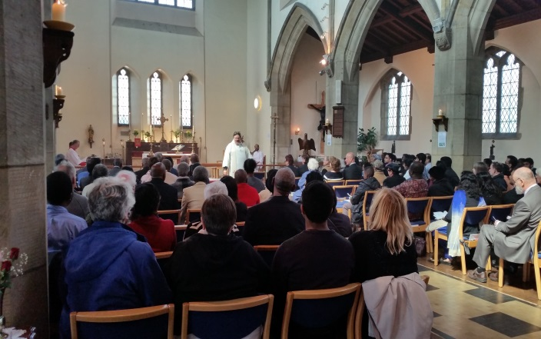

Centenary Service on 10th May 2015

Incumbents – There have been 9 incumbents of the parish & their names are listed on the Incumbents Board by the church door. The longest serving priest, so far, has been Reverend Downie from 1930 to 1961 (31 years). The current incumbent, Reverend Dr. John Brown, initially Priest in Charge & now Vicar, when appointed, divided his time equally between the parish & a role as Adult Education Advisor for the Barking Episcopal Area, but no longer serves in the latter role. The position as Vicar is now “half time”. The Reverend Bridget DeMello, formerly Associate Minister has permission to officiate and choses to associate herself at St. Luke’s

Finance
All expenses incurred by the parish, including the £23,600 annual contribution to central church funds, are met from income received through the letting of the Trinity Centre, rent from the Nursery Site, fund raising efforts and the generous giving of church members.

Updated to 2.11.25

