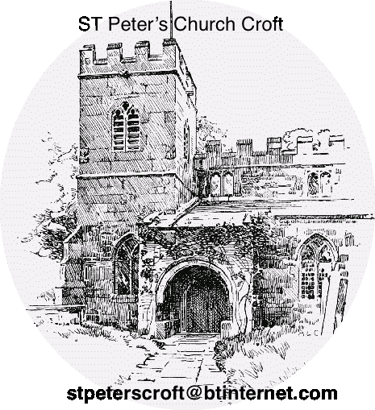

From St Peters Church, Croft on Tees

We were just wondering if you would like to take part in St Peter’s Church Lottery 2026 Draw?
The prizes are: -
1st £100, 2nd £60 and 3rd £35

The first draw will made on be Sunday 25th January 2026. After that the draw will be made on the 2nd Sunday of the month.
The annual cost is £52 which buys you a number (1 >100 randomly allocated).

Please return this application to any church member or Sue Dent. Or email us on suemdent@icloud.com or stpeterscroft@btinternet.com

All profits go towards the upkeep of the church. (Charity No 646171)
Thank you.

- Direct Bank Payment to St Peters Church Draw (NO apostrophe in Peters)
Sort Code 30-99-50 Account No. 39724068 with your reference (Name)

- I/We choose to pay annually (£52 per ticket) and would like tickets
- I/ we enclose our payment

For administrative purposes it would be very helpful to choose Option 1 (please tick if this is your choice)

Please make cheques payable to St. Peters Church Draw

Your Name or the names you would like the ticket for.

Address: Phone: Email:

Signed

