SUNDAY 2nd November 2025.



Loving God and Loving our Neighbour


Sunday 2nd November All Souls start of ‘Missing You Trees’
11.00am Watton Contemporary Service
11.00am Aston Family service
11.15am Stapleford Prayer and Praise

LOOKING AHEAD

Sunday 9th November Remembrance Sunday
10 55pm Aston Annual Service of Remembrance at the War Memorial followed by service in Church
10 45am Watton Annual Service of Remembrance with uniformed groups in Church ending with procession to the War Memorial
10 45am Bramfield Joint Remembrance Service for Bramfield, Stapleford and Waterford

You are welcome to attend ANY church

MIDWEEK

Fortnightly MONDAY 2pm ASTON Bible Study Fellowship 3 Long Ridge Aston with tea and biscuit. All are welcome. Next meeting Monday 17th November Contact Pauline at pauline.manley1966@gmail.com

St Andrew’s Bramfield Wednesday's 10am Morning Prayer - short said service followed by coffee and chat 11am. Next service date to be advised.

NIGHT PRAYER Alternate WEDNESDAYS at 7.30pm on ZOOM. Next meeting Wednesday 12th November on ZOOM. Contact Tim Alexander for link tim_alexander3@hotmail.com

Bonfire night Sunday 2nd November. Waterford village Hall. Fun starts at 5.30pm. Tickets: www.waterfordvillagehall.co.uk

Wednesday 19th November 2.30pm Stapleford village Tea afternoon in Church. All are welcome for tea, coffee cake and chat

Christmas Fayre Saturday 22nd November 11am – 4pm. Watton Memorial Hall, 118 High street. See and talk with father Christmas. Many different stalls. Tea coffee cake and mince pies.

Bramfield Christmas Bazaar Sunday 30th November 2pm – 4pm. Bramfield Village Hall.

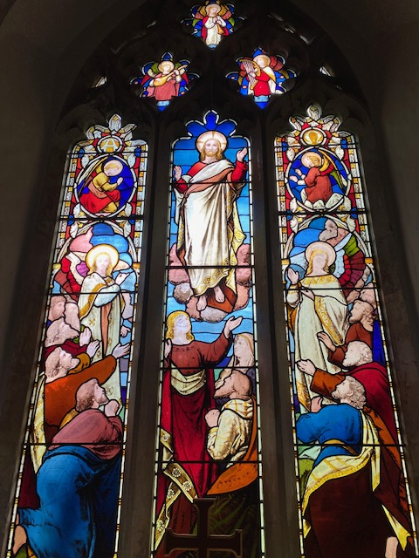
Collect Prayer for the Twentieth Sunday after Trinity.

God, the giver of life, whose Holy Spirit wells up within your Church: by the Spirit’s gifts equip us to live the gospel of Christ and make us eager to do your will, that we may share with the whole creation the joys of eternal life; through Jesus Christ your Son our Lord, who is alive and reigns with you,
in the unity of the Holy Spirit, one God, now and for ever. Amen.

(The east window in St Andrew’s Church, Bramfield behind the altar shows Jesus lifted up to heaven, the end of his earthly life, his return to God’s right hand on high)

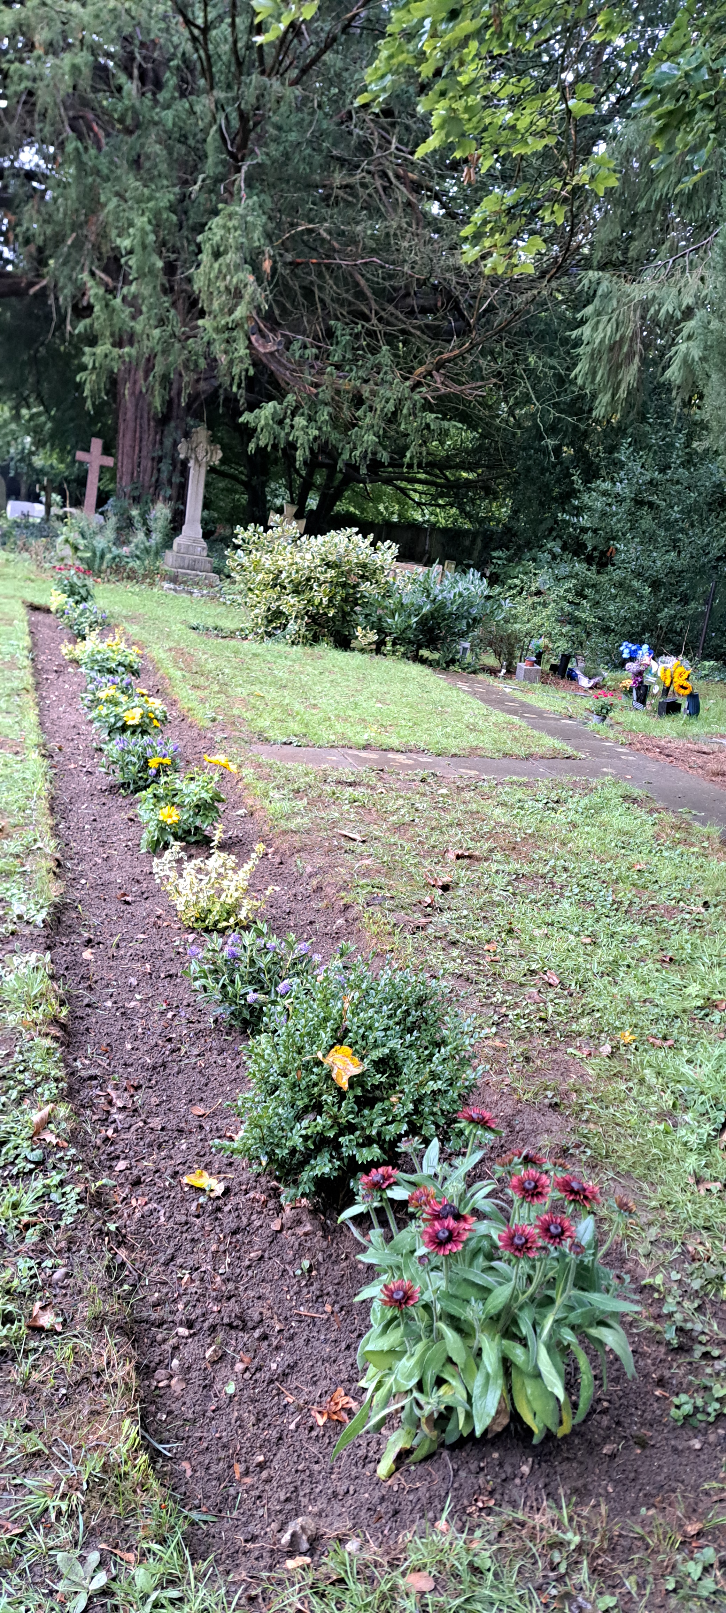
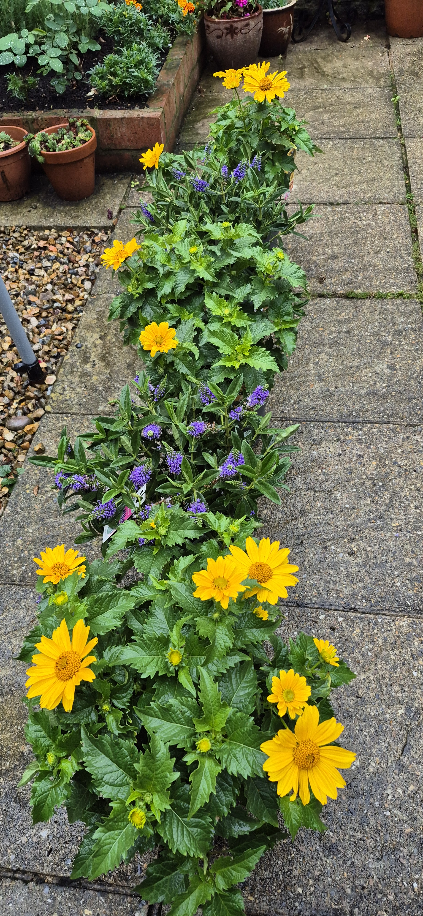
Newly planted border for the Garden of Remembrance at St Mary’s Aston
PRAY for PEACE in ISRAEL and GAZA, UKRAINE and all areas of conflict


Lord God, though peace seems humanly impossible,

we continue to pray for an end to violence and bloodshed.

We pray your comfort for the fearful and broken – hearted.


Change the hearts of those set on revenge and destruction.

Give wisdom to world leaders as they respond to aggression.

Bless all who work for understanding, reconciliation and justice which alone bring lasting peace. Amen.

‘God give us peace that lasts, not through the fear of might, but through the force of love, and love of life and right’. Amen

Hymn for Trinity 20. (HAM 436)
1 Awake, our souls; away, our fears;
let every trembling thought be gone;
awake and run the heavenly race,
and put a cheerful courage on.
2 True, 'tis a strait and thorny road,
and mortal spirits tire and faint;
but they forget the mighty God
that feeds the strength of every saint:
3 The mighty God, whose matchless power
is ever new and ever young,
and firm endures, while endless years
their everlasting circles run.
4 From thee, the overflowing spring,
our souls shall drink a fresh supply,
while such as trust their native strength
shall melt away, and droop, and die.
5 Swift as an eagle cuts the air,
we'll mount aloft to thine abode;
on wings of love our souls shall fly,
nor tire amidst the heavenly road.

Author: Isaac Watts

We believe that responding to the climate crisis is an essential part of our responsibility to safeguard God's creation and achieve a just world. Climate change hits hardest the poorest countries and poorest people of the world. Meantime, the widespread destruction of the natural world is a crisis for creation.

Our Environment Programme exists to enable the whole Church to address this — in faith, practice and mission. This includes tackling our own carbon emissions (aiming for Net Zero Carbon by 2030) and our wider work. More information can be found using the following web-link: http://www.churchofengland.org/about/church-england-environment-programme#na

Energy Hub Funded by UK Government: Find out how to:

1. Save energy

2. Save money. Reduce energy bills

3. Reduce carbon. Improve energy footprint

4.Increase comfort

For useful resources and guidance on where to get started visit: linktr.ee/energy_hub


https://app.ecochurch.org/user/21703/summary

In these autumn months don't forget to leave some water out for wildlife. A shallow dish of fresh water is good for birds, hedgehogs and many insects, keeping them hydrated and cool. If you have the space, a bigger long term project might be to create a pond in your garden.

As the days get shorter prepare your home for cooler days and nights. Research suggests an average 40% of home heating is lost through gaps around windows, doors, loft hatches and floorboards. Extra insulation, and fixing drafts saves energy. Put some draft excluder around windows and outside doors. Fit a weather proof letter box. Fit thermal linings for some thin curtains. They are cheap and really easy to clip in. Try to think of one thing to do - it saves energy and is good for the planet too.

Beane valley Benefice vacancy advert
I am pleased to confirm that the advert for the Rector of Beane Valley Benefice has been uploaded onto the St Albans Diocese website. Here is a link to the advert for you all to view: Rector for the Beane Valley Benefice – The Diocese of St Albans
Web site: http://www.stalbans.anglican.org

This has also been sent to the Worshipful Company of Grocers as Patron.

Our prayers are also with the new Archbishop of Canterbury designate, The Rt Revd and Rt Hon Dame Sarah Mullally DBE as she becomes the 106th Archbishop of Canterbury and the first woman to lead the Anglican Church.

CARING for our CHURCHYARDS


TUESDAYS Waterford Working Parties – Contact Churchwarden Malcolm Wandrag to offer help m.t.wandrag@gmail.com
To help in Stapleford or Watton or Bramfield please contact the Churchwardens.ASTON church open Sundays 12.00-16.00 and Wednesdays 10.00 -17.00 Church and churchyard working parties first Tuesday of month 10am to 12 noon. Contact Churchwarden Sara wardenstmarys@gmail.com
All our churchyards are cared for by volunteers.
Donations and offers of help are welcomed.
To include a loved one in the Book of Remembrance contact the churchwardens

Prayer for Growth for Aston, Bramfield, Stapleford, Waterford and Watton at Stone
Jesus teaches us to pray for our churches to grow. Jesus says: ‘Ask the Lord of the harvest, therefore, to send out workers into his harvest field’ (Matthew 9:38). In ways we don’t understand, God uses all our prayers.


Heavenly Father, you call us to sow seeds of faith in our communities. We ask you to fill us with your Holy Spirit that our lives may show the joy and new life we have in you. Guide our speaking and actions that others may be drawn to know your love. Lord Jesus, bless our churches that we may grow in numbers, love and service. We ask this in your name. Amen.
We pray for others to know God’s love.

Tie 5 knots in a piece of string - let each knot represent a friend or family member. Keep the string in your pocket and, as you feel the string, pray for those people to know God’s love. Set an alert on your phone to remind you to pray for those 5 people every day.

A prayer for those who seek to know God.
Lord Jesus, when your followers walked the Emmaus road wondering what was true and what was not, you came alongside them and revealed yourself in Scripture and in broken bread. Come alongside those we know and love who may wonder or seek at this time. Reveal yourself in your love and make us ready to walk alongside them too, until they see your face and know your presence. Amen.
Heavenly father we pray for guidance for our Beane valley benefice churches during the vacancy. Amen.
InTouch Age UK Hertfordshire
offer confidential, non-judgemental emotional and practical support on bereavement, physical & mental health issues, cancer, end of life, a partner with dementia or any other problem. Call 01992 634964/630623 or email intouch@ageukherts.org.uk Web page Age UK Hertfordshire | Our Services
Bereavement Support You can access online help at griefshare.org
thebereavementjourney.org cruse.org.uk teardropgrief.co.uk ataloss.org












’s
afternoon
Tea

rty
at 64 Rivershill
Sunday 24th July 2.00-5.oopm

Bring & Buy <> Raffle <> Jams
Proceeds to Both

TAKE AWAY AVAILABLE

