Remembering
We are soon going to gather around memorials in our town centres or in our Parish churches to remember. What is it that you are remembering?
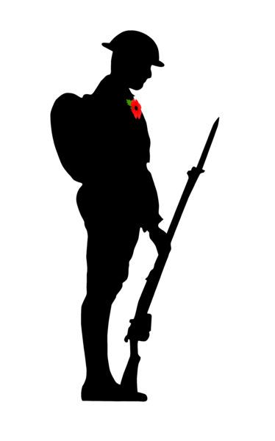
I stand before war memorials remembering different things: those who lost their lives in wars, those named on these memorials and those not named, the civilians who lost lives as a result of war; I remember that not all wars are ‘just’ wars and that sometimes the loss of life is senseless; I remember the impact of war on nature, the flora and fauna of a place. When I walk Bredon Hill in the summer and see the glorious swathes of poppies, I remember how they burgeoned in the churned up fields of Belgium and France in the first World War.
Remembering in the Bible is more than just holding past events, events which may be recent or even several millennia in the past, in our minds and reflecting on them and thinking, “Oh well, that was that.” We remember in order to live today upholding faith and values which honour God, people, land. We remember in order to avoid all which devalues God, people, land. Remembering is life-giving, it is using our members, hands and feet and voice among them, to foster life and not death. This is truly godly, holy.
For the Christian all death is a scandal, even though it is natural, part of the ‘life cycle’. There is something within us which makes us shake our heads in the face of death, “This is not right,” ripples in our consciousness. In the story which unfolds in many voices in the Bible, death is not meant to have the last word. Jesus’ resurrection, that bizarre truth upon which the Christian faith is founded, reinforces this deep sense of death not being OK. This extra ordinary story ripples in our consciousness, synchronized with the sense that death is a scandal. That life is the last word gives us hope and energy to work for all that is life giving. That life will enfold death transforming it, redeeming it, gives us hope.
Alfred Nobel left a lasting memorial of a different kind, a prize. A prize that would enable life-giving action to take root and make a difference in the world in all the spheres of life which impact people most: physics, chemistry, medicine, literature, economic sciences, making peace.
This year’s peace prize went to a woman who is striving, at great cost, to promote peace in her country. Dictatorship brought fear, and ‘significant social and economic challenges’ as one reference coyly put it. God, people, land are not being respected. The Nobel Prize committee have put the spotlight on work which seeks to bring peace. Their investment has no guarantees of success, but it is a powerful sign of faith and hope, a deep conviction that their actions can make a difference, will help to make a difference.
As we gather around our memorials this year. As we hear the words ‘never again’, the reason these memorials were erected, can we think about the way we use our influence and means to foster life and not death in our worlds.
L’chaim!
Katryn

