Social media and online presence  Find us on facebook  Christ Church Moss Side  Or  Achurchnearyou.com  Thanksgiving  The gift of new life is worthy of a celebration and we want to share in your joy.  We’ll invite you to a simple celebration Thanksgiving Service where  you and your family/friends can come to church and thank God for the gift of your  baby.  A thanksgiving service makes no assumptions or expectations regarding the faith or lifestyle of the family who take part and requires no promises from them – exactly what many are looking for – while still ensuring you can thank God for and celebrate the gift of your child.  Each thanksgiving takes place as part of our main Sunday service.  The first step is to come along one Sunday morning and speak to the vicar or one of the team after the service. | 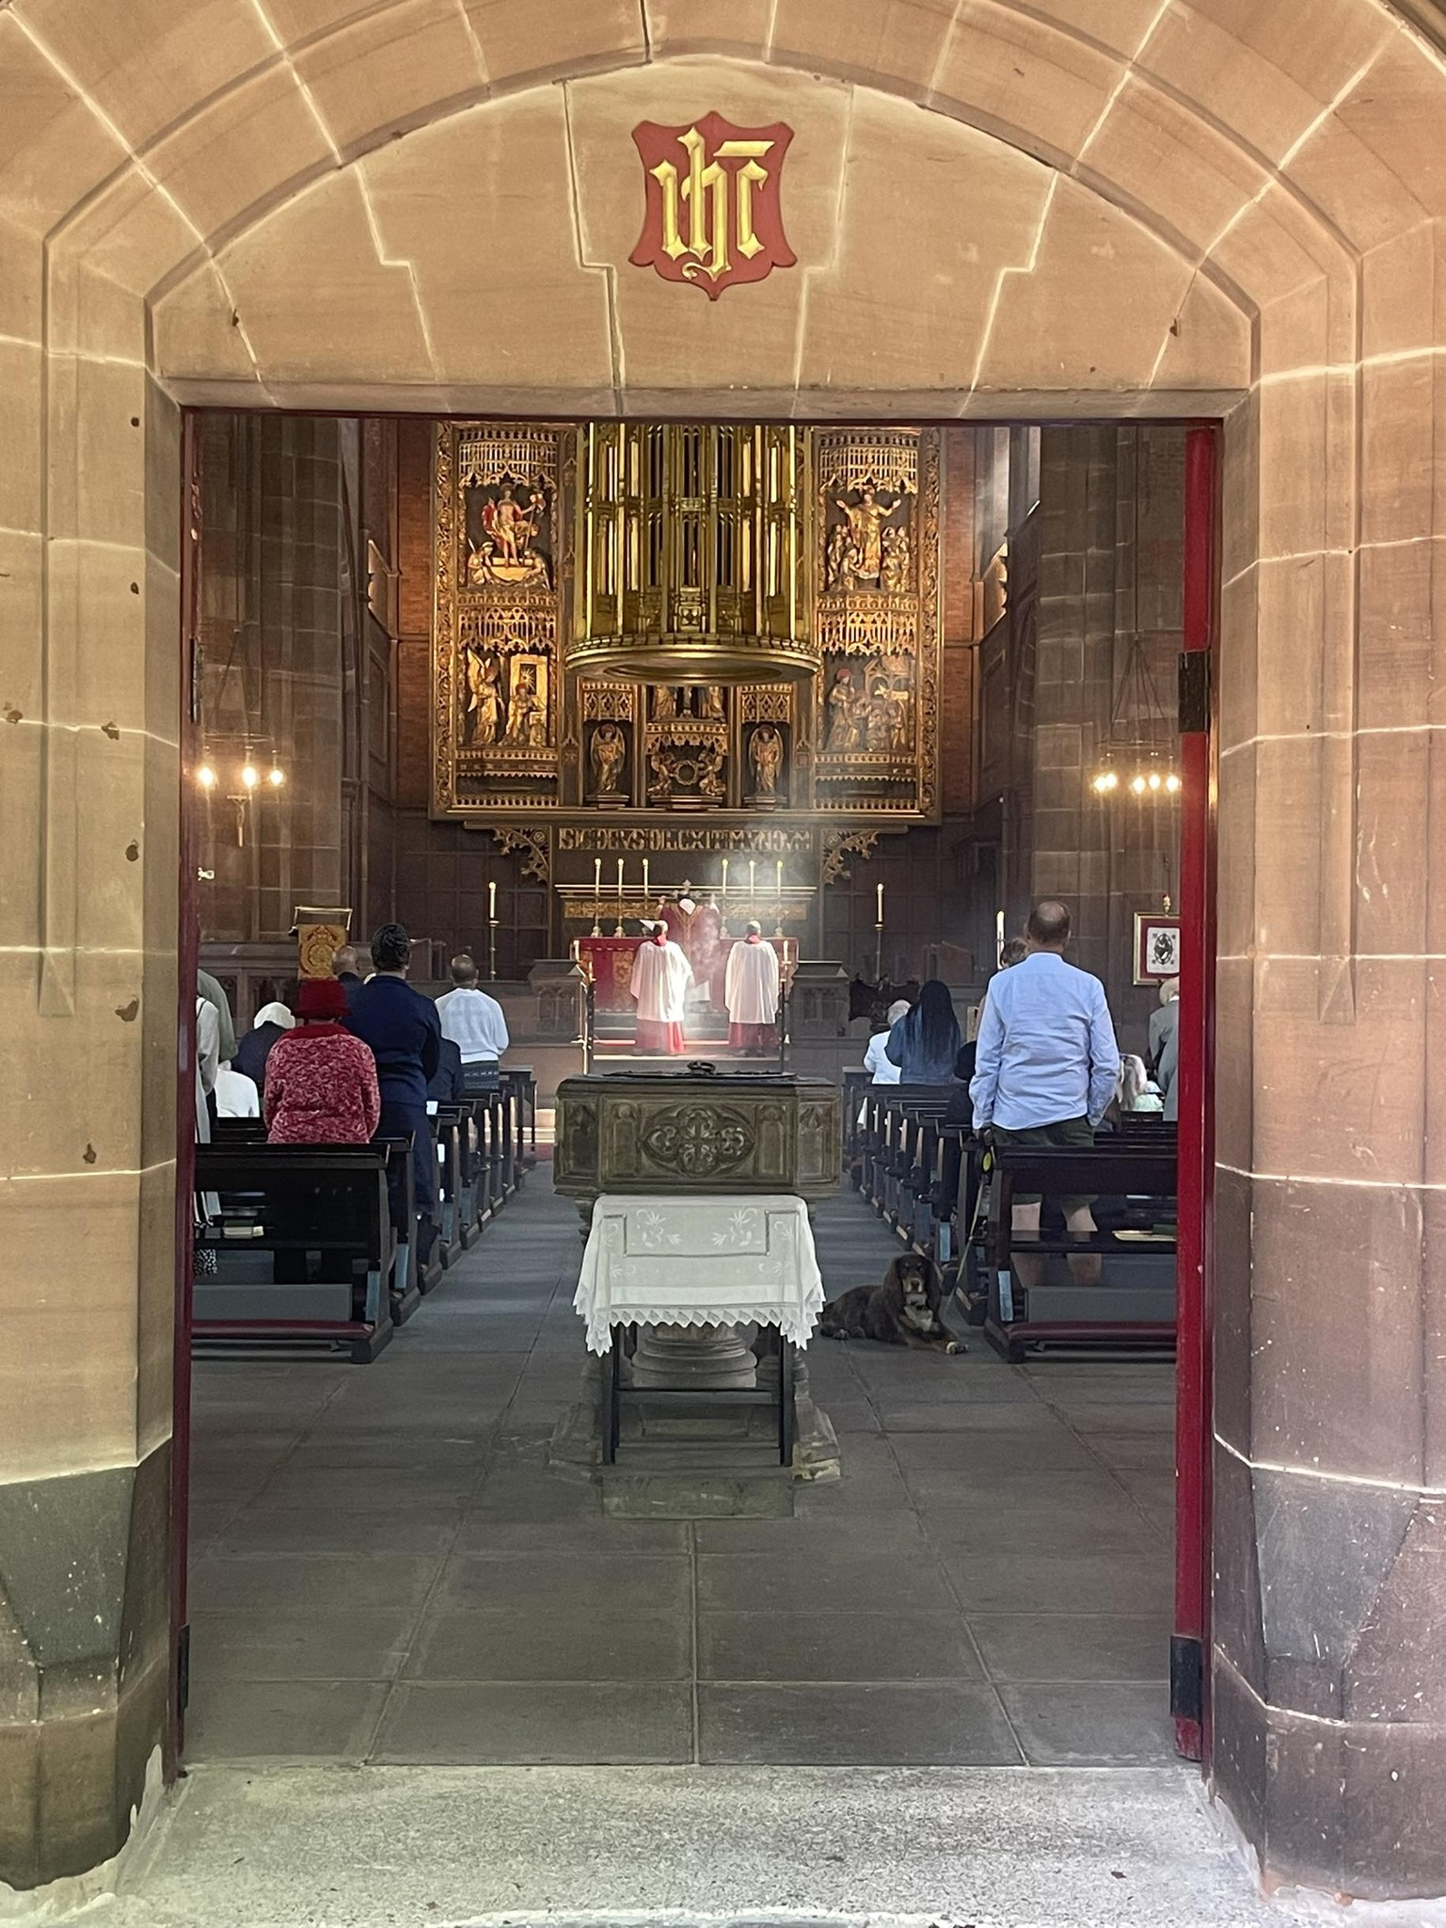  Service Time  Parish Mass  Sunday 11am  Rector  Fr Richard Hume | Christ Church  Moss side  Baptism  of infants  New life in christ  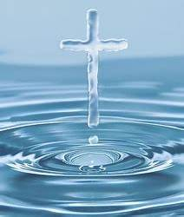
Baptism signifies that someone has decided to follow Jesus, and is regularly attending public worship as an adult or the children are being brought up in the life of the Church family so it's important you are attending church on Sundays and engaging with worship and the Christian community BEFORE requesting baptism. Whilst we don’t make you “jump through any hoops”, attendance is mandatory before we consider going ahead.  We recognise that many who seek to have their child baptised have been encouraged by family and friends to ‘do the right thing’. We want you to consider seriously whether it’s the right course of action for you and your child and whether you feel able to make the promises and declarations, not only for yourselves but for your child too. There is no obligation or pressure from us, we merely want to assist you in making the right choices.  This leaflet contains information on a Thanksgiving service if you feel you cant make these promises or the commitment required. | In the Bible, new believers were baptised publicly in a river. This was part of their public commitment to follow Jesus, often being a costly decision not to be entered into lightly.  We will help you to work through a preparation session, spending time thinking about the Christian faith and what it means to know and trust Jesus as our King and Saviour.  For those wishing to baptise their children, this includes thinking through the commitment to Jesus Christ that parents and godparents are asked to publicly declare, as well as looking at what it will mean to raise the child within the church family.  Godparents should be confirmed, this means that when promises were made as babies by their own Godparents, they confirmed them later in life, declaring with their own mouth their belief in the Christian faith. If your chosen Godparents have not been confirmed, you should consider someone who is. | At a baptism service, the parents and Godparents will make the following promises before God as well as declaring their own faith. It’s important that you are confident to make them.  · Do you reject the devil and all rebellion against God?  · Do you renounce the deceit and corruption of evil?  · Do you repent of the sins that separate us from God and neighbour?  · Do you turn to Christ as Saviour?  · Do you submit to Christ as Lord?  · Do you come to Christ, the way, the truth, and the life?  Baptism is an outward sign that shows someone knows they need their sins forgiven, and committed to following Jesus as their Saviour.  If you’d like to find out more, speak to the vicar after a morning service. Baptism is a public declaration and therefore takes place in the main Sunday service.

