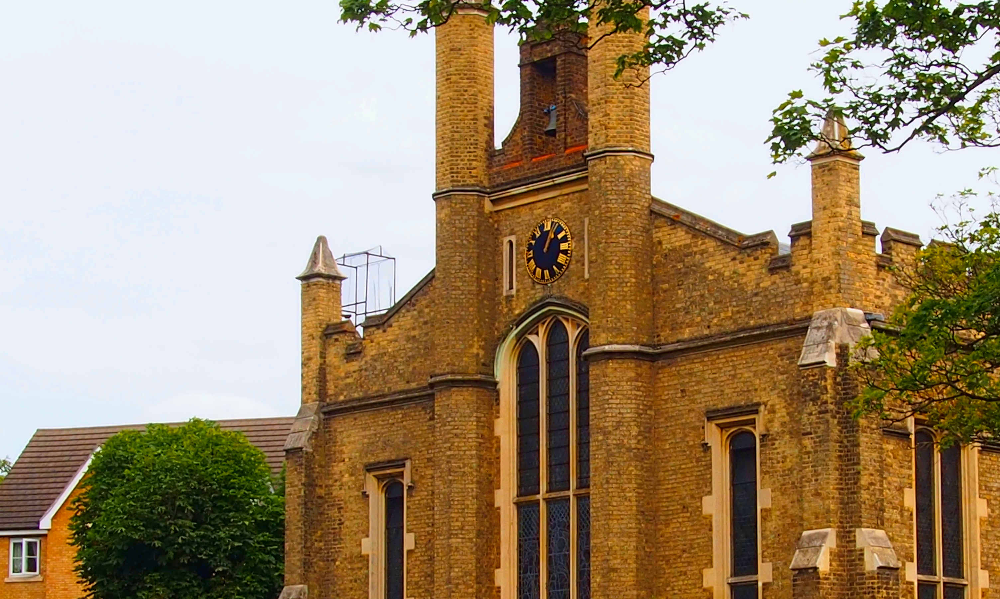
Health
and Safety
Policy

Our Health and Safety Policy

Christ Church, Waltham Cross
(Church of England)

High Street
Waltham Cross
Hertfordshire
EN8 7ED

As a church, we understand that we owe a duty of care to ensure the safety of those who visit or use our church, hall or churchyard.
We also know that, where we are an employer or control premises in certain circumstances, we have to meet the requirements of health and safety law.
We are aware that employers with five or more employees must have a written health and safety policy to meet their duty under Section 2(3) of the Health and Safety at Work etc. Act 1974.
Risk Advice Line

As a valued Ecclesiastical customer you can contact us through our Risk Advice Line on 0345 600 7531
(Monday to Friday 9am – 5pm, excluding bank holidays)
and one of our in-house risk professionals will be able to assist.
Alternatively, you can email us at risk.advice@ecclesiastical.com and one of our experts will call you back within 24 hours.



1.0 General statement of policy

1.1 Our policy is to ensure, so far as is reasonably practicable, that our activities are carried out safely and do not pose a risk to the health of our employees, volunteers, congregation, visitors and others who may use the church, churchyard or any other building we are responsible for. This will be in accordance with good practice and any relevant statutory provisions where they apply. The Parochial Church Council (PCC) accepts its overall responsibility for this.
1.2 We will ensure that adequate resources are made available to achieve this objective. Any decisions we make will have due regard for it.
1.3 We will appoint a member of the PCC to have specific responsibility for this policy and its implementation. To keep matters under review, we will include ‘health and safety’ as a standing item on the agenda for all meetings of the PCC. We will monitor the effectiveness of the policy, amending it where we believe it is no longer valid.
1.4 It is the duty of each employee and volunteer to exercise personal responsibility for their own safety and that of others. This policy will be brought to their attention. We will try to ensure that everyone involved with the church plays their part in its implementation.
1.5 Further detail about our organisation and arrangements for managing health and safety is set out in this document. A copy of it will be kept in the church and made available to others on request.

Signed*:

*on behalf of the Parochial Church Council as agreed at a meeting on:

Date:

- Organisation and responsibilities

2.1 The person with overall responsibility for implementing our policy is:

Michael Beccato-Fischer (Churchwarden)

He will ensure that the arrangements set out in this policy satisfy any health and safety law, seeking specialist health and safety advice if necessary.

2.2 The following person(s) have day-to-day responsibility for implementing our policy.
They are:

Michael Beccato-Fischer (Churchwarden)

He will ensure that the arrangements set out in this policy are implemented - this may include delegation of some tasks to other PCC / church congregation members.

  - All employees and volunteers have a responsibility to cooperate in the implementation of this policy and to take reasonable care of themselves and others while on church business or premises.

3.0 General Arrangements
This section sets out our general arrangements for managing health and safety and dealing with specific risks.
3.1 Competent Assistance
Where necessary, we will appoint someone who is competent to assist us in meeting our health and safety obligations. Where such an appointment is made, we will record the details here:
Our person appointed to assist us is: Not appointed
3.2 Risk Assessment
Where necessary, we will complete risk assessments to identify what we need to do to comply with health and safety law. We will record our findings, implementing any necessary precautions. We will review and revise these where we suspect that they are no longer valid.
3.3 Information and Training
We will provide any necessary information and training for our employees and volunteers in a timely manner. We will keep a record of what is provided. We will also give relevant information to contractors and self-employed people who may need this to complete their work safely.
3.4 First Aid
We will provide adequate first aid facilities including – as a minimum – a suitably stocked first aid box and a person who will take charge of the first aid arrangements. We will also provide relevant information for employees and volunteers.
Our first aid boxes are located: The kitchen – Marked Cupboard; Back of the Church
Our person in charge of first aid arrangements is: Michael Beccato-Fischer
3.5 Accident Reporting
We will record details of any accidents that occur, (in an accident book if required). We will report to the enforcing authority and keep records of certain accidents to employees, volunteers and members of the public in accordance with the Reporting of Injuries, Diseases and Dangerous Occurrences Regulations (RIDOR).
The accident Reporting Book is kept in the Kitchen First Aid Cupboard

3.6 Monitoring
We will make periodic checks to ensure that our precautions remain effective and adequate. We will also ensure that any lifting, work or electrical equipment and church utilities are inspected as necessary to ensure that they remain safe. We will keep records of the checks we make.
3.7 Contractors
If we employ contractors, we make sure that they have their own health & safety policy and Public and Employers Liability insurance by asking to see copies of the relevant documents.
3.8 Record Keeping
Our Health and Safety Risk Assessments, records and other documents are kept in: Church Laptop and Office Filing Cabinet
4.0 Specific Arrangements
4.1 Asbestos
As far as we can reasonable ascertain there is no Asbestos in the church buildings.
4.2 Church Buildings

We will ensure that the fabric of our buildings is regularly inspected to make sure it is safe. This will include, but not be limited to, the 5 yearly ‘Quinquennial’ inspection report. Defects will be repaired as soon as is practicable bearing in mind that a faculty may be required. Where necessary, temporary measures will be taken to prevent danger until permanent repairs can be made. This will include glazing.
4.3 Church Garden

We will ensure that boundary walls and gates are kept in good repair. We will have trees inspected by a competent person and have any necessary work carried out to make them safe.
4.4 Construction Work

Where maintenance, refurbishment and restoration work is planned for our church, we will identify what we need to do to ensure the safety of all those concerned before work starts. We will also determine if we have any responsibilities under the Construction (Design and Management) Regulations and comply with these if necessary.
4.5 Display Screen Equipment

Where our employees and volunteers regularly use computers daily, for continuous periods of an hour or more we will analyse workstations to identify precautions, implementing these as necessary.
4.6 Electricity

We will ensure that any electrical system, fixed machine and portable appliances is inspected, tested and maintained by someone who is competent to prevent danger. Any defective equipment will not be used until it is repaired or replaced. We will keep records of the checks made.
4.7 Events

Where we intend to hold large or unusual concerts, services or other fund-raising events, we will identify any additional precautions that are necessary and implement these.

4.8 Fire Safety
We will complete a specific risk assessment to identify what steps are necessary to prevent, detect and take in the event of a fire. We will record our findings, implementing any necessary precautions. We will review and revise these where we suspect that they are no longer valid.
- Fire extinguishers are positioned throughout the church, hall and kitchen (fire blanket) – these will be serviced by a competent person on an annual basis and records kept.
- The emergency lighting system is to be checked on a regular basis and records kept.

4.9 Heating Systems
We will ensure that our gas heating systems are suitably maintained and checked annually by a competent person. Any defects found will be corrected immediately and we will keep records of the checks made.
4.10 Hazardous Substances
We only use domestic cleaning or horticultural products and petrol. We will ensure that these are stored, used and disposed of in accordance with the manufacturers’ instructions taking any necessary precautions that are specified.
4.11 Lifting Equipment & Ladders
We will ensure that any lifting equipment brough into the church premises, and any ladders in use in the church premises are properly maintained and thoroughly examined periodically by a competent person.
4.12 Manual Handling
We will avoid the need for lifting or carrying heavy objects as far as is possible. Where this is not practical, we will make use of lifting aids (such as, trolleys) or other precautions including team lifting.
4.13 Preparation of Food
We will ensure that on those occasions when we prepare food, we use a clean and disinfected work surface, utensils and equipment.
We will store food in such a way as to avoid contamination, provide hand-washing facilities and suitable arrangements for the disposal of waste
We will display allergy warning signs when selling ‘home-made’ cakes and goods.
4.14 Risk Assessments
Risk assessments will be undertaken for:
- The church, hall and ancillary interior spaces.
- The church exterior spaces, e.g. garden, garage store, boiler room.
- Individual group activities, e.g. Parent and Toddler group.
- Individual services where there is potential increased risk, e.g. Christingle, Carols by candlelight, etc.
- Individual social events, especially those open to the public, e.g. coffee mornings, fairs, etc.
- Fire safety.
4.15 Slips and Trips
We will implement suitable precautions to prevent slips or trips, taking account of any difficulty the frail, elderly or disabled may have in negotiating access. We will make periodic checks to ensure that floors, coverings, steps and pathways remain in good condition, free from obstruction and that any precautions (such as, handrails, lighting) remain adequate. We will correct any defects identified, keeping records of the checks we make. We will have arrangements in place to manage pathways in winter weather.

4.16 Working at Height
Where possible we will try and avoid the need for work at height. Where this is not practicable, we will ensure that any work is properly planned to identify suitable precautions. We will make sure that these are implemented, including the provision of any training and checks to ensure the safety of any equipment used.
4.17 Work Equipment
Any work equipment (including any hand tools) we provide will be suitable, in good condition and properly maintained. Where necessary, some equipment (such as, ladders) will be regularly checked to make sure they are safe. We will keep records of any checks we make.
4.18 Working Alone
We will identify circumstances where our employees and volunteers work alone and implement suitable precautions to ensure their safety.

5.0 Adoption of good working practices

5.1 Ecclesiastical Insurance provide a library of policy and good practice guides. These have been adapted in the preparation of this policy.

5.2 Documents can be found here: https://www.ecclesiastical.com/risk-management/church-health-and-safety/

5.2 The Risk Reminder calendar published by Ecclesiastical Insurance is adopted as systematic approach to the help us look after and protect Christ Church and those who use it. The calendar is reproduced on page 7.

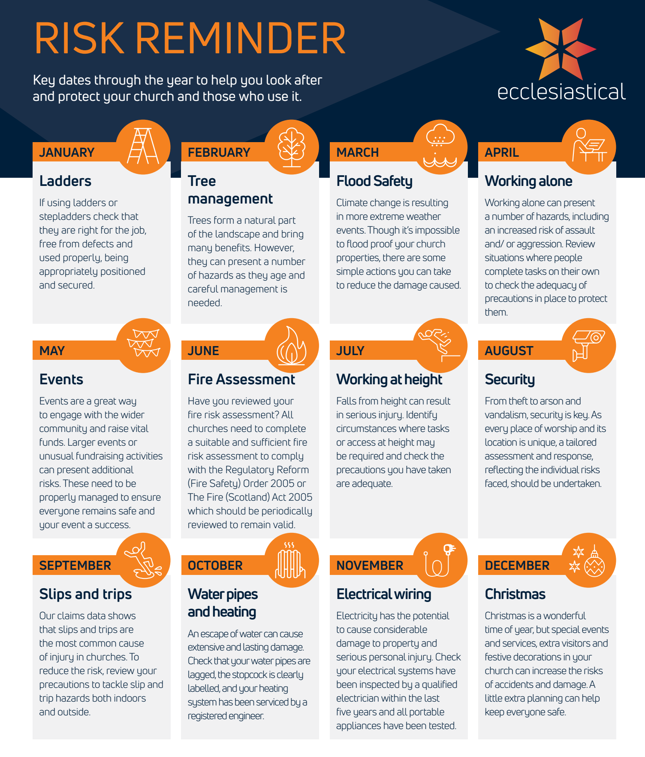

6.0 Policy preparation and review

6.1 A note about the information in this Policy
We have prepared this Policy in good faith. The information in it is based on our understanding of current law and practice.

  - Annual Review
    - This Policy is to be reviewed on an annual basis by the Parochial Church Council (PCC) at its September meeting.
    - If no changes are needed, the Policy above will remain in effect until the subsequent years review (subject to 6.2.4).
    - If changes are needed, the Policy will be amended, re-issued as a new version and ratified at the November PCC meeting.
    - A fully reviewed Policy will be issued as a new version at least every five years.

This policy document has been prepared as version two (V2) by Michael Beccato-Fischer.
Signed: 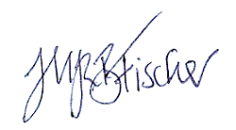 Date: 10th August 2025

6.3 Annual Review Record: Health & Safety Policy (V2) dated 10 August 2025

Date | Status | H&S Officer Signature
1/09/2025 | Year 0: Initial PPC approval
 | Year 1: Reviewed: Unchanged Update needed
 | Year 2: Reviewed: Unchanged Update needed
 | Year 3: Reviewed: Unchanged Update needed
 | Year 4: Reviewed: Unchanged Update needed
 | Year 5: FULL REVIEW

