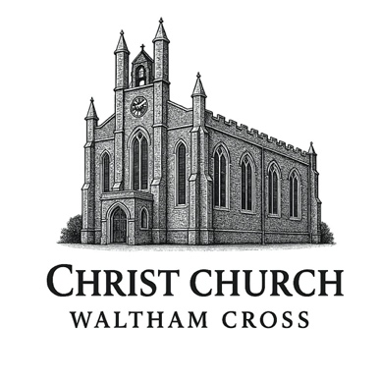

Christ Church,
Waltham Cross

DISABILITY AWARENESS
POLICY
2025

Original Document April 2004
Reviewed September: 2025
Review Date September: 2026

Mission statement.
We are made in the image of God, and as such all people are of equal importance and significance. In God there is no distinction between male and female, Greek or Jew, bond or free – disabled or able. We all, irrespective of our status have privileges and responsibilities in the practice and outworking of our faith. Just as there is a ‘bias to the poor’ so there is a Biblical imperative to have a corporate responsibility to those on the margins of society and within the structures of our church.
This policy enshrines the principle that all people attending Christ Church, Waltham Cross, for whatever reason, are treated equally.
The Equality Act (2010) states that churches must take reasonable steps to ensure that our policies, practices and procedures enable people with disabilities (lay and ordained) to enjoy and fully participate in all aspects of the life and work of Christ Church.
Definition of disability
‘A person suffers a disability if he or she has a physical or mental impairment that has a substantial long-term adverse effect on his or her ability to carry out day to day activities’ (Disability Discrimination Act 1995 Part 1)
Physical or mental impairments include sensory impairments (such as those affecting sight and hearing) and learning difficulties. The definition also covers certain medical conditions when they have a long term and substantial effect on people’s everyday lives and mobility.

Implementation
- To ensure the inclusion of people with disabilities we will develop the following good practice in areas covered by this policy:
- A positive attitude to include all people as equals and so enable their full and equal participation, where possible, in both sharing in and leading worship is at the heart of the Gospel.
- Where possible all should be able to access the building independently.
- Where possible there should be accessible seating, with varying seat height, some with arms.
- Where possible there should be free movement around the building for someone to independently use a wheelchair or other aids to assist their movement.
- Where possible steps and obstructions should be removed. Full participation in all aspects of worship is central to the experience of the worshipper.
- Gathering for Communion at the altar is the heart of Christian worship. Therefore, where possible the altar should be fully accessible for communion in the way it is for the able bodied.
- Singing in the choir, serving, chalice assistants, reading lessons, leading intercessions, are all part of worship and where appropriate should be accessible to all.
- A loop system should be available and used at all times.
- Large print service books and hymn books should be available.
- PCC meetings and all committee meetings should be held in accessible locations.
- All church activities, socials, prayer groups, Bible studies and courses should be held in fully accessible locations.
- All material for meetings should be available in large print.
- All church buildings including halls require a current access audit which should be reviewed and implemented annually.
- In addition
- Making notices and pew sheets available in large print format (i.e. font 16)
- Ensuring that service books, bookstalls and display racks can be found and reached easily by the visually impaired or wheelchair user.
- Ensuring that sidesmen and women know how to relate to and communicate with all kinds of people with disabilities including where they should sit, what books they need, how they receive communion.
- Ensuring that the aisles and doorways are kept clear of furniture and equipment so that there are no hazards to access
- Checking the sight lines and lighting in the church for members of the congregation who are visually impaired or need to lip-read.

Our Aims
Christ Church aims to:
- Ensure that all worship and activities are available to every person
- Ensure easy access to all buildings and facilities for every person

Achieving our Aims
To successfully achieve our Aims we will:
- Regularly assess our buildings, facilities, worship and activities to identify any changes that are needed to achieve our aims
- Actively seek the opinions and suggestions of those with disabilities
- Annually review potential improvements/changes to our buildings, facilities, worship and activities, generate an Action plan if necessary

Review of Policy
The PCC will review this Policy on an annual basis.

Approved by the PCC

Dated: 1/9/25

