**How can I donate money**

**to my church?**



**Holy Trinity, Dawley**

**St. Leonard, Malinslee**

**St. John, Lawley**

**St. Mary, Ketley**

There are lots of ways that you can donate to your church. Regular weekly or monthly donations are most helpful as they enable us to anticipate what our regular income might be throughout the year and to be able to budget accordingly. We also welcome one-off gifts, should you wish to donate for a particular purpose, to mark a special occasion or as a particular thanksgiving for something that God has done for you.

***Direct payments to our bank account:*** You can set up a Standing Order to pay a regular amount each month directly from your bank account to ours. We can provide you with the information that you need to do this. This is the most helpful way for us to receive donations as it reduces the amount of cash we have to handle, and enables us to have an idea of what our regular monthly giving income is. One off donations can also be paid directly into our bank – just ask for our bank details.

***By cash:*** During our services each week there is the opportunity to place cash into the offertory plate that is passed around.

***Using our contactless machines:*** These are a convenient way to donate for those who don’t carry cash – all you need is a card or a smartphone, and you can donate anytime when you are in church.

***Giving online:*** You can donate to your chosen church at anytime by visiting our website ([www.telfordchurch.co.uk](http://www.telfordchurch.co.uk)), selecting your church, and clicking on the page ‘Donating to….’. All you need is a credit/debit card or other means of paying online.

***Donating as you shop:*** If you shop online, each of our churches has an account with [www.easyfundraising.org.uk](http://www.easyfundraising.org.uk). If you register with easyfundraising, and select your church as a cause, they will donate a small percentage of the money that you spend to your church at no cost to yourself.

***Weekly giving envelopes:*** At Holy Trinity and St Mary’s churches, you can request weekly giving envelopes for your donations. These are helpful if you’re not able to be at church each week as you can put a weekly amount in each envelope and bring them when you can come, and place them in the offertory place

At St Leonard’s and St John’s, weekly giving envelopes are not used, but maybe you consider deciding on a weekly amount that you would like to donate and set this aside on the weeks not in church and bring it all when you next come.

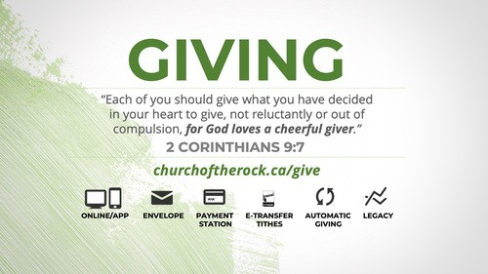

***Gift Aid :*** Gift Aid is an arrangement that allows charities (including churches) to reclaim tax on a donation made by a UK taxpayer. This means every donation will be worth 25% more, at no extra cost to the giver. For example, with Gift Aid our churches can claim an extra 25p for every £1 donated, which makes a huge difference.

If you would like to support your church with Gift Aid, you simply need to complete a Gift Aid Declaration. A Gift Aid Declaration is the giver’s declaration that they wish for the church to reclaim tax on their gift and can be made for a [single donation](https://www.churchofengland.org/sites/default/files/2021-11/Gift-Aid-declaration-single-002.docx)or for [multiple donations](https://southwark.anglican.org/wp-content/uploads/2021/02/Charity_GAD_Multiple_Donations-1.pdf).

We can claim Gift Aid on all cash donations under £30 which are placed in the offertory plate or given through our contactless machines, regardless of whether you are a tax payer or not. If your donation is larger than £30 or you are paying a donation directly to the bank, and you are a tax payer, please let us know and we can make sure that your donation attracts Gift Aid.

**Thank you** for reading this leaflet -we hope that it is helpful. If you want more information about any of these ways of donation, there is a card included in the pack. Please fill this in, return it to church and we will get back to you.