NOTICES FOR 19th OCTOBER

REQUESTS
FACEBOOK
I am asking for items for the church Facebook please. ie photos of events or posters of events to be sent to me at my email address Ruth.townsend68@gmail.com or via the message option on the church Facebook page.
Please could posters not be in word. They fall apart into their separate bits when I try and post them. A photo of the poster is great.
Any photos of recent events gratefully received please, but please check you have sought permission for posting.
Many thankyous,
Ruth

THANK YOU’S

Thank you to all those who contributed towards the beautiful flowers for the Harvest thanksgiving and also to those who brought in all sorts of wonderful things for the children’s clay pictures. Anything left has either gone in for well dressing or to ladies in the Cabin in Belper who make amazing things using nature’s bounty - which is God’s bounty.
I’m sure we all appreciated such a wonderful weekend of joy in praising and thanking God for His generosity.
Sylvia

CHURCHYARD WORK MORNING

Churchyard work morning
Saturday 18th Oct
9.30-11.30am

We will be mowing, composting and managing our wildlife meadow near the bierhouse. Please join me with gloves and secateurs at the ready!

Sophy



Throughout Autumn something special is happening in our night skies. Huge numbers of redwing are migrating from Northern European forests, which empty of most bird species before winter strikes. Coming from Scandinavia and Russia they migrate into the UK, Ireland and western France. Bird books describe the redwing call as seeih and once you have learned it, you may hear a redwing call overhead every few minutes, wherever you are in the UK, as they pass over in a wave of birds. There are a few pairs (about 80) of redwing breeding in Scotland but really, they are a winter visitor to our shores.

Redwings are a small thrush, of similar size to our song thrush but with darker brown plumage and the characteristic flash of colour from the red feathers on their under-wings as they fly. Look out for them feeding in the churchyard, you may be seeing birds fuelling up on migration or winter visitors who will stay for a few months. Redwings feed on berries, fallen fruit and will find soil invertebrates in short grass, pulling up worms or digging out leather jackets. They can be seen in flocks, with other thrushes such as fieldfare, mistle thrush and song thrush, feasting on yew berries and making a real mess! Winter thrushes descending on churchyard yews is one of the sights that chart the changing seasons.

You can help redwing and other thrushes by providing berry bearing shrubs and trees and thinking of your hedges as larders for weary travellers. Leave hedges untrimmed until February or early March so that birds may shelter within them and feed on hedge fruits such as hawthorn berries. Churchyards are usually free of pesticides which allows soil invertebrates to thrive, providing lots of nutritious meals. Yew trees provide both food and shelter and also give us the opportunity to really look at these lovely birds and think about the long journey they have made to reach us.

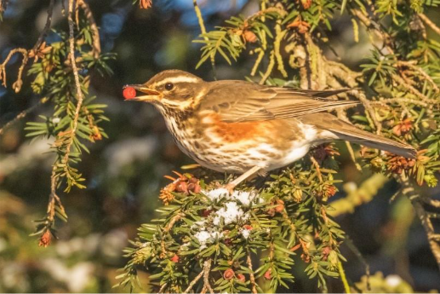

Octobers tip for the month from the ECO Church website
Provide food and shelter for wildlife, now and in preparation for next year. Clean all your bird feeders to avoid the spread of disease to winter migrants and put up a nest box well in advance of breeding season. A nest box could also prove a cosy spot for small birds to spend the night on particularly cold winter evenings ahead

REQUEST
Do you have a Eco tip to share for next weeks notice sheet? If so please send to me at office@crichstmarys.org

