**Saint Hilda’s Church**  
**Parish Newsletter  
28th in Ordinary Time**

**12th October 2025**

**Parish Mass 11am  
Said Mass with hymns  
Celebrant and Preacher   
Father Simon**

Hymns   
Introit: 334 All People that on earth do dwell  
Offertory: 285 For the beauty of the earth  
Communion: 297 Lord Jesus Christ  
Angelus

Recessional: 436 Praise my soul

Sides people: Liz & Mason  
Reader First Lesson: Margaret  
Psalm 98 (97) Margaret  
Reader Second Lesson: Pat A  
Intercessor: Carole

***Coffee will be served after Mass in the Croft***

***If you are new to St Hilda’s or just visiting,   
please feel free to join us.***

**Please remember with love and prayers all on our prayer list here at St Hilda’s**



John Pymm, Marion, Lynda, Susan Hughes,   
Mary Bardsley, Keith Bentley,   
Archdeacon Rachel,   
Robert Williams,Jane, Beryl & Peter Holland,  
Helen, Linda Clarke, Susan Lees, Sian Fletcher, Renée Lukes, Derek Hughes, James Lucas  
Francesca Boothman, Fr Paul Denby,   
Mavis & David Belton, Roy Walker,   
Hilary Graham, Kevin McGuire,Jean Adamson,  
 Fr Croft, Jenny Mulholland,

Maryrose & Walter Thompson,   
Paul & Michael & Av Jones.

also, any others who are known to us, whose names are not mentioned here and need our prayers.  
  
**Income Survey 2025** It is that time of year again! Please can all regular members of St Hilda’s pick up an income survey form and place in the box provided. This is something we are required to do and is completely anonymous.

***This week at St Hilda’s***

Tuesday: Coffee Morning 9am   
Low Mass with Laying on of hands 10am

Heaton Park WI 7pm – 9pm

Thursday: Lunchtime Drop-In 11am

Friday: Harvest Supper 7pm

Sunday: Parish Mass 11am - 29th Sunday in OT

***Future dates for your diary***

**October**   
24th Parish School closes for half term

25th Children’s Party booking in the Croft

**November**

1st Afternoon Tea in the Croft 2pm

2nd Family Church 9.30am Parish Mass 11am & Baptisms at 12.30pm

11th Heaton Park WI 7pm

16th Saint Hilda’s Day 11am followed by a Bring and Share Lunch TBC

20th Lunchtime Drop In

27th School Christingle service

30th PCC meeting 12.15pm

**December**

6th Parish Christmas fair  
9th Heaton Park WI 7pm

11th KS1 Nativities



We remember before God all those who have died specially those who have passed in the night with no-one to comfort them.

We remember with love and prayers those whose “minds” fall during this week

12th October

Janet Davies 2020

13th October

Marie Antoinette Mahon 2016

13th October

Anne Nangle 2021

15th October

Lilian Hale 1977

17th October

Florence Graham 1994

18th October

Kenneth Crowley 2006

Joyce Christine Greenwood 2013

Arthur Hickie 2019



**Parish Christmas Meal** at the Woodthorpe. If you would like to come please let us know ASAP.

**Sunday 19th October**

**29th Sunday in Ordinary Time**

**Parish Mass 11am**

Sides people: Rachel & Melanie

First Reading: Melanie

Psalm 121 (120): Melanie

Second Reading: Tina

Intercessions: Ken

**SCHOOL NEWS**

On Tuesday, Mrs Clemmett attended Manchester Cathedral for the Choral Evensong with the commissioning of New Headteachers from church schools in The Diocese of Manchester. The Bishop of Middleton and Debra Smith led the service. It was a great privilege to receive a blessing & commissioning from Bishop Mark as the new headteacher of St Hilda's.

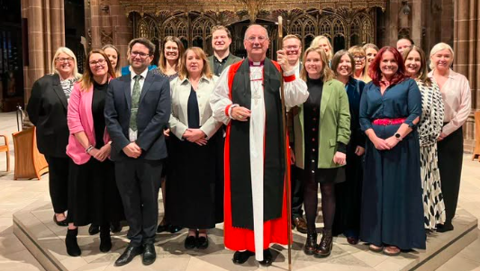

Mrs H Clemmett

**If you wish to contribute by standing order instead of the envelope scheme.   
The bank details are as follows:**

**St Hildas PCC Sort code: 01-07-20  
Account number: 06803806**

If you wish to change from the envelope scheme to standing order, please see our treasurer Andrea ASAP

St. Hilda PCC are always very grateful to receive any contributions to the upkeep of the Parish

church however small.

Follow St Hilda’s Church on the following platforms

Church website: http://sthildaprestwich.org.uk/  
Facebook: <https://www.facebook.com/Sthildaprestwich>

Any church near you: Search St Hilda Prestwich

Or you can request to join the church contact list, this is an email which is sent direct to your inbox on a weekly basis. You can either email Carole PCC secretary at [sthildaprestwich@gmail.com](mailto:sthildaprestwich@gmail.com) or speak to her directly.

**Coffee Morning** takes place on a weekly basis. We are open from 9am for takeaway coffee or you can eat in.   
**Table top sale** every Tuesday at Coffee Morning and Sunday after Mass in the Croft. New items added each week.

**Harvest Supper** This coming Friday at 7pm. **PLEASE LET US KNOW IF YOU ARE COMING**

**REMEMBRANCE DAY** **APPEAL** – Please could you save your used plastic drinks bottles for us.

**Thought for the week**

Some things you hear with your ears,

others you hear with your heart

**PARISH PRAYER**

Loving Father,

We pray for our Parish Church of   
St Hilda, during this vacancy. We pray for Ken our churchwarden and all the PCC members who help to share the responsibilities during this time.

Help us to meet the needs of our church, to love one another, so we can continue to grow in faith.

We pray for the Society and all who have helped us maintain the Holy Mass during this time.

We pray for the Parish School, for the children, parents and staff.

In the power of your Holy Spirit, we look to the future and pray that the right person will be found to lead us and to do your will here at St Hilda’s.

Help us to prepare the way for a new priest, so we can all work together to love and serve you here in our community and parish.

Amen.

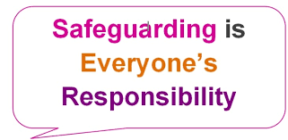

We take the safeguarding of children and vulnerable adults very seriously here at St Hilda’s. Therefore, if you have any concerns please speak to the Parish Safeguarding Officer:

Mrs Shirley Diver: 07922 330069

Or the Diocesan Safeguarding Advisor

Abbey Clephane-Wilson: 0161 828 1465