Message to Marton Friends for Sunday 19th October 2025
Dear Marton Friends
Please find attached this week's update, which includes a link to a special video reflection recorded by Rev Steve himself. We continue to pray for the whole Whiting family at this time.
Just a quick note to thank everyone who contributed to the financial offering at our Harvest Service in September. As well as sending John McGall back home with his car full of very practical gifts for the foodbank, the money collection of £117 was sent to RABI (the Royal Agricultural Benevolent Institution) who aim to provide wrap-around support to farmers in times of crisis, mental health support, counselling, expert advice and guidance. Their letter of thanks says, 'Together, we can continue to be there for farmers, whatever the season may bring'. Amen!

The PCC also made a special gift of £55 as a token of appreciation for our very own Canon Robert Law for his 55 years of service as an ordained minister. This was split between 2 charities of Robert's choosing: Great Ormond Street Hospital and UK-Med, a humanitarian medical charity providing aid in conflict and disaster (https://www.uk-med.org/)
A reminder that this weekend, Sunday 19th, we have a Celtic Evening Worship service at 6pm in Marton Church. This is the last of our evening services before we revert to afternoon services at 3pm right through from the beginning of November to the end of March 2026.
No Tuesday Midday Prayers this coming week (21st) and then on 28th we'll hopefully be meeting at Frances's house (11-12). We'll be back in Marton Church on Tuesday 4th November and then the following week it'll be our Remembrance Service on Tuesday 11th. If you'd ever like to join us for Midday Prayers, do please get in touch and I'll confirm that week's arrangements with you!
Dates for your diary:
Tues 21st October at 1pm: David Mather's Funeral in Marton Church (no Midday Prayers). After the funeral service, the family only will depart for Thirsk Crematorium. Teas and coffees will be available in church and then everyone is invited to The George in Easingwold (from 3pm).
Tues 28th October: 11-12 Midday Prayers (hopefully) at Frances's house
Sun 2nd November at 3pm: Celtic Communion
Tues 4th November: 11-12 Midday Prayers in Marton Church
Tues 11th November at 10.50am: Remembrance Service in Marton Church (no Midday Prayers)
Sun 16th November at 3pm: Celtic Worship
Sun 30th November at 10.30am an Advent Carol Service in Farlington Church
Sun 7th December at 3pm: Celtic Communion
Sun 14th December at 3pm: Carols by Candlelight.

This week I received an email announcing that Ray Simpson has died. Some of you will recognise this name, as he wrote a number of books about Celtic Christianity, includig 'Celtic Daily Light', which has been the source of a number of our weekly blessings! I thought it would be appropriate to finish this email with a tribute to him from Anamchara Books. ('Anamchara' is Gaelic for 'Soul-Friend' - someone who prays with you, supports you, counsels you and encourages you on your faith journey. Anamchara Books https://www.anamcharabooks.com/ is a treasure trove of interesting reads!)
Let's all give thanks this week for those who have prayed for us, supported, counselled or encouraged us through the years.
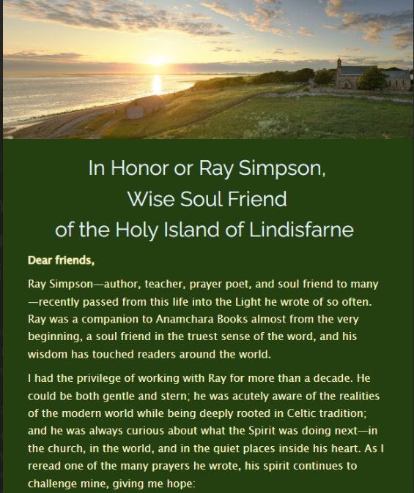

Lord,
be within me to give me strength,
over me to protect me,
beneath me to support me,
in front of me to be my guide,
behind me to prevent me falling away,
surrounding me to give me courage....
so that I may walk into the great unknown.
Amen.
Every blessing
Caroline
878242

