SUNDAY 12th October 2025



Loving God and Loving our Neighbour

Sunday 12th October Trinity 17 Prisons Sunday
9.30am Watton Harvest Festival. Holy Communion
11am Watton Contemporary service at Richard Knight’s house
11am Aston Family service
11.15am Bramfield Holy Communion
11.15am Stapleford Prayer and Praise

LOOKING AHEAD
Sunday 19th October Trinity 18
11am Watton Contemporary service.
11am Aston Holy Communion
11.15am Stapleford Prayer and Praise
11.15am Waterford Morning prayer

You are welcome to attend ANY church

MIDWEEK

Fortnightly MONDAY 2pm ASTON Bible Study Fellowship 3 Long Ridge Aston with tea and biscuit. All are welcome. Next meeting Monday 20th October Contact Pauline at pauline.manley1966@gmail.com

St Andrew’s Bramfield Wednesday's 10am Morning Prayer - short said service followed by coffee and chat 11am. All are welcome.
NIGHT PRAYER Alternate WEDNESDAYS at 7.30pm on ZOOM. Next meeting Wednesday 15th October on ZOOM. Contact Tim Alexander for link tim_alexander3@hotmail.com

Saturday 11th October at 7.30pm. Music for Cello and Piano. St Mary’s church, Stapleford, SG14 3NB. Tickets £20. Email: musicatstmarys@outlook.com
Wednesday 15th October 2.30pm. Stapleford village tea afternoon in church. All are welcome for tea, coffee, cake and chat.

Bramfield Quiz Night Saturday 1st November 7.30pm. Tables of 8 to include Ploughman’s Supper. £8.00 per person. Bramfield Village Hall.

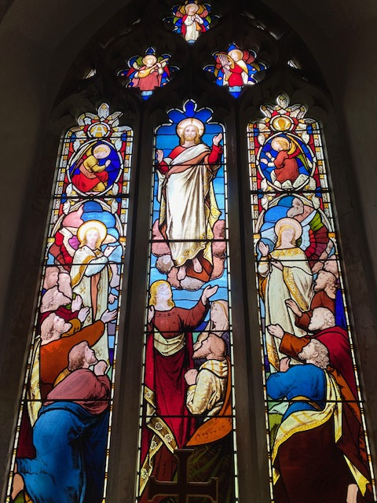
Collect Prayer for the Seventeenth Sunday after Trinity.

Almighty God, you have made us for yourself, and our hearts are restless till they find their rest in you: pour your love into our hearts and draw us to yourself, and so bring us at last to your heavenly city where we shall see you face to face; through Jesus Christ your Son our Lord, who is alive and reigns with you, in the unity of the Holy Spirit, one God, now and for ever. Amen.

(The east window in St Andrew’s Church, Bramfield behind the altar shows Jesus lifted up to heaven, the end of his earthly life, his return to God’s right hand on high)

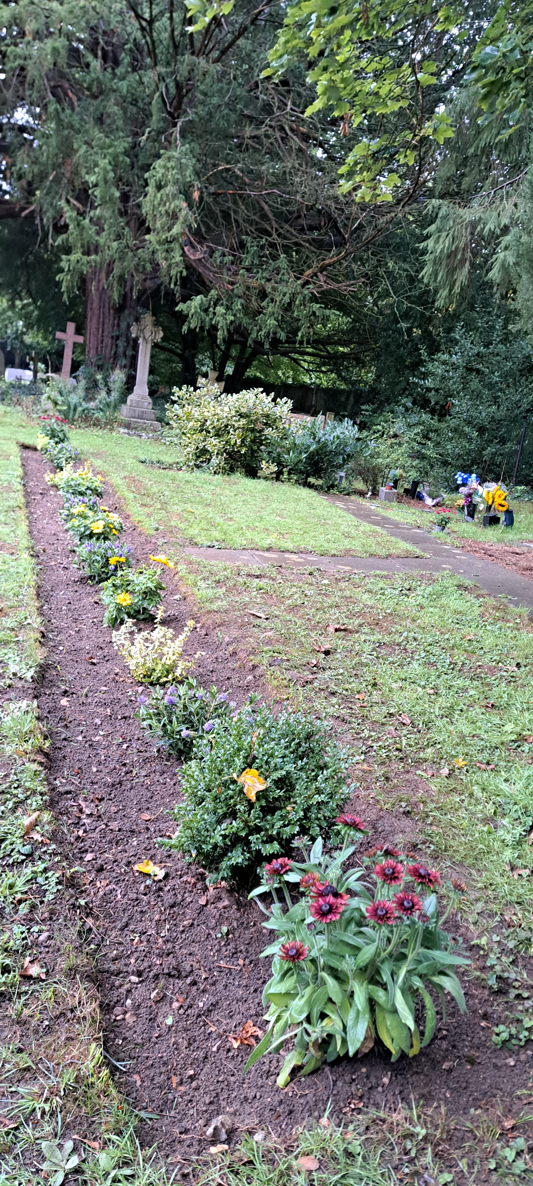
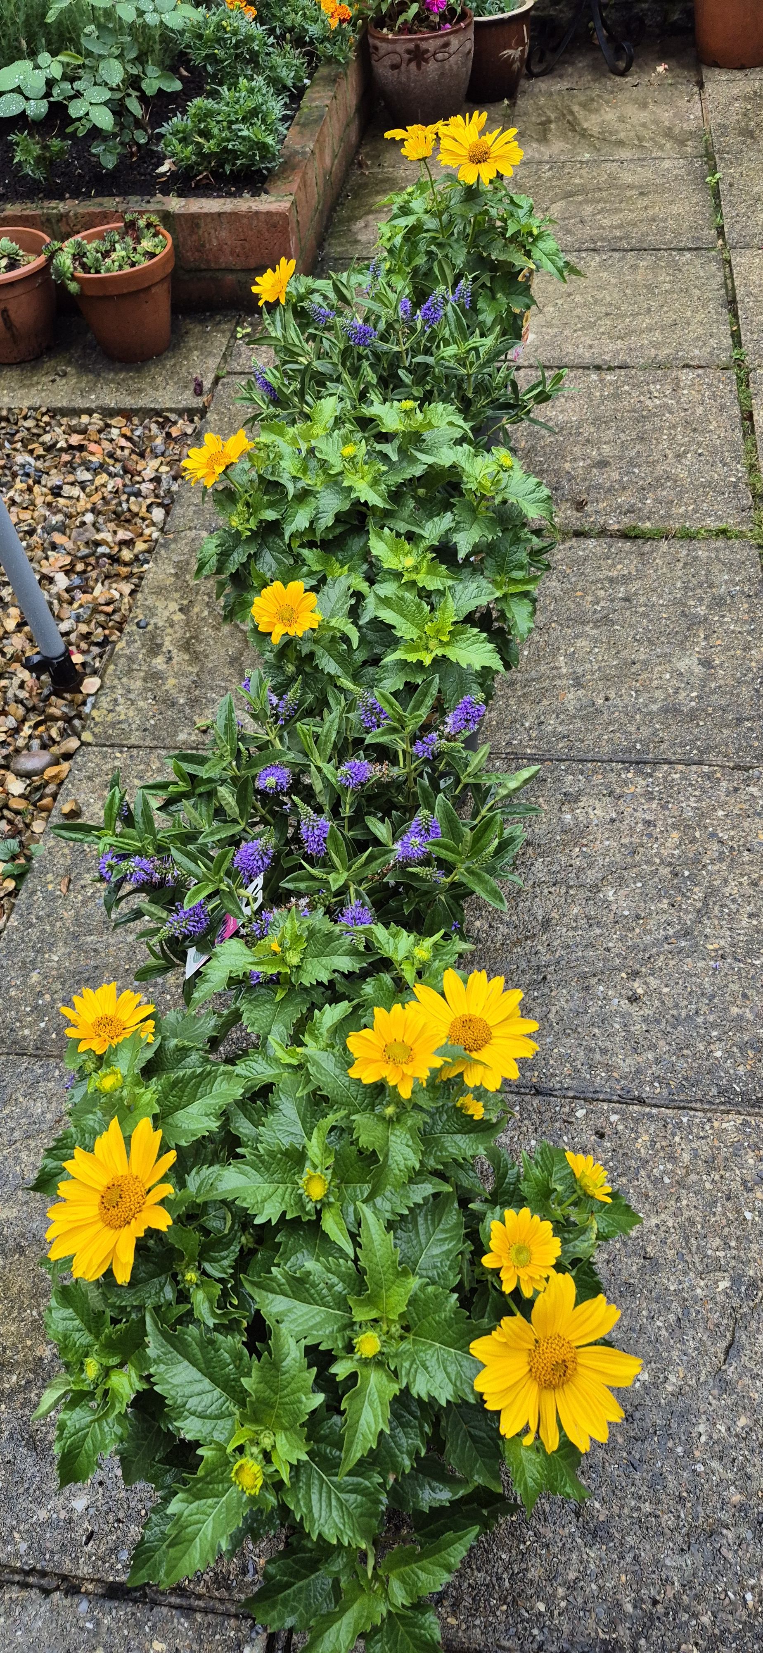
Newly planted border for the Garden of Remembrance at St Mary’s Aston

PRAY for PEACE in ISRAEL and GAZA, UKRAINE and all areas of conflict


Lord God, though peace seems humanly impossible,

we continue to pray for an end to violence and bloodshed.

We pray your comfort for the fearful and broken – hearted.


Change the hearts of those set on revenge and destruction.

Give wisdom to world leaders as they respond to aggression.

Bless all who work for understanding, reconciliation and justice which alone bring lasting peace. Amen.

‘God give us peace that lasts, not through the fear of might, but through the force of love, and love of life and right’. Amen

Hymn for Trinity 17. (HAM 118)
1 Firmly I believe and truly
God is Three and God is One;
and I next acknowledge duly
manhood taken by the Son.
2 And I trust and hope most fully
in that manhood crucified;
and each thought and deed unruly
do to death, as he has died.
3 Simply to his grace and wholly
light and life and strength belong,
and I love supremely, solely,
him the holy, him the strong.
4 And I hold in veneration,
for the love of him alone,
Holy Church as his creation,
and her teachings as his own.
5 Adoration ay be given,
with and through the angelic host,
to the God of earth and heaven,
Father, Son, and Holy Ghost.
J.H.Newman

We believe that responding to the climate crisis is an essential part of our responsibility to safeguard God's creation and achieve a just world. Climate change hits hardest the poorest countries and poorest people of the world. Meantime, the widespread destruction of the natural world is a crisis for creation.

Our Environment Programme exists to enable the whole Church to address this — in faith, practice and mission. This includes tackling our own carbon emissions (aiming for Net Zero Carbon by 2030) and our wider work. More information can be found using the following weblink: http://www.churchofengland.org/about/church-england-environment-programme#na

Energy Hub Funded by UK Government: Find out how to:

1. Save energy

2. Save money. Reduce energy bills

3. Reduce carbon. Improve energy footprint

4.Increase comfort

For useful resources and guidance on where to get started visit: linktr.ee/energy_hub


https://app.ecochurch.org/user/21703/summary

In these dry summer months don't forget to leave some water out for wildlife. A shallow dish of fresh water is good for birds, hedgehogs and many insects, keeping them hydrated and cool. If you have the space, a bigger long term project might be to create a pond in your garden.
Beane valley Benefice vacancy advert
I am pleased to confirm that the advert for the Rector of Beane Valley Benefice has been uploaded onto the St Albans Diocese website. Here is a link to the advert for you all to view: Rector for the Beane Valley Benefice - The Diocese of St Albans
Web site: http://www.stalbans.anglican.org
This has also been sent to the Worshipful Company of Grocers as Patron.

Our prayers are also with the new Archbishop of Canterbury designate, The Rt Revd and Rt Hon Dame Sarah Mullally DBE as she becomes the 106th Archbishop of Canterbury and the first woman to lead the Anglican Church.

CARING for our CHURCHYARDS

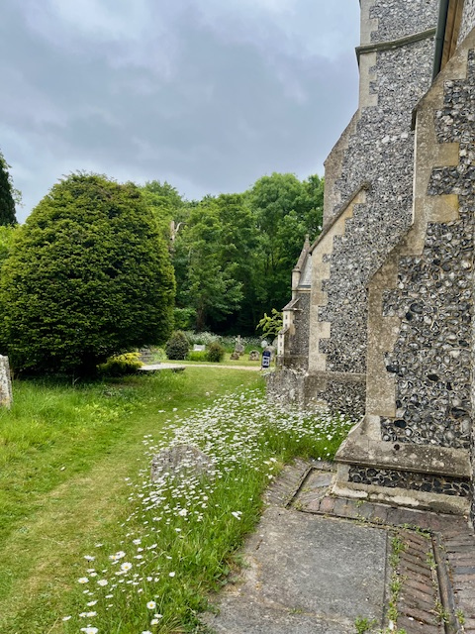
TUESDAYS Waterford Working Parties – Contact Churchwarden Malcolm Wandrag to offer help m.t.wandrag@gmail.com
To help in Stapleford or Watton or Bramfield please contact the Churchwardens.ASTON church open Sundays 12.00-16.00 and Wednesdays 10.00 -17.00 Church and churchyard working parties first Tuesday of month 10am to 12 noon. Contact Churchwarden Sara wardenstmarys@gmail.com
All our churchyards are cared for by volunteers.
Donations and offers of help are welcomed.
To include a loved one in the Book of Remembrance contact the churchwardens

Prayer for Growth for Aston, Bramfield, Stapleford, Waterford and Watton at Stone
Jesus teaches us to pray for our churches to grow. Jesus says: ‘Ask the Lord of the harvest, therefore, to send out workers into his harvest field’ (Matthew 9:38). In ways we don’t understand, God uses all our prayers.

Heavenly Father, you call us to sow seeds of faith in our communities. We ask you to fill us with your Holy Spirit that our lives may show the joy and new life we have in you. Guide our speaking and actions that others may be drawn to know your love. Lord Jesus, bless our churches that we may grow in numbers, love and service. We ask this in your name. Amen.
We pray for others to know God’s love.

Tie 5 knots in a piece of string - let each knot represent a friend or family member. Keep the string in your pocket and, as you feel the string, pray for those people to know God’s love. Set an alert on your phone to remind you to pray for those 5 people every day.

A prayer for those who seek to know God.
Lord Jesus, when your followers walked the Emmaus road wondering what was true and what was not, you came alongside them and revealed yourself in Scripture and in broken bread. Come alongside those we know and love who may wonder or seek at this time. Reveal yourself in your love and make us ready to walk alongside them too, until they see your face and know your presence. Amen.
Heavenly father we pray for guidance for our Beane valley benefice churches during the vacancy. Amen.

InTouch Age UK Hertfordshire
offer confidential, non-judgemental emotional and practical support on bereavement, physical & mental health issues, cancer, end of life, a partner with dementia or any other problem. Call 01992 634964/630623 or email intouch@ageukherts.org.uk Web page Age UK Hertfordshire | Our Services
Bereavement Support You can access online help at griefshare.org
thebereavementjourney.org cruse.org.uk teardropgrief.co.uk ataloss.org












’s
afternoon
Tea

rty
at 64 Rivershill
Sunday 24th July 2.00-5.oopm

Bring & Buy <> Raffle <> Jams
Proceeds to Both

TAKE AWAY AVAILABLE

