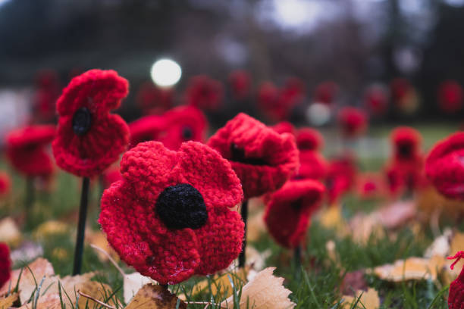

Remembrance Day Service - Sunday, 9th November @ 10.45am @ Oaksey

The Church will also be open to view the 2,000 knitted Poppies and World War 1 displays on:

Monday, 10th November: 10am to 4pm

Tuesday, 11th November: 10am to 4pm and 7pm to 9pm

Donations to Malmesbury Branch of the Royal British Legion can be made at the Church, in cash, or using the QR Code.

