**The Rector's Ramblings**

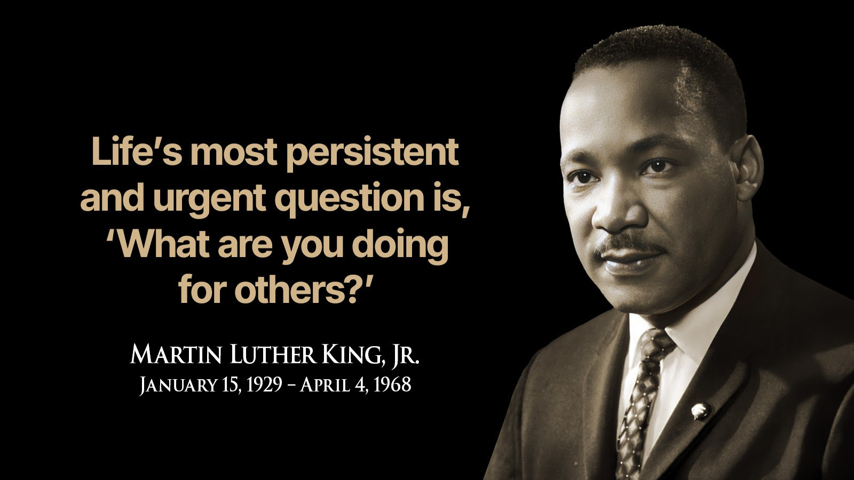

So this morning, as I said down to write this Ramble, I was faced with a dilemma. Do I write the Ramble I intended on random acts of kindness, or do I reflect on the terror attack in Manchester? Do I talk about acts of compassion or acts of hatred? Well, I’m going to go with the former, because we are bombarded everyday with bad news, with stories of hate and violence, but there are so many more good and kind people in the world than there are the kind of people we see so often on our TV screens and in our newspapers, filled with anger and hatred.

Yesterday I had to get the bus into town to go and collect the car from the garage. At the stop in South Street, as the driver closed the doors, a man rushed up, tapped the glass, and told the driver that there was an old man coming but he couldn’t walk very fast. The driver said ‘OK, I’ll wait’ but then the doors closed. Now I don’t know if he closed them, or if they closed automatically, but there was then another tap on the glass as two women also told the driver about the man wanting the bus. Again the driver said he’d wait. At that point the man came into view, supported by two more women, one of whom was carrying his shopping. As they got him onto the bus, the driver asked where he was going, because our bus was due to terminate at the station. The man didn’t know, he’d forgotten where he lived, and which bus he needed, he just knew he needed a bus. So after settling him down the women left and we carried on to the bus station. When we arrived, I and driver tried to find out more, tried to find out where he lived, but after he had emptied his pockets there was nothing that told us anything about him. So I helped him off the bus and walked him up and down the station to see if any of the numbers or place names meant anything to him but they didn’t. Then came the next act of kindness. As we walked back a group of pupils from the High School were sitting on one of benches and when one of them saw us coming, she nudged her friends and told them they had to stand up because the man needed a seat. I left him on the bench to catch his breath and relax while I went and found the driver again. I told him the situation and where the man was, and the driver went off to find someone from the office who could help him. I admit I had to leave at that point but I was confident the driver would be true to his word. When I left the garage I had to drive back past the station and although the man was still there, he did have 3 members of staff with him, and I am positive that between them, probably with the help of the police, they would have got him home.

Now if I had gone back and found the people who had helped in South Street, or the pupils from the High School, or the driver and staff at the station, and thanked them for being Good Samaritans, there is, I think, a fairly good chance that they would have objected to the title. Afterall, Good Samaritans do amazing things that save lives, that change lives, and all they did was help one old man in need. So often we think of Good Samaritans as people who are special, people who act in a way we never think we could. From the first Good Samaritan in the Bible (Luke 10: 25 – 37) to modern day examples where people often put themselves in danger to help someone else, sometimes losing their own lives in the process, we think of Good Samaritans as being people we could never aspire, or hope, to emulate. But any act of kindness, any act of compassion, is the act of a Good Samaritan. All of the people who helped yesterday did their bit to help one person find their way home, find their way back to safety and security, they were all Good Samaritans. Because the vast majority of the human race is made up of people who choose kindness over cruelty, who choose love over hate. People who buy an extra tin to put in the foodbank collection, not steal from the shelves. People who stop to pick someone up when they fall, not kick them when they are down. People who help an old man get on the bus, not just walk past as if he doesn’t exist.

My prayers last night were that the old man got home, and that he gets the ongoing help and support he needs. They were in grateful thanks for all the people who helped him. But they were also for the people who died in the Manchester attack, for all the people who were trapped in the Synagogue wondering, fearing, if the attacker had a bomb. They were for all members of the Jewish Community in this country now wondering if they will be the next target. But they were also in grateful thanks for the Manchester Council of Mosques who declared they will stand with their Jewish neighbours and that “any attempt to divide us through violence or hatred will fail… there is no room for violence or hate in Manchester - only unity, peace and respect for one another”.

Yesterday was a reminder of the call to all of us to be Good Samaritans in whatever way we can, in acts of kindness, generosity, and compassion, but also to live in unity, peace and with respect for all people, whatever their age, race, religion, ethnicity, or social standing. We are all equal in the eyes, and the heart, of God and yesterday was a reminder we should also all be equal in each other’s eyes and hearts as well, and ask ourselves the question at the top of the Ramble – ‘what are we doing for others.’ – a question the people in Chichester answered yesterday in their actions and in their compassion, by being Good Samaritans.

*Rev Sarah*

**Worship in the Valley Parish**

## 5th October

**Harvest Festival Holy Communion**

**10am**

**East Dean**

## 12th October

**Holy Communion**

**10am**

**Singleton**

**Rev Sarah Manouch**

*07468 854864 priestvalleyparish@gmail.com*

*Please note that I am part-time. My principal working days are Friday and Saturday as well as Sunday. I am not available on a Thursday.*