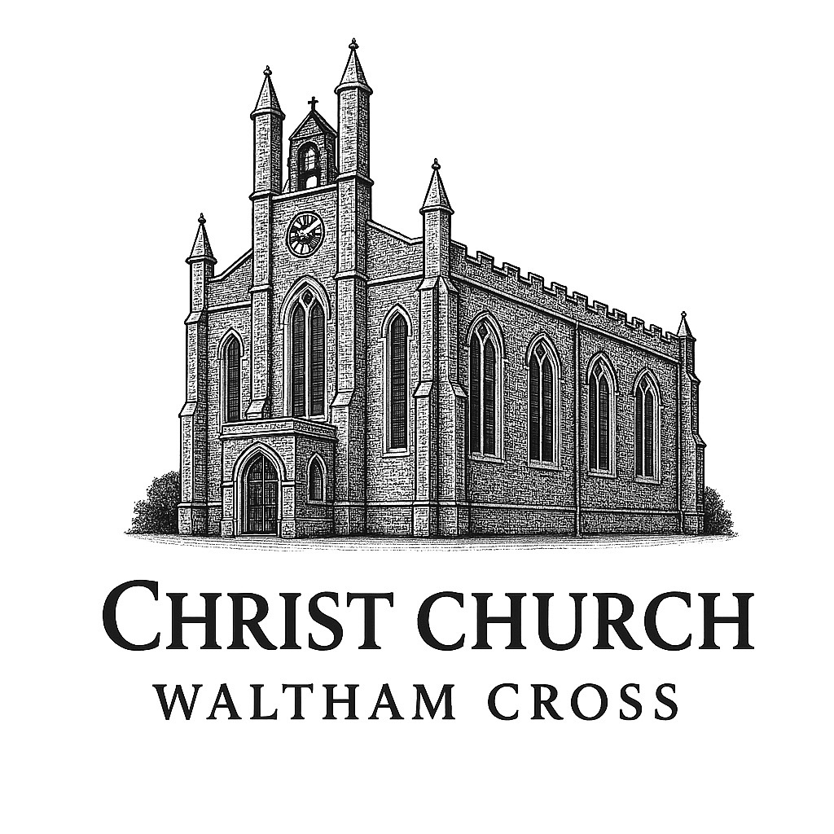
Christ Church, Waltham Cross

Safe Use of Images Policy 2025

Data Protection
The Data Protection Act 2018 places certain duties on us to ensure that we have relevant consent to take and publish images and that we keep all data secure.

Always ensure that you have checked whether there are reasons that a particular person cannot be photographed or identified, especially if it is a child.

You must obtain the permission of all the people who will appear in a photograph, video or webcam image before you record the footage. That means children as well as adults.

If you are taking images at an event attended by large crowds, such as a sports event, this may be regarded as a public area so you do not need to get the permission of everyone in a crowd shot.
However, there is no clear guidance on this so if in doubt, avoid using such images and use a library image instead.

It is a requirement of the Data Protection Act that you safeguard your images (both digital and hard copies) by storing them securely and only allow use by those authorised to do so. When you are finished with images, destroy or delete them.

If you hold copies of images on file, you can’t release these without up-to-date consent forms. Take care with images that you have archived. An image taken at a specific time and in specific circumstances can not necessarily be used again at a later date or in a different context. Doing so can result in legal action.

When publishing images of children and young people, follow these guidelines:
- If you publish their picture, do not publish a name
- If you publish their name, do not publish a picture
- Do not publish full names, addresses or e-mail addresses
- Do not publish individual close-up portraits
- When publishing children’s’ work simply label it as by ‘John’
- Give adult leaders and parents the opportunity to request that their contact information is not included in any published material
If parents are permitted to take images during or after an event or service, make it clear from the start that they must be for private use only and ask for them not to put the images on the internet or on Social Media (particularly if a parent posts a picture on the web that shows children other than just their own child). If the picture is being used for public use then consent must be obtained.

You might want to provide written guidance to parents beforehand and/or make an announcement at the start of the event/service.

Consent
When taking images, ensure you have written permission to take and publish the images before you start. This permission should cover:
- How the image will be used
(i.e. for a one-off article or as a general resource that could appear in a number of contexts)
- How it will NOT be used
(i.e. alongside articles or text that are of potentially sensitive or offensive subjects)
- Where it will be used / who will it be available to
(i.e. in internal/public-facing printed newsletters, on the web or on a website, in a DVD, in local and/or national media, in exhibitions etc.)
- How long it will be used for
(i.e. once only, for 2 years, 3 years, indefinitely etc. Be mindful that people’s circumstances change and it can become inappropriate to continue to use a photo)

Please see appendix 1 (Page 4) for our consent form.

For children under 18 years old, the form should be completed by a parent or guardian.
Consent forms should also be obtained for adults, particularly if they are considered ‘vulnerable’, for example those with learning disabilities.
The parent/guardian or social worker may give written consent in these circumstances.
Be aware that some people may require help to understand and complete a consent form, need the information translated into a different language or have it supplied in a different format.
Completed consent paperwork should be kept on file for the duration of the time the image is being used. Once this time is up, the image should be destroyed.
Do not use an image unless you know that you have permission to do so. If you are unsure, use an alternative.

Copyright
Copyright law applies to almost everything, and can be complex and ambiguous. A few basic points are listed below:
- Copyright automatically belongs to the person who created the work. In the UK it does not need to be registered. Take care with any images you release to the media, it is your responsibility to check with the owner of the copyright that it is OK to use them.
- If you are using someone else’s image you must get their written permission, and always credit the artist
- Images are protected for the lifetime of the creator and for 70 years after his/her death
- Downloading images from the internet and using them on your church website without the copyright owners consent may breach copyright laws, and could be considered a criminal offence, leading to heavy fines. Be aware that picture agencies and photographers are increasingly using software to track their images.
- If you put something on the web, you must obtain electronic global broadcasting rights from the owner of the copyright.

Context
Be careful about the context in which you use an image, especially if it is of children.
- If you’re using it for publicity specifically related to an event, there should be little problem as long as the relevant consents have been obtained.
- For information that covers sensitive areas always use a library picture. Using pictures of real children alongside these subjects could result in legal action by parents / carers.
- Do not use a photo in a context that is different to that stated on the consent form.
- Ensure that images cannot be construed as being provocative.
- When taking/using images, be representative of diversity by reflecting gender, race and disability.

New media
‘New media’ describes anything that relies on digital technology or computerised methods of communication, for example the internet, email, streaming, multimedia storage devices, mobile phones, podcasts, webcams, websites, blogs, social media, chatrooms etc.

New media is now very widely used; along with this increased use comes an increased responsibility to consider how we use images safely within the new technology.

The information shared by new media is more accessible than in non-digital formats; it is easy for people to amend, manipulate or copy images, which makes them more open to abuse. As such
we must be more vigilant than ever about obtaining the relevant consent to publish images, how we publish them and monitoring their use.

If you plan to use an image in any form of new media, you should obtain electronic global broadcasting rights from the owner of the copyright and ensure that the consent form states that the image will be used in digital formats, including the web.

If you are a web-publisher, do not use an image that has been uploaded onto the system by someone else without checking with the original publisher/owner that the relevant permissions have been obtained.

Do not pixelate (blur) an image in order to obscure the face of the person in it – use an alternative picture.

Disability Discrimination Act (DDA)
When using images in new media, you must comply with the DDA. The DDA applies to everyone who provides a service to the public. Service providers must ensure that they do not discriminate against disabled persons when using new media images. In order to comply with the DDA, you will need to ensure that all images have meta-tags and that you do not overlay a photo with text.

Releasing images to the media
The legislation governing whether or not the media can publish an image is complicated and ambiguous. If you are in any doubt about having an image published, do not release it to the media.

If you do release an image to the media, be aware that you are responsible for checking that all the relevant written consents have been obtained for the people in it and the owner of the copyright agrees to the image being published. If the media publishes an image you have supplied and the consents have not been obtained, responsibility falls to you.

The laws surrounding this issue are becoming stricter, especially for pictures of children and vulnerable adults. Be extremely cautious not to release any pictures of children who are in care, under wardship or involved in family law cases. The same applies for adults who may be at risk from domestic abuse or similar. The legal implications are serious.

Appendix 1

Image consent form

Christ Church, Waltham Cross

Occasionally, we take photographs of the children at our church. We may use these images in our church magazine or in other printed publications that we produce, in displays and on our website. We may also make video or webcam recordings for training, or other church use.

We also send images to the news media, or our church may be visited by the media who will take their own photographs or film footage (for example, of a visiting dignitary or other high profile event). Children will often appear in these images. The news media may use the images in printed publications (including local or national newspapers), on televised news programmes or on their website. They then store them in their archive. They may also syndicate the photos to other media for possible use, either in printed publications, on websites, or both.
When we submit photographs and information to the media, we have no control on when, where, if or how they will be used.

To comply with the Data Protection Act 2018, we need your permission before we can photograph or make any recordings of your child.

Conditions of use:

- This form is valid for the period of time your child attends this church. Images of your child will not be used after this time. Please write to the church [email address below] if you wish to withdraw consent at any time.
- The images we take will be of activities that show the church and children in a positive light.
- Embarrassing or distressing images will not be used. The images will not be associated with negative or sensitive issues.
- We may use group photographs or footage with very general labels e.g. ‘Sunday School’.
- We will only use images of pupils who are suitably dressed.
- We will make every effort to ensure that we do not allow images to be taken of any children for whom we do not have permission or who are ‘at risk’ or disallowed from having their photographs taken for legal or social reasons.
- We will take all reasonable measures to ensure the images are used solely for the purposes for which they are intended. However we cannot guarantee this and take no responsibility for the way images are used by other websites or publishers or for any consequences arising from publication.

Please note that websites can be viewed throughout the world and not just in the United Kingdom where UK law applies. In giving your consent you understand that images may be used in printed and electronic form.

To give your consent, please complete the information overleaf and return the form to the church.

Please tick those that apply:

I give permission for my child’s image to be taken and used in publicity material
for the church, including printed and electronic publications, video and webcam recordings and on websites

I give permission for images of my child to be used by the news media in printed and/or electronic form and stored in their archives.
This might include images sent to the news media by the church and images / footage the media may take themselves if invited to the church to cover an event.

I do not want my child’s image used in any publicity

I have read and understood the information overleaf.
Name of child:
Parent’s or carer’s signature:

Name (in block capitals)

Date:

Church:

If you require help completing this form, please contact your child’s church.
Safeguarding Officer – Sarah Mugabi

Christ Church,
Waltham Cross
EN8 7ED

