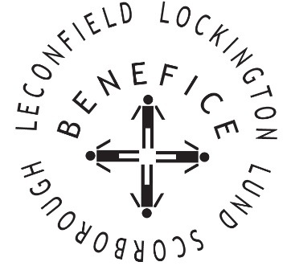

**Church Services for**

**November 2025**

Wherever you are from, you are welcome to join us for any of these services

Sunday 2nd 9:30am Holy Communion St Leonard’s Scorborough

11:00am Morning Worship St Mary’s Lockington

**2.30pm Light a Candle of Hope St Catherine’s Leconfield**

Wednesday 5th 9.30am Mid Week Service

With healing prayers St Mary’s Lockington

Sunday 9th **10:45 Remembrance Service St Catherine’s Leconfield**

**Followed by Communion**

Sunday 16th 9:30am Holy Communion St Mary’s Lockington

Wednesday 19th 9:30am Mid Week Service

With healing prayers St Catherine’s Leconfield

Sunday 23rd 9:30am Holy Communion All Saints Lund

11:00am Contemporary Worship St Mary’s Lockington

Thursday 27th 7:00pm Celtic Evening Prayers St Catherine’s Leconfield

**Sunday 30th 10:00am Benefice Holy Communion St Mary’s Lockington**

**Advent Sunday**

For more information see the benefice newsletter *‘*Messenger’pasted-image.tiff

Service times, events and *Messenger* can also be found at:

<http://www.achurchnearyou.com> for the four churches