A short guide to St. Alban’s Church Wickersley
(based on that written by Raymond Draper – previous rector)
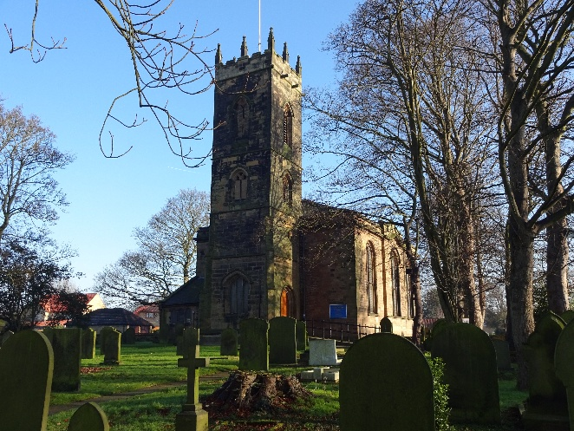
The Tower is the oldest part of the Church. It is all that is left of the Church built by Roger de
Wickersley in the fifteenth century. The fifteenth century building replaced an earlier church built on this site around 1150. There are three bells in the Tower and one of these, restored in 1951, was found to have been cast in the fifteenth century. It bears the name “John Elcock” who was Rector from 1438. The other two bells bear the dates 1781 and 1799. In the re-ordering of 1986 the new oak doors and a new ringing chamber were added, and the original stone door frame to the medieval ringing chamber was discovered. On the North Wall of the Tower in the Porch the “Wickersley Charities Board” can be seen. This records those sums given by benefactors for the poor of the parish. One of these benefactors, John Aldred, a nineteenth century pioneer in the chemicals industry, is buried in the Churchyard. These “Wickersley Charities” are still distributed (although the sums are now only small) every Christmas. The Tower is one of the prominent features of the district, standing on one of the highest points for miles around. It is likely that the first Church on this site had a tower or spire for we read in a legal document of 1419 of the “Lamp of St. Nicholas” in Wickersley Church. This was probably a light to guide travellers along the road to and from Bawtry, as this was the main port for exports and imports for 500 years for Rotherham, Sheffield and North Derbyshire. The Tower can be clearly seen at night as it is floodlit and we fly the flag of St.George on major Christian Festivals.
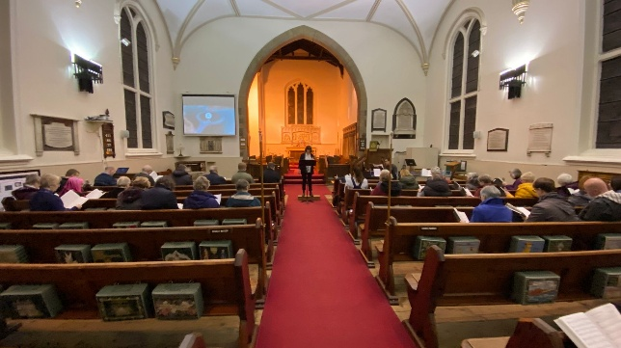
The Nave was erected between 1833-1836 by the Rev. John Foster. He probably built it around the De Wickersley Church, butting up to it. This method of construction would have many advantages as it would have enabled people to continue to use the Church while construction proceeded. This may also explain the height of the new Nave. It is possible that the roof we now see was constructed above the old fifteenth century roof - without disturbing it. So the old Church provided the scaffolding and the shuttering for the new. The Church of 1833-6 also included a small chancel, probably built around the chancel of Roger de Wickersley’s church. A window of this chancel (now bricked up), and the building line to show where it was extended in 1886, can be seen outside the building from Church Lane.
On the North Wall of the new Nave is a marble slab which contains the Brass name-plates from the coffins that were disturbed during this major re-ordering work of 1833-6. It records the names of members of this church from the seventeenth and eighteenth centuries. The list of Rectors on a board beside the Font goes back to 1240. The most interesting tombstone, and the oldest, lies under the carpet in the centre aisle. It is that of Roger de Wickersley who died in 1472 and of his wife Margaret. The inscription around the edge of the tombstone is in early English and the stone bears the de Wickersley family arms. It was originally in the North Chancel of the fifteenth century church and was moved to this position in 1836. In the centre of this tombstone is the ancient Christian sign ‘IHS’, which can also be seen in many other places throughout this Church.
On the South Wall the Bell Memorial commemorates a local family of stonemasons. Wickersley was a quarrying village as well as an agricultural community.
The War Memorial with its mosaic picture of St. Michael, is a fine piece of work and reminds us both of the Art of the Eastern Church and of the devastating effect of World Wars.
The Memorial above the pulpit records the long ministry of John Foster who was Rector here for 59 years from 1804-1863.

The Chancel was extended in 1886 during the ministry of the Rev. Frederick Freeman. He was a wealthy high Churchman who was determined to do all he could to strengthen the worship of this Church. Not only did he build the Chancel but he was responsible for the installing of all the stained-glass windows, and he established the Choir. There are many memorials to the Rev. and Mrs Freeman in the Church. The Organ is an electronic instrument, installed in the early years of the 21st century. The Church has a mixed Choir which sings in the Chancel.
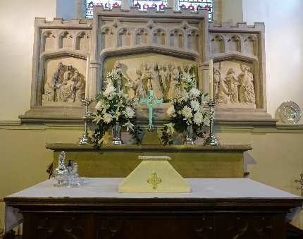
The Stone Reredos behind the Altar, local tradition claims, was brought by the Rev. Frederick Freeman from Oberammergau in the 1880’s. The tomb of Dr Holt Yates, a remarkable Victorian philanthropist and enthusiast, lies in the Chancel - partly obscured by the carpet and Choirstalls. He was responsible for building the Christian Institute on Morthen Road, and he is one of the most interesting and colourful figures from nineteenth century Wickersley.
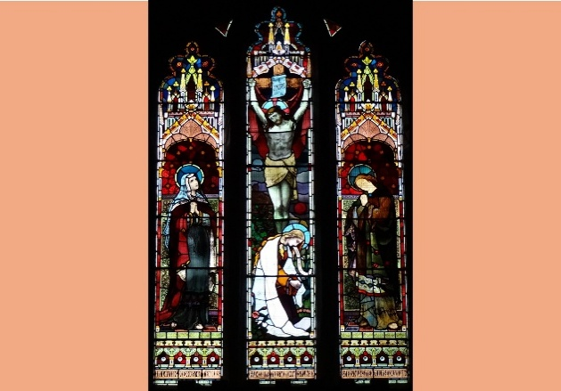
The Windows are perhaps the most striking feature of the Church - they were erected between 1885 and 1890.
The East Window is a copy of the original fifteenth century window which was recorded in Hunter’s famous book on the History of South Yorkshire (1832). The Latin inscription emerging from the mouth of the woman kneeling reads “Domine Miserere Mei” -“O Lord have mercy upon me”. The East Window is flanked by two often unnoticed windows depicting the Te Deum, a glorious early hymn of the Church. In the Chancel opposite the Organ is a fine window depicting St. Cecilia, the Patron Saint of Musicians and Church Music.
The twelve windows of the Nave represent the twelve apostles. The lower windows give a representation of the apostles - with the names of each apostle in a band at ‘neck level’. The upper windows depict a scene from the apostle’s life. We may rejoice at the mistake in the window of St. Philip, on the North side, where Philip the Apostle is confused with Philip the Deacon; for here we have an unusual representation in an English Church of a black face, the Ethiopian Eunuch of Acts Chapter 8. At the top of a window in the North side is a picture of Bishop Titcomb, the first Bishop of Rangoon in Burma from 1877 to 1881. He was a cousin of Dr.Yates, and his son was a famous painter W.H.Y. Titcomb.
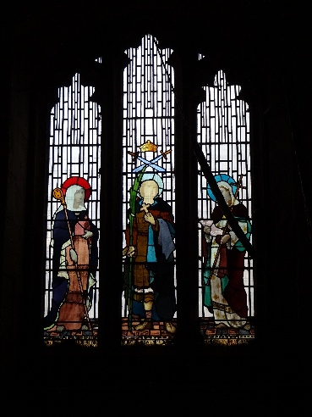
On the South Wall at the top of one window is a picture of Queen Victoria - for her Jubilee in 1887. At the bottom of the “St. Thomas Window” by the font is the name of the Newcastle firm that designed and erected these fine windows - H.M. Barnett.
The windows in the Tower are often missed by visitors. They depict three British saints:
St. Alban (the Patron Saint of this Church, and the first known British Martyr - who died in 209 at the Roman City of Verulamium, modem St.Alban’s), St. Hilda, Abbess of Whitby (who died in 680 and was a great light in the Northern Celtic Church), and St. Winifred (a learned Abbess from Holywell - in Wales). These fine windows were all cleaned, repaired, and protected in 1986.

