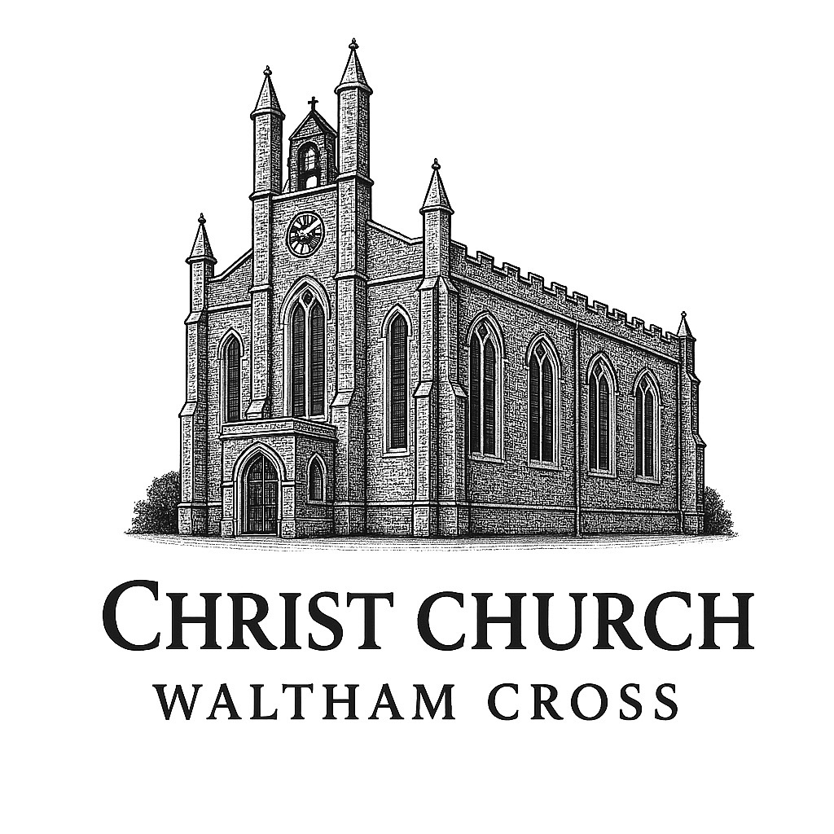
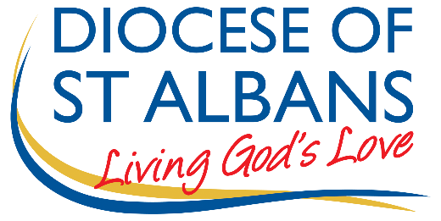

St Albans Diocese and Christ Church, Waltham Cross

Ex-Offenders Recruitment Policy

- St Albans Diocese, as an organisation assessing applicants’ suitability for positions which are included in the Rehabilitation of Offenders Act 1974 (Exceptions) Order using criminal record checks processed through the Disclosure and Barring Service (DBS), the diocese complies fully with the code of practice and undertakes to treat all applicants for positions fairly
- St Albans Diocese undertakes not to discriminate unfairly against any subject of a criminal record check on the basis of a conviction or other information revealed
- St Albans Diocese can only ask an individual to provide details of convictions and cautions that we are legally entitled to know about. Where a DBS certificate at either standard or enhanced level can legally be requested (where the position is one that is included in the Rehabilitation of Offenders Act 1974 (Exceptions) Order 1975 as amended, and where appropriate Police Act Regulations as amended)
- St Albans Diocese can only ask an individual about convictions and cautions that are not protected
- St Albans Diocese is committed to the fair treatment of its staff, potential staff or users of its services, regardless of race, gender, religion, sexual orientation, responsibilities for dependants, age, physical/mental disability or offending background
- St Albans Diocese has a written policy on the recruitment of ex-offenders, which is made available to all DBS applicants at the start of the recruitment process
- St Albans Diocese actively promotes equality of opportunity for all with the right mix of talent, skills and potential and welcome applications from a wide range of candidates, including those with criminal records
- St Albans Diocese select all candidates for interview based on their skills, qualifications and experience
- An application for a criminal record check is only submitted to DBS after a thorough risk assessment has indicated that one is both proportionate and relevant to the position concerned. For those positions where a criminal record check is identified as necessary, all application forms, job adverts and recruitment briefs will contain a statement that an application for a DBS certificate will be submitted in the event of the individual being offered the position
- St Albans Diocese ensures that all those in St Albans Diocese who are involved in the recruitment process have been suitably trained to identify and assess the relevance and circumstances of offences
- St Albans Diocese also ensures that they have received appropriate guidance and training in the relevant legislation relating to the employment of ex-offenders, e.g. the Rehabilitation of Offenders Act 1974
- At interview, or in a separate discussion, St Albans Diocese ensures that an open and measured discussion takes place on the subject of any offences or other matter that might be relevant to the position. Failure to reveal information that is directly relevant to the position sought could lead to withdrawal of an offer of employment
- St Albans Diocese makes every subject of a criminal record check submitted to DBS aware of the existence of the code of practice and makes a copy available on request
- St Albans Diocese undertakes to discuss any matter revealed on a DBS certificate with the individual seeking the position before withdrawing a conditional offer of employment.

This code was adopted by the Parochial Church Council of Christ Church Waltham Cross:
1st September 2025
To be reviewed by September 2026.

