The Rector's Ramblings
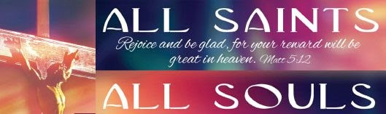
This weekend the Church celebrates two very important, if often overlooked, Feast Days. The Feast of All Saints (1st November) and the Feast of All Souls (2nd November), also known as The Commemoration of the Faithful Departed. Now in The Valley Parish we, like most of the Church, will be celebrating All Saints on Sunday (2nd), with a service at All Saint’s Church in East Dean. We’ll be singing the usual hymns, including ‘For all the Saints’, and we’ll listen to the readings set for All Saints, because All Saints is seen by many as the more important Feast Day, but is it?

Well firstly, I suppose, we need to understand what these two days are about. All Saints is about those the Church has, over the past 2000 years, recognised as showing powerfully the grace of God in action. From the earliest martyrs like St Stephen to those in more modern times like St Maximilian Kolbe, the Polish Priest who offered his life in exchange for another Auschwitz, and Saint Mother Teresa, who served the poor of Calcutta for over 40 years. These men and women, canonised and, I suppose, put on a pedestal, are an inspiration to us all, but not in a way that many of us can live up to. None of us, I hope, will be called upon to give our life for another, none of us will suffer intense persecution or oppression, none of us will leave our homes to go and work with those considered unclean and unworthy. The Saints with a capital S are perhaps a little beyond our reach, a little beyond even our comprehension sometimes.
But what of All Souls? Although it started way back in the 6th century, it was following the First World War that All Souls took on the wider name of ‘The Commemoration of the Faithful Departed’. Millions of men and women across Europe never returned home and their graves, marked and unmarked, are hundreds of miles from family and friends. The Church understood the need for those grieving to be able to remember their loved ones and to come together in their grief and in thanksgiving for those they will see no more in this world. It is, I believe, a day that all of us can relate to because it is more personal, and therefore is probably in fact the more important Feast Day. It is the remembrance of those known to us, our family and friends, who didn’t make the headlines, who didn’t lose their lives in the service of God, but gave their lives to the service of God and to us. It is about the everyday saints, our parents, our family, our friends, our teachers, who inspired us, taught us, and left us with a legacy that will stay with us all our lives.
This year has been a particularly hard one for the people of the Valley Parish. I have had the honour and privilege of officiating at 9 funerals, walking with families as they came to terms with the loss of a father or mother, a husband or wife, a brother or sister, a son or daughter, but I know of many others who chose a simpler cremation service, or who celebrated the life of a loved one with a coming together in their home or the pub.
Although we will be celebrating the saints with a capital S on Sunday, we will also be remembering those known to us personally. Whether they died this year, last year, 15 or 30 years ago, they are still part of us, they are still part of our lives because they live on in us, in who we are and in what we do.
Whether you join us on Sunday or not, why not take a moment to remember all those you have known who have died. Give thanks for their life and for all they meant to you and to others, and remember that they have walked through the valley of the shadow of death and are now resting in peace with God, with no more pain, no more sorrow, and where every tear has been wiped away.
Rev Sarah
Worship in the Valley Parish

2nd November

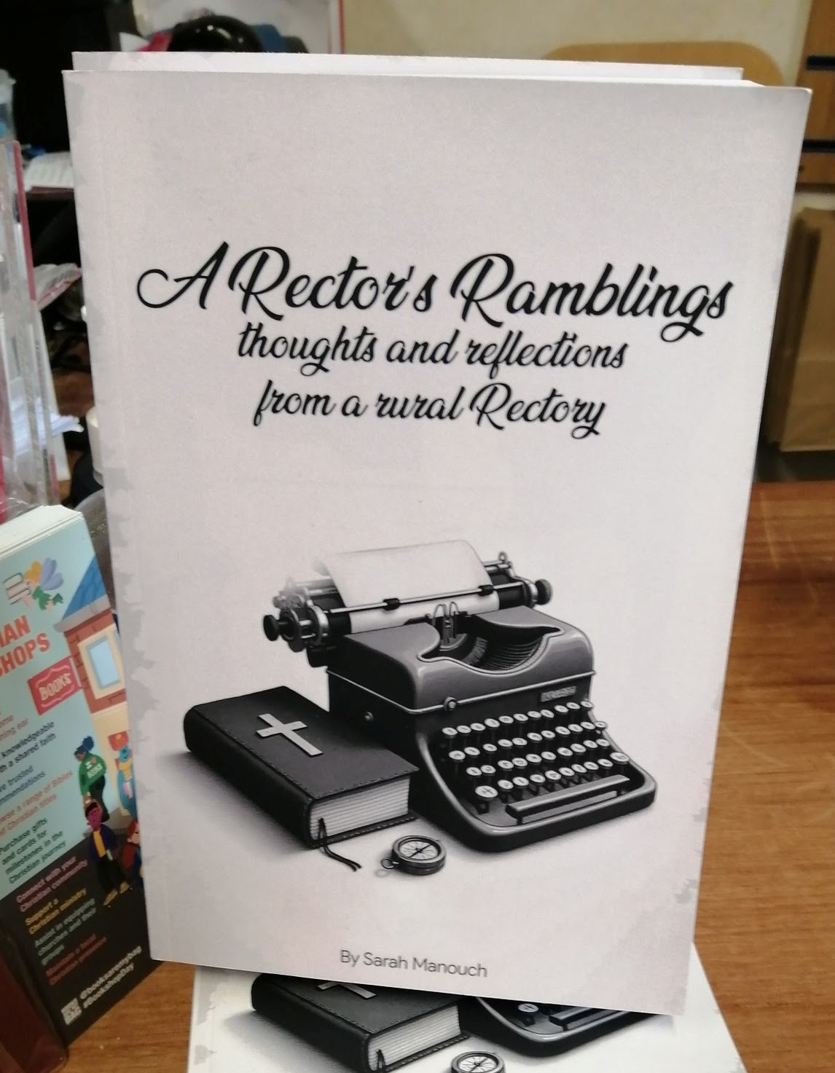
Holy Communion for All Saints
10am
All Saints, East Dean
Yes, this is a blatant plug - but A Rectors Ramblings is now available from me, or from St Olav's Christian Bookshop (price £10). A compilation of some of the Rambles I have sent out over the past 4 years, some may make you smile, some may make you think, and one or two may make you cry (sorry).

Rev Sarah Manouch
07468 854864 priestvalleyparish@gmail.com
Please note that I am part-time. My principal working days are Friday and Saturday as well as Sunday. I am not available on a Thursday.

