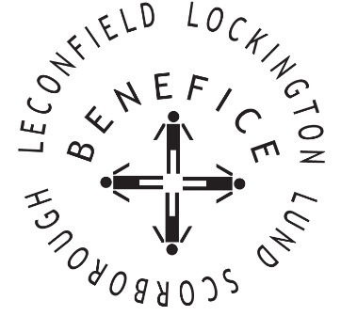

Church Services for
November 2025
Wherever you are from, you are welcome to join us for any of these services

Sunday 2nd 9:30am Holy Communion St Leonard’s Scorborough

11:00am Morning Worship St Mary’s Lockington

2.30pm Light a Candle of Hope St Catherine’s Leconfield

Wednesday 5th 9.30am Mid Week Service
With healing prayers St Mary’s Lockington

Sunday 9th 10:45 Remembrance Service St Catherine’s Leconfield
Followed by Communion

Sunday 16th 9:30am Holy Communion St Mary’s Lockington

Wednesday 19th 9:30am Mid Week Service
With healing prayers St Catherine’s Leconfield
Sunday 23rd 9:30am Holy Communion All Saints Lund

11:00am Contemporary Worship St Mary’s Lockington

Thursday 27th 7:00pm Celtic Evening Prayers St Catherine’s Leconfield

Sunday 30th 10:00am Benefice Holy Communion St Mary’s Lockington
Advent Sunday

For more information see the benefice newsletter ‘Messenger’
Service times, events and Messenger can also be found at:
http://www.achurchnearyou.com for the four churches

