Junior Church at St Oswald’s

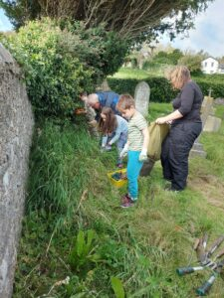

Junior Church is for children aged 3 to 11 and under 3’s accompanied by an adult.
We meet every Sunday in term time at St Oswald’s Church Hall just before 11am. We explore our faith together through activities, games, songs, drama and fun.

In Junior Church, as well as exploring our faith, we have a strong focus on faith in action. We have our own wildlife area in the graveyard where we have planted wildflowers, made a pond, hedgehog house and several bug hotels. We have also put up bird and bat boxes as part of our focus on caring for God’s wonderful creation.

We lead a benefice-wide challenge to collect things needed by a local charity throughout Lent and also visit the charity to learn more about their work. The charities we have supported so far have included Morecambe Bay Food Bank, the Olive Branch in Lancaster and the Lancaster and District Homeless Action Service.
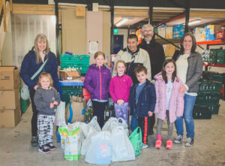

Each year we also raise money for other charities with a cake stall after the Harvest Festival.

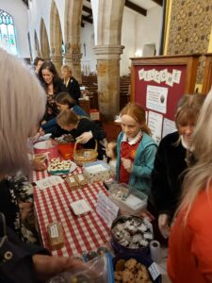

Although we spend a lot of our time exploring our faith apart from the congregation, we maintain strong links with our church family. We join the congregation in church each Sunday for communion and tell them what we have been doing at the end of the service.

We also create displays about what we have been learning about, in the window as you enter the church.
Once a term we join the congregation for an “All Together” service when we help in all sorts of ways, greeting, reading, singing, doing the offertory and collection and so on. We also join the congregation for Mothering Sunday and Harvest Festival and join in the Act of Remembrance at the War Memorial.

The two highlights of our year are the Palm Sunday workshop and our visit to Hyning Monastery.
During the Palm Sunday workshop, we walk through the events of Easter with the disciples, sharing the last supper, praying in the garden of Gethsemane and creating an Easter Garden as we witness the events of Easter and then creating an artwork to represent the risen Lord.
When we visit Hyning Monastery, the sisters lead our session and then we join them for their midday office. This is followed by a Junior Church family picnic in the beautiful gardens, a wonderful opportunity to spend time enjoying one another’s company.
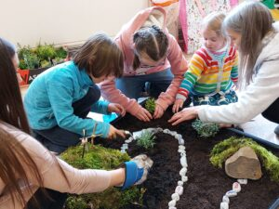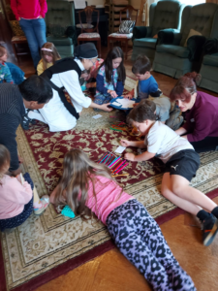
Visitors are always welcome at Junior Church and we are very happy for parents to stay if their child does not feel confident enough to come on their own.
For more information about Junior Church contact Vanessa Alpin on 07746 790979.

For more information about Junior Church contact Vanessa Alpin on 07746 790979.

