**Congratulations!**

Congratulations on your forthcoming marriage and a warm welcome to you if you are thinking about being married at Holy Trinity. We will do our best to make your wedding day memorable for you, your family and your friends. This will be a very exciting time for both of you with many things to think about and plan.

### Why choose a church wedding?

What makes a church wedding special?  Maybe a lot of different things -

* the holy building
* the words we use
* walking down the aisle
* the music
* the flowers
* the personal touch through meeting the minister to plan the service
* having God’s blessing on the relationship

Christians believe that marriage can be a reflection of God’s love for us. A church wedding gives you the opportunity to declare your love and commitment before family, friends and God as well. This helps put your marriage on a firm foundation.

**Can we get married at Holy Trinity?**

Many people worry that they will not be ‘allowed’ to get married in a church. Come and talk to us and we’re happy to guide you through the possible options. Holy Trinity is a Church of England parish church which does mean that there are certain legal requirements for those getting married. To be married at Holy Trinity one of the couple needs to be a resident in the parish, or is on the electoral roll of the church* or has a qualifying connection with the parish.

A qualifying connection means that you can show

That one of you:

* has at any time lived in the parish for a period of at least 6 months *or*
* was baptised in the parish concerned *or*
* was prepared for confirmation in the parish *or*
* has at any time regularly gone to normal church services in the parish church for a period of at least 6 months

*or*

That one of your parents, at any time after you were born:

* has lived in the parish for a period of at least 6 months *or*
* has regularly gone to normal church services in the parish church for a period of at least 6 months

*or*

That one of your parents or grandparents:

* ·was married in the parish

* The electoral roll is our membership list, made up of those who worship here regularly. People can join the electoral roll once they have attended Holy Trinity regularly for six months, and if they intend to continue doing so.

**What if one of us is divorced?**

We believe that marriage is for life, but also recognise that sadly, some marriages do break down. The Church of England agreed in 2002 that divorced people could remarry in church under certain circumstances. If you are divorced and wish to remarry at Holy Trinity you will need to speak with our Rector about your situation. He will need to make a decision according to the Church of England’s official guidelines before he is able to confirm your booking. We want to help you in every way we can, and even if it is not possible to do your wedding, we can offer you a [service of prayer and dedication after a civil wedding](http://www.cofe.anglican.org/worship/liturgy/commonworship/texts/marriage/civilmarriage.html) (commonly called a Blessing).

**What if one of us is not British?**

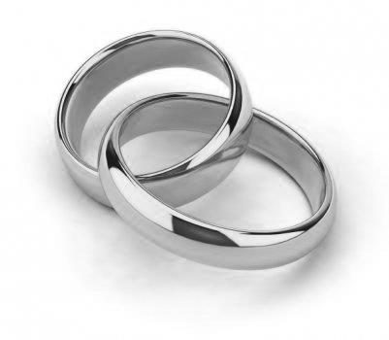If either of you is a foreign national you will need to obtain a license for your wedding (now called officially a ‘marriage schedule’). Our Rector will be able to advise you about this.

**How much will it cost?**

A great deal less than the reception! The basic fee for a wedding in the Church of England until the end of 2025 is £581, which includes the calling of Banns and the Marriage Service itself. This fee is identical for all Church of England churches, whether a cathedral or a tiny chapel. In addition to this there are a number of optional extras which you may choose such as organist, choir, heating and bells. You will be able to discuss this further when you meet with our Rector.

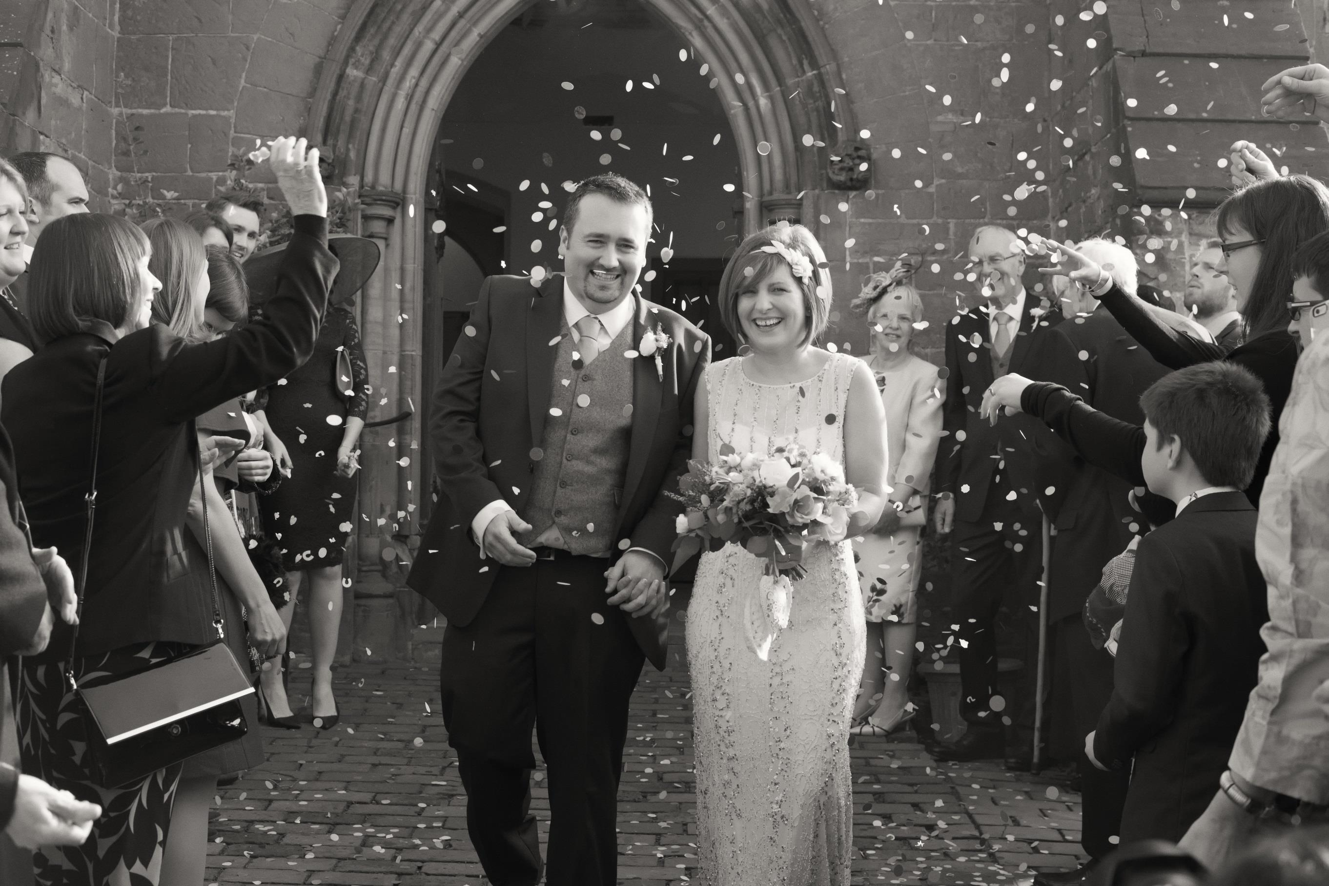

**How do we book?**

#### If you are looking to get married at Holy Trinity, please call either our Church Administrator or our Rector for an initial conversation.

#### To make a booking you will need to meet with our Rector who will guide you through the legal and practical steps in arranging your wedding. You will need to bring your passports as photo ID and proof of your current address.

**Rector**: **Revd Richard Coldicott**

T: 01273 967598   
E: rector.holytrinityhpp@gmail.com

**Church Administrator: Claire Levin**

Church Office, Holy Trinity Church,

High Street, Hurstpierpoint, BN6 9TS

T: 01273 835109 E: [admin@holytrinityhurst.org](mailto:admin@holytrinityhurst.org)



www.holytrinityhpp.org

Weddings

@

