**What happens to the money**

**I give to my church?**



**Holy Trinity, Dawley**

**St. Leonard, Malinslee**

**St. John, Lawley**

**St. Mary, Ketley**

Our churches would not remain open without the donations that you give! The Church of England is often seen as wealthy, and it is a surprise to many that a church’s ministry and building is mainly funded by local people who give to it.

Whilst the Church Commissioners do have significant investments, these are invested in a long-term and responsible way to generate income to pay for approximately 15% of the costs of the church’s ministry and mission on a sustainable basis. Without that income the parish ministry of The Church of England would be significantly diminished. But the vast majority of the church’s financial resources are raised by local communities, and this is a remarkable testament to you and your generosity.

In 2024, our income for the whole parish (excluding any trust income) was **£139,343**

As you can see, the majority of this came from donations from our congregations given at services or directly to the bank and from fundraising. We received some grants, fees for weddings and funerals, money from letting our buildings, as well as the refund received for those who Gift Aid their donations. Like any other charity, we are almost completely reliant on the money you donate to enable us to survive!

# **So what do we spend your money on?**

In 2024, our total spending included:

* **£60,166** on our Common Fund payment to Lichfield Diocese, which contributes towards the cost of ministry in the parish. This does not cover the full cost for us to have two full-time paid clergy – the extra cost is covered by the diocese.
* **£21,860** towards the running costs of our buildings (providing gas, electricity, heating)
* **£25,421** towards the upkeep of our buildings (including repair and replacement of items)
* **£10,357** to insure our buildings

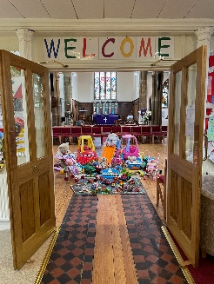

# **What does your money achieve?**

Your donations enabled us to do the following in 2024

* to provide weekly services at each church, as well as occasional special services,
* to provide various services at Christmas and during Holy Week and Easter where we welcomed our communities to come and celebrate with us, including some services at St James’, Stirchley
* to put on a monthly Messy Church for local families at Holy Trinity
* to baptise 53 people, marry 3 couples and take funerals for 55 families
* to run events for our local communities, including the Food Bank drop in and exercise session at St Leonard’s, Lawley Smallies at St John’s, and Trinity Tots and All Friends Together at Holy Trinity, and supporting the Food Bank at the Dawley Christian Centre
* to host school visits to our churches
* to lead worship in local schools
* to put on various social events

