**The Rector's Ramblings**

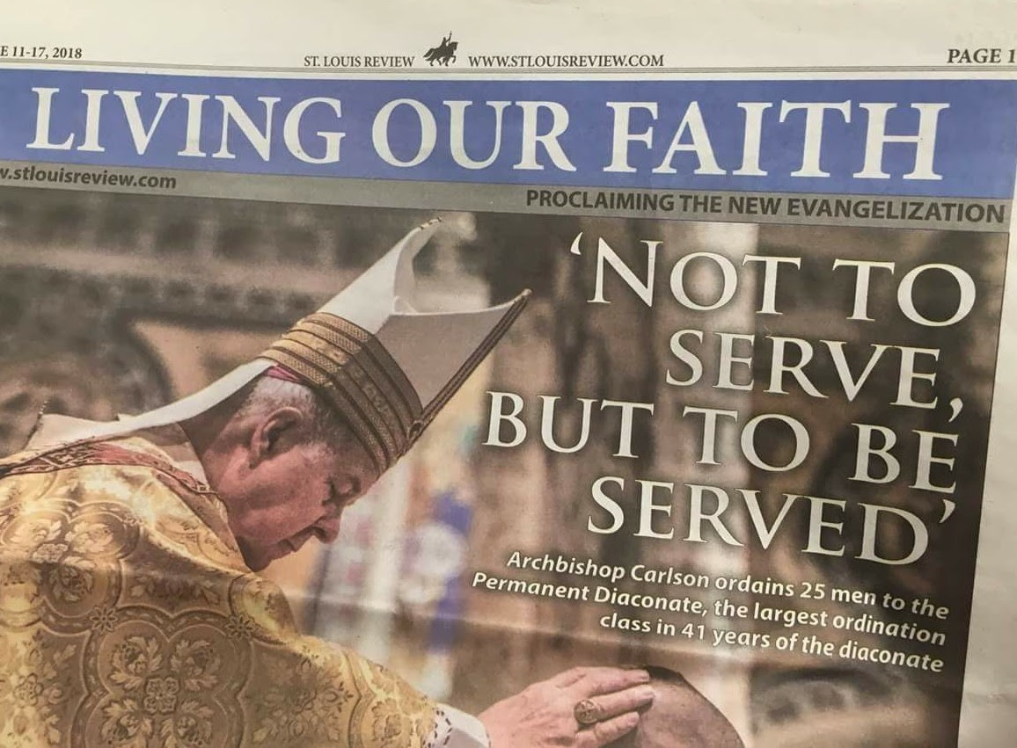

So, can you see what is wrong with the newspaper headline above? In 2018 the St Louis Review, the weekly newspaper of the Archdiocese of St Louis, went viral around the world for all the wrong reasons. What should have been a celebration of the ordination of 25 men to the Permanent Diaconate in the Roman Catholic Church instead became first of all a bit of a global joke, and then prompted a very welcome and much needed inter faith discussion about the meaning of service. On the meaning, and the calling, to serve, not to be served.

I was reminded of this today as I was privileged to lead the prayers at the daily worship in West Dean School. The children, and the staff, have been thinking about service this week, and how they can be of service to others. I was delighted that in the look back over the week, when the children were asked to consider people who serve, a Priest was in there, along with a Police Officer and a Barista! But they didn’t stop there. They have been thinking about how they can serve others, not necessarily in the big things, joining the army when they are older, standing for parliament, or joining one of the caring professions, but in the little everyday ways that we can help people, how we can serve others. It could be as simple as opening a door, giving up your seat on the bus, helping someone carry their shopping, or sitting down with someone who really needs a listening ear. But West Dean are not the only school to be looking at big topics. In Singleton this term they are considering generosity, the joy of giving and sharing with others, and I look forward to joining them for their worship and hearing what the children have not only been learning about generosity, but how they have been putting it into practise – which I know they will be doing, just as the children of West Dean will be doing all they can to be of service to whoever needs them.

The two topics, the two calls to action, service and generosity, are linked, very closely linked. It is of course generous to give our time to serve others, especially if you are a volunteer for charity, or in the schools, or in within the faith community, but generous service is also in the simple things I mentioned above. It is generous to open a door for someone, because it costs time. It is generous to give up your seat, because it means we need to stand, perhaps at the end of a long day when all we really want to do is take the weight off our feet. It is generous to spend time with someone who needs to share their concerns, their grief, or their worries, because we have to put aside our own issues to give our full attention to them. All of these are acts of service, generously giving of ourselves.

But there is a bigger picture to service and to generosity, and that is when we are generous with our time, with our gifts, with our blessings, in the service of people we will never meet. The volunteer behind the till at the charity shop may serve the customers in front to them, but they are also being of service to the people the charity helps and supports. When we donate to the foodbank we are being of service to the thousands of people who are not blessed with enough food on the table. When we donate to disaster appeals, we are generously giving of our wealth to serve the people whose lives, and often livelihoods, have been adversely affected by natural disasters or wars.

Jesus said ‘For the Son of Man came not to be served, but to serve, and to give his life as a ransom for many’ (Mark 10: 45). We are not asked to give our lives in service to others, but we are called to give of what we have, our time, our money, our gifts, generously to those who do not have the blessings we have, who do not have food on the table, a roof over their head, or the freedoms we enjoy, to worship, to travel, to even dress the way they wish. That is generous service, that is service to God by being of service to his people, whatever their race, creed, colour, gender or faith.

‘Whoever wishes to be become great among you must be your servant, and whoever wishes to be first among you must be slave to all’ (Mark 10: 43 – 44)

*Rev Sarah*

**Worship in the Valley Parish**

# 21th September

## Holy Communion 10am St Andrew's, West Deann

## Sunday 28th September 2025 - 6pm

**Westbourne Deanery Evensong, St Nicholas Church, Thorney Island**

Join with the congregations from across the Deanery to celebrate a BCP Evensong at the beautiful church of St Nicholas, overlooking Chichester Harbour. As the church lies on a military base, I will need to know if you will be attending, with names and car registration details, latest date to be included is Sunday 21st September.

**Rev Sarah Manouch**

*07468 854864 priestvalleyparish@gmail.com*

*Please note that I am part-time. My principal working days are Friday and Saturday as well as Sunday. I am not available on a Thursday.*