SUNDAY 28th September 2025



Loving God and Loving our Neighbour

Sunday 28th September Trinity 15 Creation 4
9.30am Watton Holy Communion.
11.00am Watton Contemporary service
11.15am Bramfield Prayer and Praise.
11.15am Stapleford Prayer and Praise

LOOKING AHEAD
Sunday 5th October Trinity 16 Dedication Sunday
11am Watton Contemporary service.
11am Aston Prayer and Praise.
11.15am Stapleford Prayer and Praise
11.15am Waterford Holy Communion

You are welcome to attend ANY church

MIDWEEK

Fortnightly MONDAY 2pm ASTON Bible Study Fellowship 3 Long Ridge Aston with tea and biscuit. All are welcome. Next meeting Monday 6th October Contact Pauline at pauline.manley1966@gmail.com

St Andrew’s Bramfield Wednesday's 10am Morning Prayer - short said service followed by coffee and chat 11am. All are welcome. Next Morning Prayer service Wednesday 1st October. (No service Wednesday 24th September)
NIGHT PRAYER Alternate WEDNESDAYS at 7.30pm on ZOOM. Next meeting Wednesday 1st October on ZOOM. Contact Tim Alexander for link tim_alexander3@hotmail.com

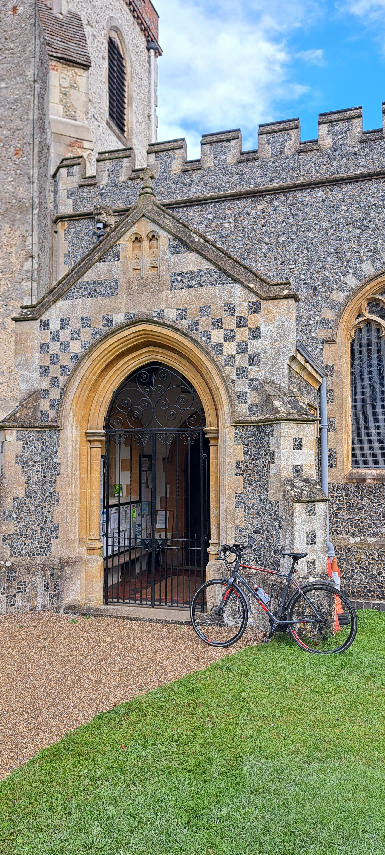
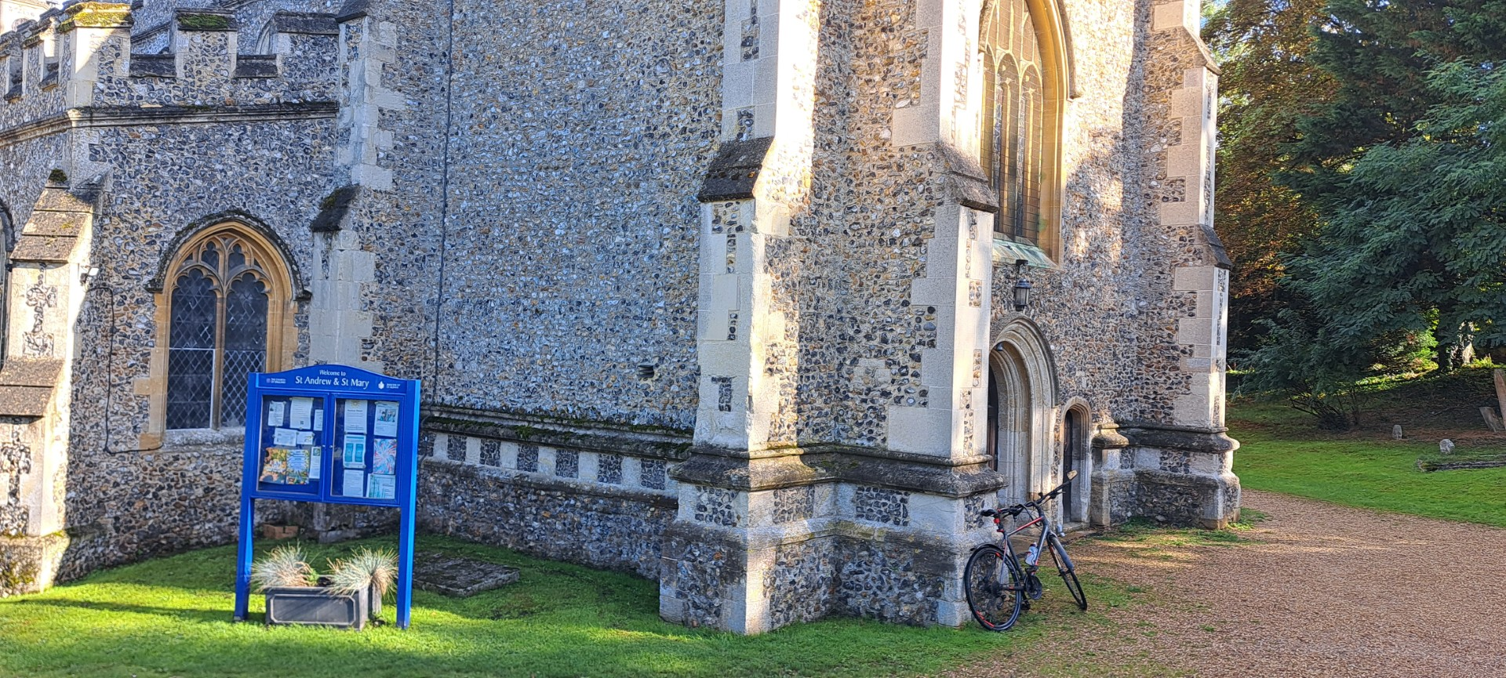
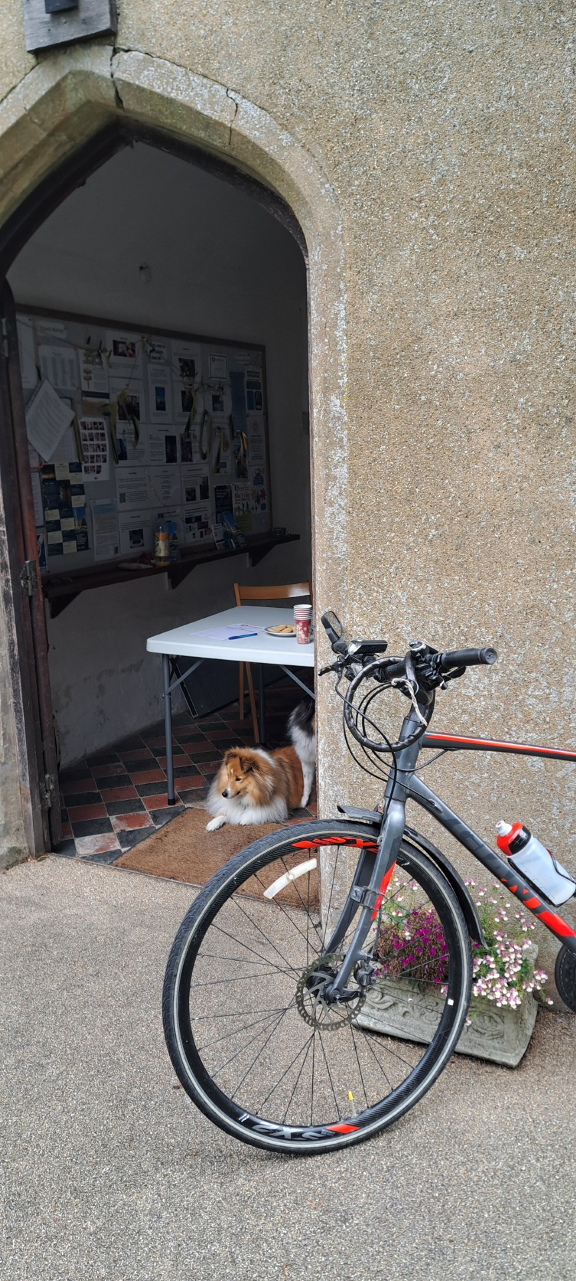
Saturday 13th September Beds and Herts Historic Churches Trust Sponsored Bike ‘n Hike. Make it lucky 13 this year - Beds & Herts Historic Churches Trust .
To sponsor Tim Alexander please see https://www.justgiving.com/crowdfunding/timothy-alexander-2#sharePage

Saturday 11th October at 7.30pm. Music for Cello and Piano. St Mary’s church, Stapleford, SG14 3NB. Tickets £20. Email: musicatstmarys@outlook.com

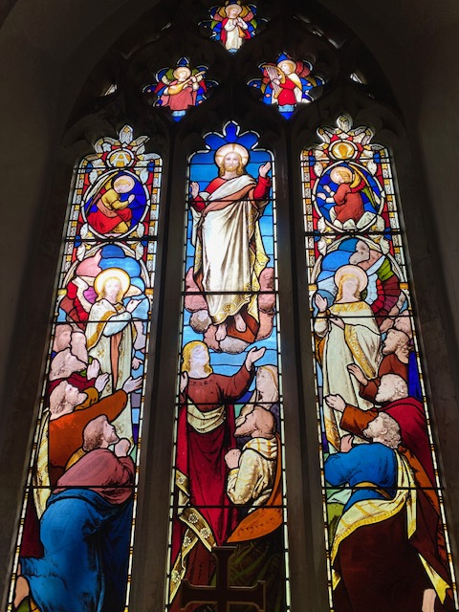
Collect Prayer for the fifteenth Sunday after Trinity: God, who in generous mercy sent the Holy Spirit
upon your Church in the burning fire of your love: grant that your people may be fervent in the fellowship of the gospel that, always abiding in you, they may be found steadfast in faith and active in service; through Jesus Christ your Son our Lord, who is alive and reigns with you, in the unity of the Holy Spirit, one God, now and for ever. Amen.
(The east window in St Andrew’s Church, Bramf.ield behind the altar shows Jesus lifted up to heaven, the end of his earthly life, his return to God’s right hand on high)

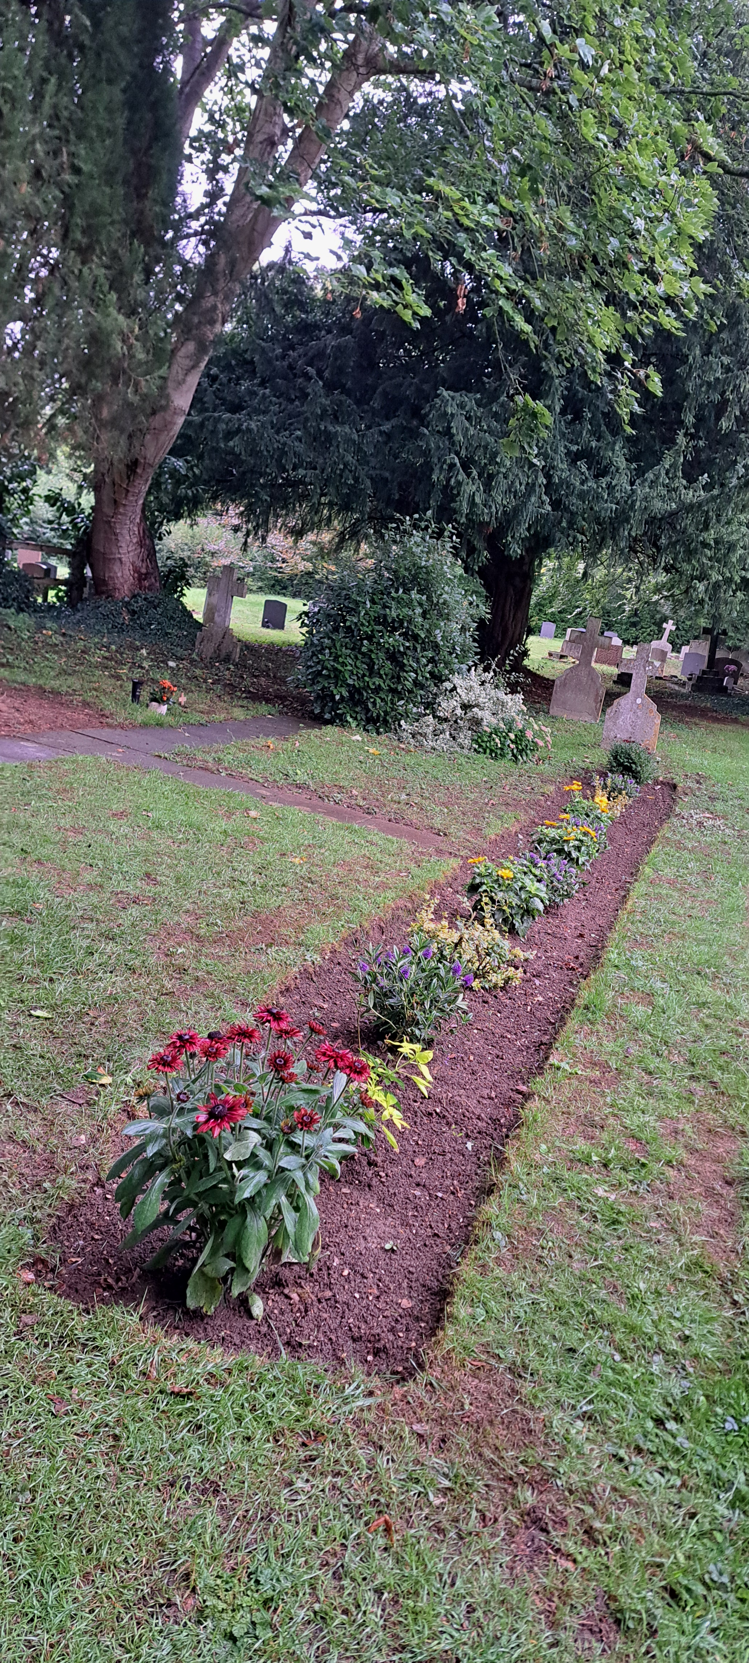
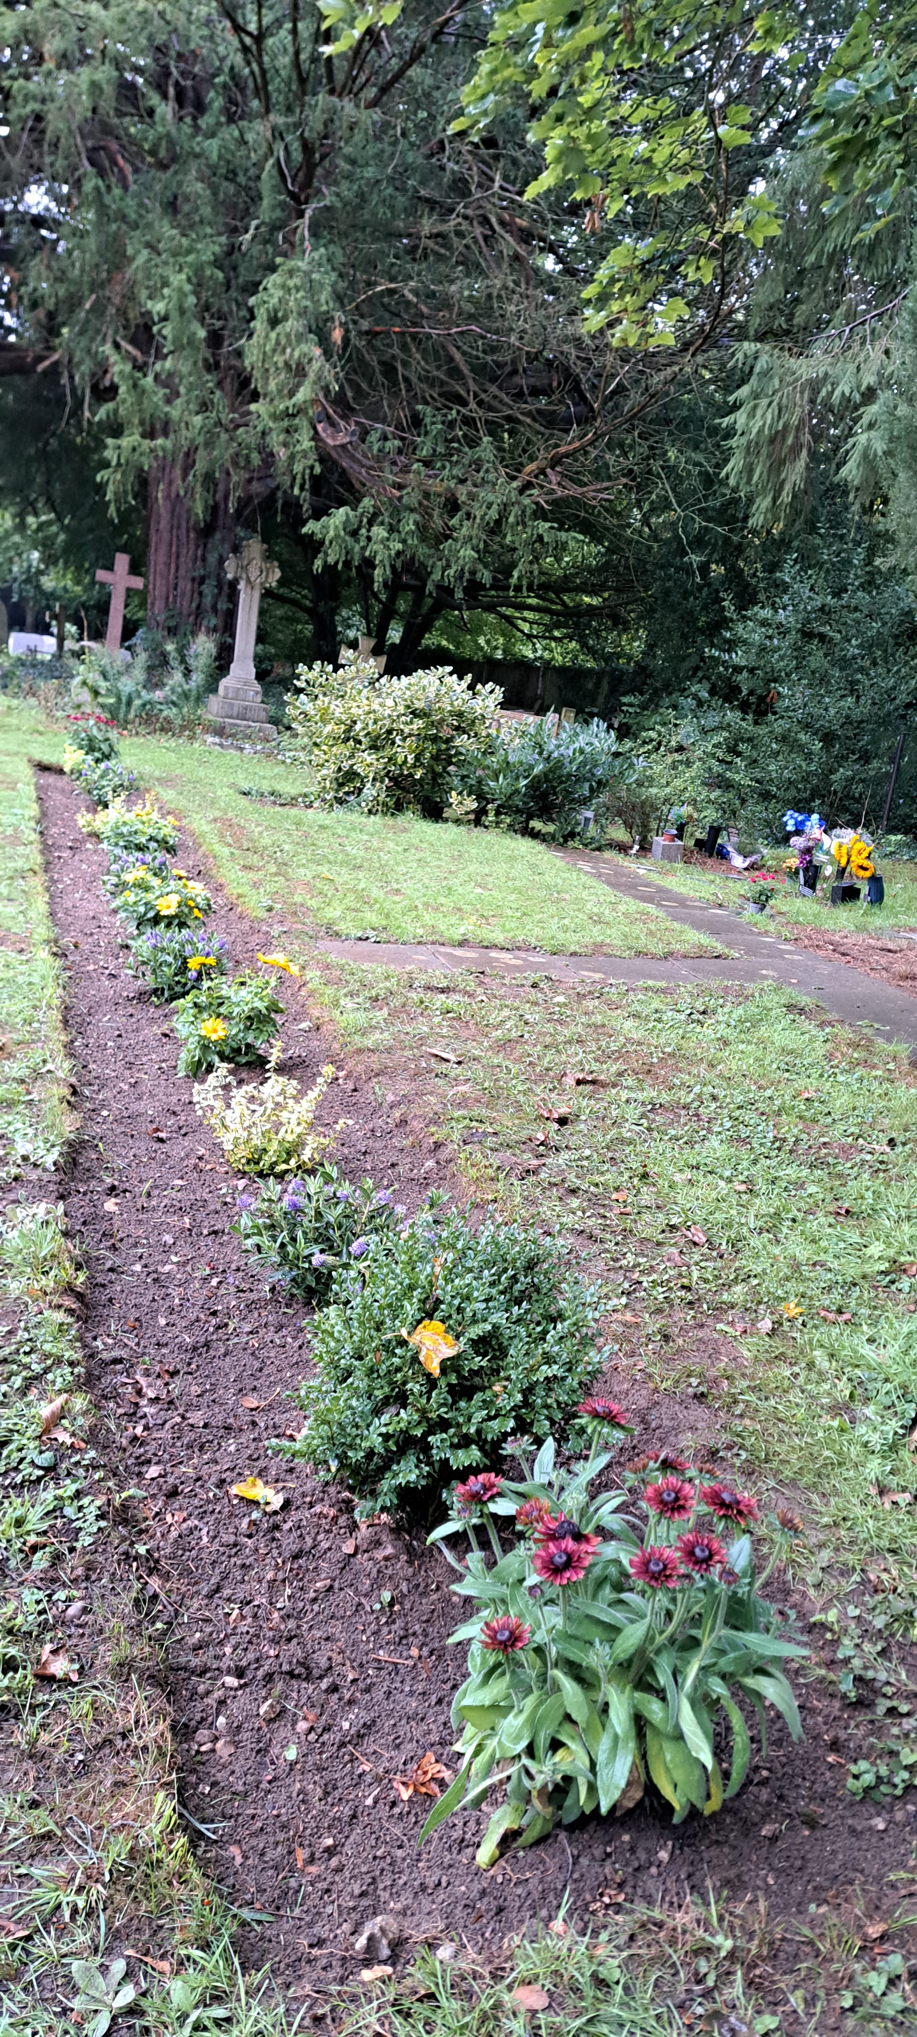
Newly planted border for the Garden of Remembrance at St Mary’s Aston
PRAY for PEACE in ISRAEL and GAZA, UKRAINE and all areas of conflict


Lord God, though peace seems humanly impossible,

we continue to pray for an end to violence and bloodshed.

We pray your comfort for the fearful and broken – hearted.


Change the hearts of those set on revenge and destruction.

Give wisdom to world leaders as they respond to aggression.

Bless all who work for understanding, reconciliation and justice which alone bring lasting peace. Amen.

‘God give us peace that lasts, not through the fear of might, but through the force of love, and love of life and right’. Amen

Hymn for Trinity 15. (HAM 346)
1 Christ is the world's true light,
its Captain of salvation,
the Daystar clear and bright
of every land and nation;
new life, new hope awakes,
for all who own his sway:
freedom her bondage breaks,
and night is turned to day.
2 In Christ all races meet,
their ancient feuds forgetting,
the whole round world complete,
from sunrise to its setting:
when Christ is throned as Lord,
all shall forsake their fear,
to plough-share beat the sword,
to pruning hook the spear.
3 One Lord, in one great name
unite us all who own thee;
cast out our pride and shame
that hinder to enthrone thee;
the world has waited long,
has travailed long in pain;
to heal its ancient wrong,
come, Prince of Peace, and reign.
G.W.Briggs

We believe that responding to the climate crisis is an essential part of our responsibility to safeguard God's creation and achieve a just world. Climate change hits hardest the poorest countries and poorest people of the world. Meantime, the widespread destruction of the natural world is a crisis for creation.

Our Environment Programme exists to enable the whole Church to address this — in faith, practice and mission. This includes tackling our own carbon emissions (aiming for Net Zero Carbon by 2030) and our wider work. More information can be found using the following weblink: http://www.churchofengland.org/about/church-england-environment-programme#na

Energy Hub Funded by UK Government: Find out how to:

1. Save energy

2. Save money. Reduce energy bills

3. Reduce carbon. Improve energy footprint

4.Increase comfort

For useful resources and guidance on where to get started visit: linktr.ee/energy_hub



https://app.ecochurch.org/user/21703/summary

Reduce single plastic use.

It’s likely that every toothbrush you have ever used, in your whole life, still exists, in a landfill somewhere. There are now biodegradable bamboo ones and biodegradable dental floss too. Why not try them.

In these dry summer months don't forget to leave some water out for wildlife. A shallow dish of fresh water is good for birds, hedgehogs and many insects, keeping them hydrated and cool. If you have the space, a bigger long term project might be to create a pond in your garden.
Beane valley Benefice vacancy advert
I am pleased to confirm that the advert for the Rector of Beane Valley Benefice has been uploaded onto the St Albans Diocese website. Here is a link to the advert for you all to view: Rector for the Beane Valley Benefice - The Diocese of St Albans

Web site: http://www.stalbans.anglican.org
This has also been sent to the Worshipful Company of Grocers as Patron.

CARING for our CHURCHYARDS

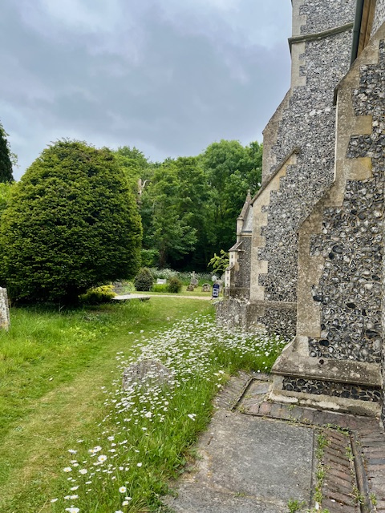
TUESDAYS Waterford Working Parties – Contact Churchwarden Malcolm Wandrag to offer help m.t.wandrag@gmail.com
To help in Stapleford or Watton or Bramfield please contact the Churchwardens.ASTON church open Sundays 12.00-16.00 and Wednesdays 10.00 -17.00 Church and churchyard working parties first Tuesday of month 10am to 12 noon. Contact Churchwarden Sara wardenstmarys@gmail.com
All our churchyards are cared for by volunteers.
Donations and offers of help are welcomed.
To include a loved one in the Book of Remembrance contact the churchwardens

Prayer for Growth for Aston, Bramfield, Stapleford, Waterford and Watton at Stone
Jesus teaches us to pray for our churches to grow. Jesus says: ‘Ask the Lord of the harvest, therefore, to send out workers into his harvest field’ (Matthew 9:38). In ways we don’t understand, God uses all our prayers.

Heavenly Father, you call us to sow seeds of faith in our communities. We ask you to fill us with your Holy Spirit that our lives may show the joy and new life we have in you. Guide our speaking and actions that others may be drawn to know your love. Lord Jesus, bless our churches that we may grow in numbers, love and service. We ask this in your name. Amen.
We pray for others to know God’s love.

Tie 5 knots in a piece of string - let each knot represent a friend or family member. Keep the string in your pocket and, as you feel the string, pray for those people to know God’s love. Set an alert on your phone to remind you to pray for those 5 people every day.

A prayer for those who seek to know God.
Lord Jesus, when your followers walked the Emmaus road wondering what was true and what was not, you came alongside them and revealed yourself in Scripture and in broken bread. Come alongside those we know and love who may wonder or seek at this time. Reveal yourself in your love and make us ready to walk alongside them too, until they see your face and know your presence. Amen.
Heavenly father we pray for guidance for our Beane valley benefice churches during the vacancy. Amen.

InTouch Age UK Hertfordshire
offer confidential, non-judgemental emotional and practical support on bereavement, physical & mental health issues, cancer, end of life, a partner with dementia or any other problem. Call 01992 634964/630623 or email intouch@ageukherts.org.uk Web page Age UK Hertfordshire | Our Services
Bereavement Support You can access online help at griefshare.org
thebereavementjourney.org cruse.org.uk teardropgrief.co.uk ataloss.org












’s
afternoon
Tea

rty
at 64 Rivershill
Sunday 24th July 2.00-5.oopm

Bring & Buy <> Raffle <> Jams
Proceeds to Both

TAKE AWAY AVAILABLE

