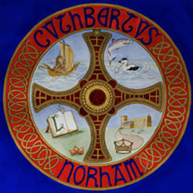

St Cuthbert’s Church Norham

**SAFEGUARDING**

**What to do if you are concerned or worried**

If you believe that you, or someone that you know, is, or may be at risk of any form of abuse, OR you believe that you know someone who may pose a risk to others, then it is important to seek advice from a Safeguarding Adviser or Officer within the Church structure.

Within the parish, the local Safeguarding Adviser is Dr Janet Young – tel: 07393 544003 and e-mail: [Janetyoung.lazda@gmail.com](mailto:Janetyoung.lazda@gmail.com).

All policy and advisory documents are kept within the church and DBS checks are undertaken on any person who may have contact or connection with any vulnerable adult of child as required.

St Cuthbert’s Church, Norham, sits within the Diocese of Newcastle. Within the Diocese there is a Safeguarding team led by Sharon Devlin, Director of Safeguarding who can be contacted by telephone - 0191 270 4138 or by e-mail - [s.devlin@newcastle.anglican.org](mailto:s.devlin@newcastle.anglican.org) .

The Diocese provides and supervises regular training to all those in the parish for whom it is required.

If the matter is of great urgency then you would be advised to take your concerns to the Local Authority Social Care Services OR to the Police via Onecall – 01670 536400

**When you talk to us, we will listen**