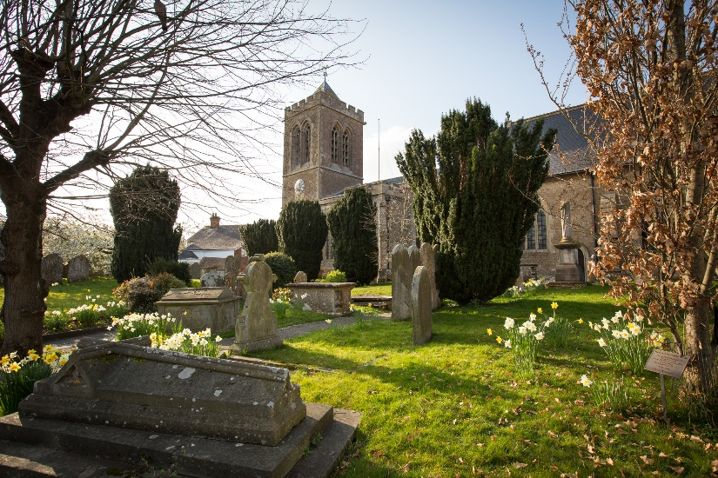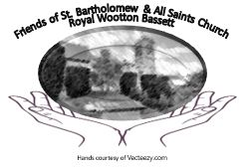

**The Friends of St Bartholomew & All Saints Church,**

**Royal Wootton Bassett**

**APPLICATION FOR MEMBERSHIP**

**The preferred payment method is by bank transfer or Standing Order to:**

**The Friends Sort code: 40-47-16 A/C: 11 44 15 31**

***When setting up bank transfers and standing orders please enter your ‘surname’ in the reference field.***

**Annual Membership: £10 per person……………………..**

**Family Membership: £20 (*do not enter children’s details*)………..**

**Life Membership: £120 per person……………………..**

**Donation: £_______.____**

I/we wish to join the Friends of St Bartholomew & All Saints Church.

**Annual Renewal Date is: 1st January**

Payment Method(tick): Cash Bank Transfer Standing Order

**Total Payment:** £_______.____

Subscriptions can be sent to The Parish Office, 1 Church Street, Royal Wootton Bassett, SN4 7BQ.

Name(s): ______________________________________________________________

Address: ________________________________________________________________________

______________________________________ Post Code: ____________

Email: _________________________________ Telephone: ____________________

Signed: _________________________________ Dated: ____________

**If you pay income tax and wish to make your payment as Gift Aid please sign below.**

***I understand that if I pay less Income Tax than the amount of Gift Aid claimed on all of my donations in a single tax year then it is my responsibility to pay any difference. TICK***

I wish to make this, and all future payments and donations to ‘The Friends’ as Gift Aid from my taxed income.

Signed: _________________________________ Dated: ____________

**Data Protection:**

**Your personal data is held and processed in accordance with the GDPR. The Friends of St. Bartholomew & All Saints Church, Royal Wootton Bassett will only use your data to contact you, under the lawful basis of ‘Legitimate Interest', on matters specifically related to the Friends. We do not share your data with any third parties. In accordance with the GDPR you are entitled to see what your rights are and these are detailed in our Data Privacy Notice. A copy of this can be found in the Parish Office or at the following location:**

[**http://www.stbartholomews-wb.com/page/88093/view/**](http://www.stbartholomews-wb.com/page/88093/view/)

**Thank you for your support and generosity**

Registered Charity No: 284809

Last revised 6th September 2025

**The Friends of**

**St Bartholomew & All Saints Church,**

**Royal Wootton Bassett**

**This is an invitation to you!**

**Please join us in becoming a 'Friend' of this beautiful and historic church.**

**Who? Why? What? How?**

If you have any questions, please contact the Membership Secretary, Jane Spencer, in person or at the following email address:

[StBartsFriends@gmail.com](mailto:StBartsFriends@gmail.com)

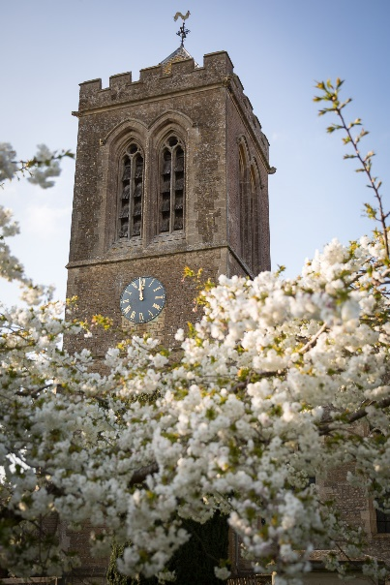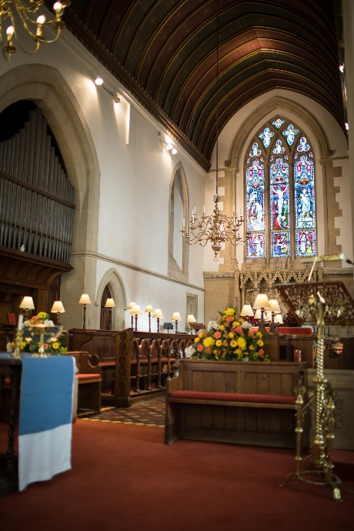

**Who are we?**

A group of people with a love for this beautiful building. You don't have to be a member of the congregation to be a 'Friend' but you will make friends if you become a member... and have fun!!

**Who runs the group?**

The Friends is a group scheme

run by a small committee of

trustees. A list of the present

trustees is displayed on one

of the noticeboards in church

or may be obtained from the

Parish Office.

**Why are we needed?**

The Friends of St Bartholomew and All Saints was formed in 1981 to raise and administer funds for the renewal and restoration works which are always needed on buildings like this. The first major work, as with so many churches, was on the church roof and major work needs big money!

**What have we achieved?**

From 1982 to 2000 the 'Friends' contributed a total of £124,215 to projects as varied as repairs to the church roof, repairs to the heating system, organ, floor tiles etc., the provision of new carpet, lighting for the pulpit, lectern and bell-tower and even a mat for the porch!

Since then, a further £49,543 has

helped provide a much needed

new sound system, carpeting,

repairs to windows and doors

plus other items needed during

the 2011/12 refurbishment.

Recently, £12,572 has been spent

on repairs and maintenance of

the building.

As you know with your own homes, the need for repairs and replacements are ongoing and increasingly expensive. The more 'Friends' we have the more we can achieve in maintaining this beautiful church not only for ourselves and our community but for future generations.

**How can I join/contribute?**

For details of membership subscriptions and one-off donations please see the form overleaf.