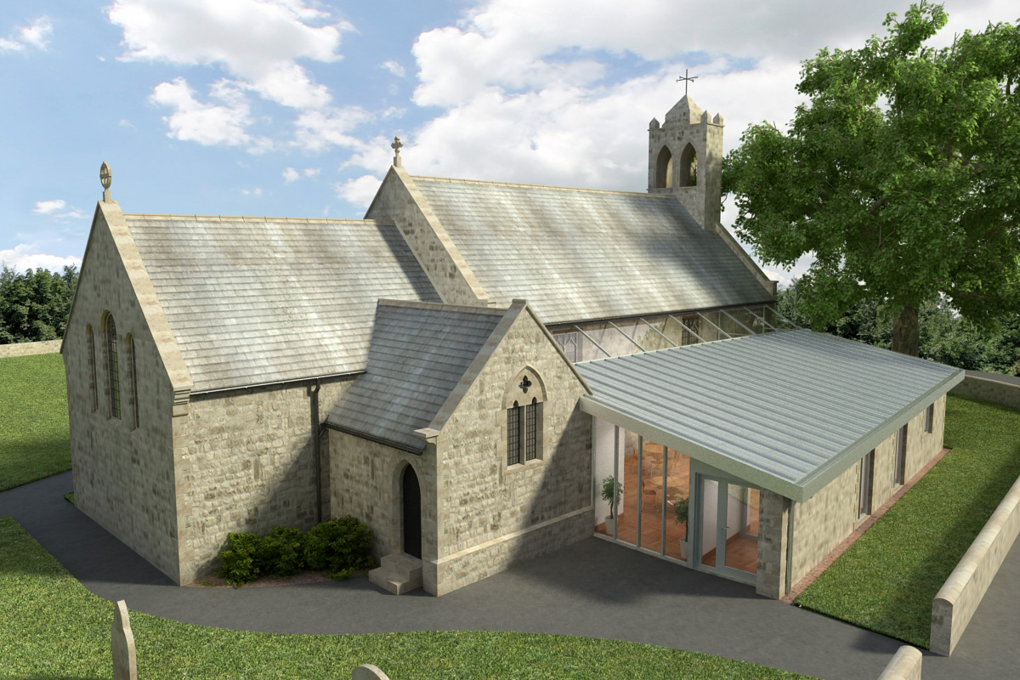St Mary’s Parish Church, Longframlington

Welcome to our Sunday Morning Prayer. This morningon, **Sunday 21st September,** which is **Trinity 14 (Proper 20),** our **Officiant** today is the **Rev Rich,** and **Steve playing the organ.** Our Officiant next week will be the **Rev Michael** and **Gisele** playing the **music**.

**Coming up at St Mary’s and our sister parishes+- Morning Prayer in St Mary’s – and on Zoom –** usuallyevery Wednesday morning at 9.30 am followed by coffee in the Community Room. The Link can be accessible from our website

https//www.achurchnearyou.com/church/16291 from “More Info on the services and Events” page.

Would you like to sponsor a bible for Whittingham School? Simply make a one off payment using the reference **`BIBLE`** by 30th September 2025. Account details: PCC of Whittingham and Edlingham Sort Code:30-90-13 Account number: 00095198.

**Harvest Festivals**- Pre notice – these will be taking place on **Sunday 5th October** in the churches and other dates within and around that date for the schools.

**Deanery Notices:**

Diocese of Manchester Choral Scholars two events: In Partnership with St Martin in the Fields Choral Scholars. Posters available.

**Saturday, 20th September** at **7 pm** In every corner sing: **St Lawrence, Warkworth**, entry free, retiring collection, refreshments from 6.30 pm.

**Sunday, 21st September** at **3 pm** Sing my soul: Choral Evensong, **St Mary, Lesbury**, service free, refreshments.

**Sunday, 28th September** at **5 pm**, **Patronal Festival Choral Evensong**, if you wish join choir from 2pm till 4 pm followed by tea and cake, come and sing with them. In **St Michael’s Church, Alnwick**.

Thank you for your giving to the life and work of our church. Our offering is taken during the third hymn, and there is a collection giving point at the back of the church for use after the service if you prefer. Regular giving by Standing Order with Gift Aid is particularly valuable to the church – speak to Audrey (01665 570 922) for more information and blank forms. All our news and much more available on our Facebook page [https:www.facebook.com/SMCLongfram/?ti=as](https://www.facebook.com/SMCLongfram/?ti=as) and

You Tube channel[https:www.youtube.com/@stmichaelsfeltonstmaryslon4157](https://www.youtube.com/@stmichaelsfeltonstmaryslon4157)

Priest in Charge: Rev Rich Townend Phone 01670 719470 Email:[revrichtea@gmail.com](mailto:revrichtea@gmail.com) Regular day off: Monday, for St Mary’s information contact Veronica Thomson (01665 570 807) or Audrey Truman ( 01665 570922).