 **JohnPaul Parish**

**Autumn Fair**

In St Paul’s Church

Barnfield Street, Accrington

Saturday 1st Nov. 10.30 – 2.00

Books – Cakes – Jewellery – Crafts

Tombola – Face Painting – Plants

Original Art

Lunches and Refreshments

Plus, lots more bargains

Free Admission

We are now collecting

for the following stalls: -

**Books**

**Bric-a-brac**

**Jewellery**

**Toiletries**

**Tombola**

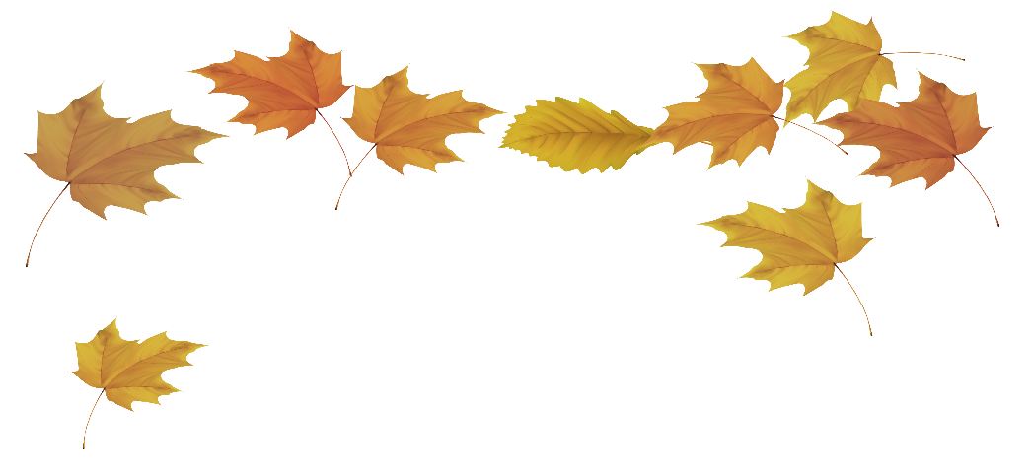

**Cakes - Donations of baking ingredients**

**Craft items**

**Toys**

**Chocolates**

**and Raffle Prizes.**

Have you any ideas for a stall or would you like to run a stall?

Please see Maureen or Kath.