**SUNDAY 14th September 2025**



**Loving God and Loving our Neighbour**

**Sunday 14th September Trinity 13**

**9.30am Watton** Holy Communion.

**11am Watton co**ntemporary service.

**11am Aston** Family service

**11.15am Bramfield** Holy Communion

**11.15am Stapleford** Prayer and Praise

**LOOKING AHEAD**

**Sunday 21st September Trinity 14**

**11am Aston** Holy Communion.

**11am Watton co**ntemporary service.

**11.15am Stapleford** Holy Communion

**11.15am Waterford** Morning prayer

**You are welcome to attend ANY church**

**MIDWEEK**

**Fortnightly MONDAY 2pm ASTON Bible Study Fellowship** 3 Long Ridge Aston with tea and biscuit. All are welcome. **Next meeting Monday 15th September** Contact Pauline at [pauline.manley1966@gmail.com](mailto:pauline.manley1966@gmail.com)

**St Andrew’s Bramfield** **Wednesday's 10am** **Morning Prayer** - short said service followed by coffee and chat 11am. All are welcome. **Next Morning Prayer service Wednesday 17th September.**

**NIGHT PRAYER Alternate WEDNESDAYS at 7.30pm on ZOOM. Next meeting Wednesday 17th  September** on ZOOM. Contact Tim Alexander for link [tim_alexander3@hotmail.com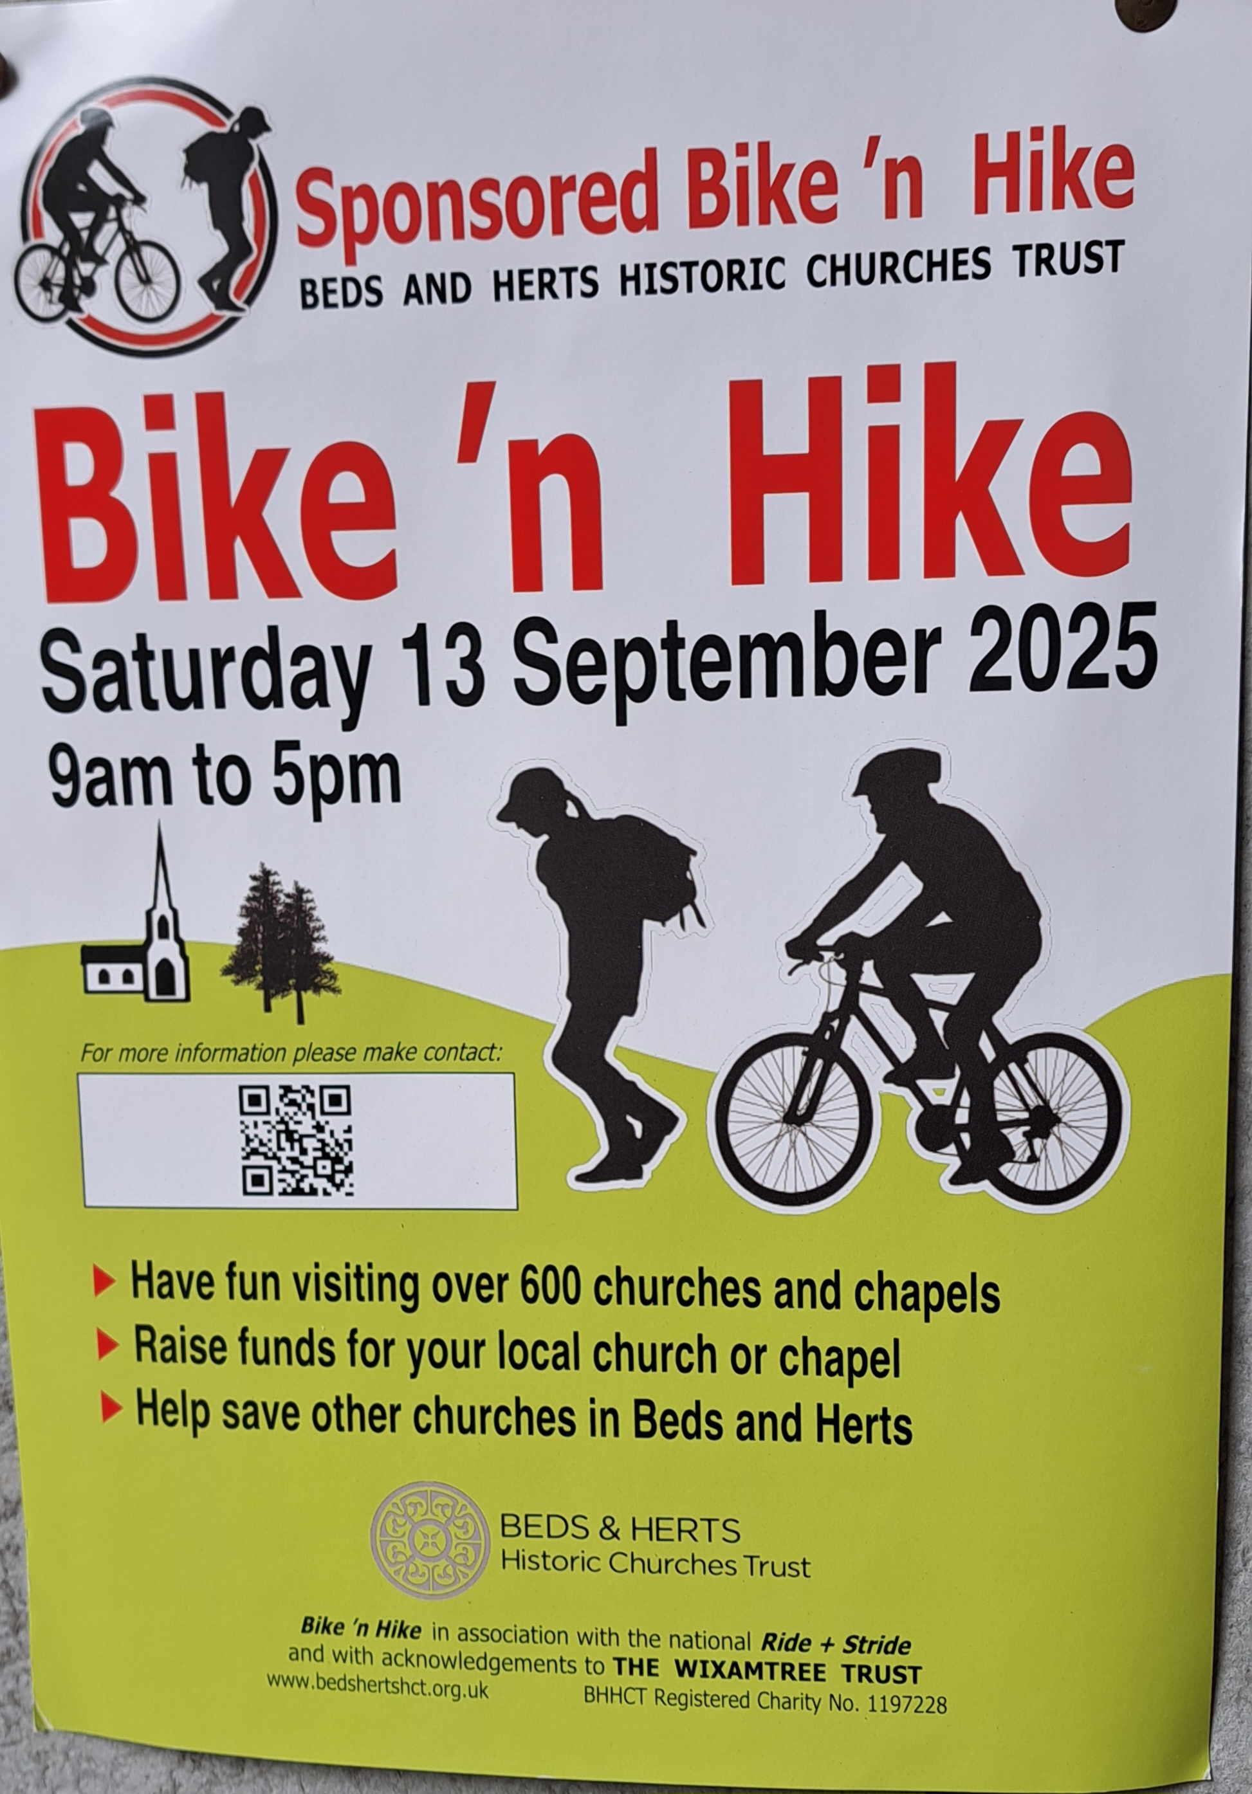](mailto:tim_alexander3@hotmail.com)

**Saturday 13th September** Beds and Herts Historic Churches Trust Sponsored Bike ‘n Hike 9am to 5pm. [Make it lucky 13 this year - Beds & Herts Historic Churches Trust](https://bedshertshct.org.uk/bike-n-hike/) . Info packs available in Benefice churches.

**Sunday 14th September** Waterford Village Fete. 1Pm – 4pm. Bouncy castle fun, Live music, Beer tent, Novelty dog show. Free entry £2 parking. SG14 2PS.

**Wednesday 17th September** 2.30pm. Stapleford village Tea afternoon in church. All are welcome.

**Saturday 20th September** 1.30pm. St Michael and All Angels church Waterford. Talk on Sir Edward Burne-Jones by local historian Dorothy Abel Smith. Followed by refreshments afterwards in Waterford village Hall, SG14 2PS.

**Saturday 11th October at 7.30pm.** Music for Cello and Piano. St Mary’s church, Stapleford, SG14 3NB. Tickets £20. Email: [musicatstmarys@outlook.com](mailto:musicatstmarys@outlook.com)

**Collect Prayer for the thirteenth Sunday after Trinity**

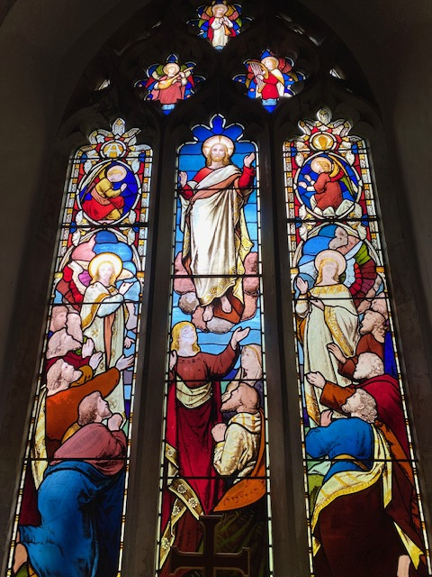

Almighty God, who called your Church to bear witness that you were in Christ reconciling the world to yourself: help us to proclaim the good news of your love, that all who hear it may be drawn to you; through him who was lifted up on the cross, and reigns with you in the unity of the Holy Spirit, one God, now and for ever. Amen

(The east window in St Andrew’s Church, Bramfield behind the altar shows Jesus lifted up to heaven, the end of his earthly life, his return to God’s right hand on high)

**PRAY for PEACE in ISRAEL and GAZA, UKRAINE and all areas of conflict**

Lord God, though peace seems humanly impossible,

we continue to pray for an end to violence and bloodshed.

We pray your comfort for the fearful and broken – hearted.

Change the hearts of those set on revenge and destruction.

Give wisdom to world leaders as they respond to aggression.

Bless all who work for understanding, reconciliation and justice which alone bring lasting peace. Amen.

‘God give us peace that lasts, not through the fear of might, but through the force of love, and love of life and right’. Amen

**Hymn for Trinity 13. Oft in danger, oft in woe (HAM 210)**

1 Oft in danger, oft in woe,  
onward, Christians, onward go;  
bear the toil, maintain the strife,  
strengthened with the bread of life.

2 Onward, Christians, onward go,  
join the war, and face the foe;  
will ye flee in danger's hour?  
Know ye not your Captain's power?

3 Let not sorrow dim your eye;  
soon shall every tear be dry:  
let not fears your course impede;  
great your strength, if great your need.

4 Let your drooping hearts be glad;  
march in heavenly armour clad;  
fight, nor think the battle long:  
soon shall victory wake your song.

5 Onward then in battle move;  
more than conquerors ye shall prove:  
though opposed by many a foe,  
Christian soldiers, onward go.

*(H.Kirke White)*

If you are struggling in the heat, please take care and ensure you drink enough water to remain hydrated. A hat would keep some of the heat off if you are walking to church.

We believe that responding to the climate crisis is an essential part of our responsibility to safeguard God's creation and achieve a just world. Climate change hits hardest the poorest countries and poorest people of the world. Meantime, the widespread destruction of the natural world is a crisis for creation.

Our Environment Programme exists to enable the whole Church to address this — in faith, practice and mission. This includes tackling our own carbon emissions (aiming for Net Zero Carbon by 2030) and our wider work. More information can be found using the following weblink: [http://www.churchofengland.org/about/church-england-environment-programme#na](http://www.churchofengland.org/about/church-england-environment-programme" \l "na)

Energy Hub Funded by UK Government: Find out how to:

1. Save energy

2. Save money. Reduce energy bills

3. Reduce carbon. Improve energy footprint

4.Increase comfort

For useful resources and guidance on where to get started visit: [linktr.ee/energy_hub](http://linktr.ee/energy_hub)



<https://app.ecochurch.org/user/21703/summary>

Reduce single plastic use.

It’s likely that every toothbrush you have ever used, in your whole life, still exists, in a landfill somewhere. There are now biodegradable bamboo ones and biodegradable dental floss too. Why not try them.

In these dry summer months don't forget to leave some water out for wildlife. A shallow dish of fresh water is good for birds, hedgehogs and many insects, keeping them hydrated and cool.  If you have the space, a bigger long term project might be to create a pond in your garden.

Benefice vacancy advert

I am pleased to confirm that the advert for the Rector of Beane Valley Benefice has been uploaded onto the St Albans Diocese website. Here is a link to the advert for you all to view: [Rector for the Beane Valley Benefice - The Diocese of St Albans](http://www.stalbansdiocese.org/vacancies/rector-for-the-beane-valley-benefice/)

Web site: [http://www.stalbans.anglican.org](http://www.stalbans.anglican.org/)

This has also been sent to the Worshipful Company of Grocers as Patron.

**CARING for our CHURCHYARDS**

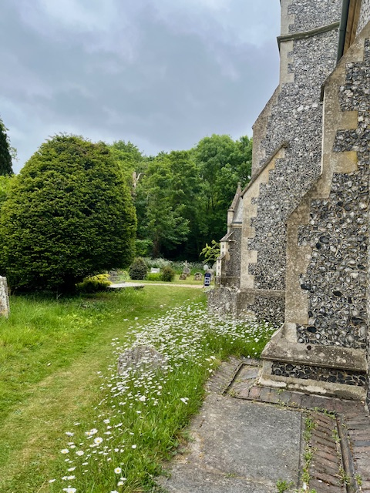**TUESDAYS Waterford** Working Parties – Contact Churchwarden Malcolm Wandrag to offer help [**m.t.wandrag@gmail.com**](mailto:m.t.wandrag@gmail.com)

To help in **Stapleford or Watton or Bramfield please** contact the Churchwardens.**ASTON church** open Sundays 12.00-16.00 and Wednesdays 10.00 -17.00 Church and churchyard working parties first Tuesday of month 10am to 12 noon. Contact Churchwarden Sara [**wardenstmarys@gmail.com**](mailto:wardenstmarys@gmail.com)

**All our churchyards are cared for by volunteers.**

**Donations and offers of help are welcomed.**

**To include a loved one in the Book of Remembrance contact the churchwardens**

**Prayer for Growth for Aston, Bramfield, Stapleford, Waterford and Watton at Stone**

Jesus teaches us to pray for our churches to grow. Jesus says: *‘Ask the Lord of the harvest, therefore, to send out workers into his harvest field’* (Matthew 9:38). In ways we don’t understand, God uses all our prayers.

**Heavenly Father, you call us to sow seeds of** **faith in our communities. We ask you to fill us with your Holy Spirit that our lives may show the joy and new life we have in you. Guide our speaking and actions that others may be drawn to know your love. Lord Jesus, bless our churches that we may grow in numbers, love and service. We ask this in your name. Amen.**

We pray for others to know God’s love.

Tie 5 knots in a piece of string - let each knot represent a friend or family member. Keep the string in your pocket and, as you feel the string, pray for those people to know God’s love. Set an alert on your phone to remind you to pray for those 5 people every day.

**A prayer for those who seek to know God.**

**Lord Jesus, when your followers walked the Emmaus road wondering what was true and what was not, you came alongside them and revealed yourself in Scripture and in broken bread. Come alongside those we know and love who may wonder or seek at this time. Reveal yourself in your love and make us ready to walk alongside them too, until they see your face and know your presence. Amen.**

**Heavenly father we pray for guidance for our Beane valley benefice churches during the vacancy. Amen.**

**InTouch Age UK Hertfordshire**

offer confidential, non-judgemental emotional and practical support on bereavement, physical & mental health issues, cancer, end of life, a partner with dementia or any other problem. Call **01992 634964/630623** or email  [intouch@ageukherts.org.uk](mailto:intouch@ageukherts.org.uk) Web page  [Age UK Hertfordshire | Our Services](https://www.ageuk.org.uk/hertfordshire/our-services/)

**Bereavement Support** **You can access online help** at  [griefshare.org](http://griefshare.org/)

[thebereavementjourney.org](https://www.thebereavementjourney.org/) [cruse.org.uk](http://cruse.org.uk/)  [teardropgrief.co.uk](http://teardropgrief.co.uk/)  [ataloss.org](http://ataloss.org/)

|  |
| --- |
|  |



’s



afternoon

Tea

rty

at 64 Rivershill

Sunday 24th July 2.00-5.oopm



Bring & Buy <> Raffle <> Jams



**Proceeds to Both**

**TAKE AWAY AVAILABLE**