**The Rector's Ramblings**

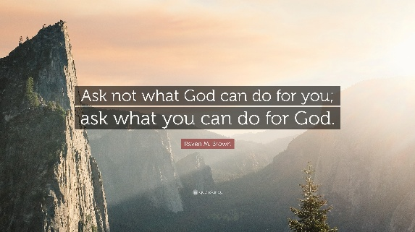

This month is, as always, a busy month. On Sunday, after the service, I, along with all the licensed clergy in the Diocese, will be heading off to the University of Kent, in Canterbury, for a 3-day clergy conference. As well as seminars, addresses, and key note speakers, it is a great opportunity to catch up with old friends I haven't seen in years, and to hopefully make some new ones.

On the 20th, we welcome Stephen Hope to West Dean church for 'Face the music with Hope', and then on the 28th, we are all invited to invade the military base on Thorney Island for Choral Evensong at St Nicholas Church, overlooking Chichester Harbour. However, the most important day this month, for me, is on Tuesday 30th September, which marks the fifth anniversary of my licensing as your parish priest. Can you believe it has been 5 years, I can't!

Now I'm not sure if it is because I have been in post for 5 years, or just because that is how it has worked out, but 2 days after my anniversary I have a Ministerial Development Review meeting with Bishop Martin. Now a meeting with the Bishop is always nerve-wracking, and a review meeting even more so, and so I have already started my preparation, asking people for feedback, reviewing the past 5 years, and putting some stats together, just in case he asks.

So what are the facts and figures for the past 5 years? Well, since I started serving the people of this parish I have led approximately 230 Sunday services, had the joy of celebrating the marriage of 10 couples (with 7 more already booked for next year), welcomed 8 babies, children and adults in to the family of faith at their baptism, walked with 30 families as they faced the funeral of their loved one, and then had the honour of leading that service. I have chaired 29 PCC and APCM meetings, and led our two schools in Easter, Harvest, Christmas, and end of term celebrations, as well as just dropping is as often as I can. I've been day chaplain at the Cathedral 25 times and led Evensong in the bookshop roughly 36 times. Not bad, although I say so myself, and I hope the Bishop will be content, if not impressed, with all that has happened.

But before you start thinking this is me bigging myself up, or asking for praise or thanks, it isn’t, I’m not. The reason for including the facts and figures is to say that as important as they are, especially to the Diocese, they can't and don't tell the whole story of my time here, because it isn't about the numbers.

The stats can't tell of the number of times someone has asked me, or another member of the church family, to pray with or for them. The stats don't record the number of chance meetings with someone, parishioner or visitor, that has resulted in a truly faith filled and meaningful conversation. The stats don't record what is the most important aspect of faith, the most important part of being a family of faith - relationships. Relationships with each other and, more importantly, our relationship with God. The 230 sermons I have preached, the 215 Rambles I have written, have, I hope, helped in some small way to deepen faith, or open people’s eyes to faith, but after the services and sermons comes the time for coffee, for chats, for fellowship. Being invited to visit someone in their home is an honour, and to take communion to the house bound or to those who, for whatever reason, are unable to attend services, is a privilege, because it helps to strengthen their relationship with God, it helps to ensure they know they are part of the faith community, the faith family.

I know there are a lot of people in the Valley parish who visit the sick, welcome the stranger and feed the hungry, whether that is because of their faith or not, but we can all do more, and we should all do more, because visiting the sick, welcoming the stranger, feeding the hungry, isn’t something we can leave to someone else, it isn’t something we can say ‘that’s not my job’, not if we are truly searching for a relationship with God, and with each other.

JFK famously said 'ask not what your country can do for you, but what you can do for your country', and the quote at the top of the Ramble encourages us to apply the same idea in our relationship with God, but we need to take it further and ask our neighbours, wherever they are in the world, not what can you do for me, but what can I do for you.

It isn’t about the stats, it’s about the people.

*Rev Sarah*

A memorial service for Dot Barkham will take place in Singleton Church on Saturday 6th September at 12pm.

**Worship in the Valley Parish**

# 7th September

## Holy Communion 10am All Saints, East Dean

**Rev Sarah Manouch**

*07468 854864 priestvalleyparish@gmail.com*

*Please note that I am part-time. My principal working days are Friday and Saturday as well as Sunday. I am not available on a Thursday.*