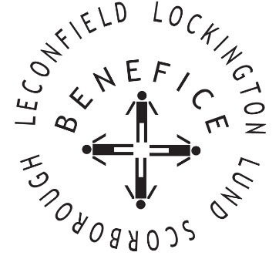

Church Services for
October 2025
Wherever you are from, you are welcome to join us for any of these services

Wednesday 1st 9:30am Mid Week Service
With healing prayers St Mary’s Lockington

Sunday 5th 9:30am Holy Communion St Leonard’s Scorborough

11:00am Morning Worship St Mary’s Lockington

Sunday 12th 9:30am Holy Communion All Saints Lund

Wednesday 15th 9.30am Mid Week Service
With healing prayers St Catherine’s Leconfield

Sunday 19th 9:00am Harvest Holy Communion St Mary’s Lockington
With Coffee & Cake

Thursday 23rd 7:00pm Celtic Prayers St Catherine’s Lockington

Sunday 26th 9:30am Holy Communion All Saints Lund

11:00am Contemporary Worship St Mary’s Lockington

For more information see the benefice newsletter ‘Messenger’
Service times, events and Messenger can also be found at:
http://www.achurchnearyou.com for the four churches

