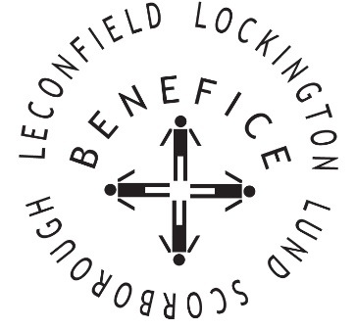

**Church Services for**

**October 2025**

Wherever you are from, you are welcome to join us for any of these services

**Wednesday 1st 9:30am Mid Week Service**

**With healing prayers St Mary’s Lockington**

Sunday 5th 9:30am Holy Communion St Leonard’s Scorborough

11:00am Morning Worship St Mary’s Lockington

Sunday 12th 9:30am Holy Communion All Saints Lund

**Wednesday 15th 9.30am Mid Week Service**

**With healing prayers St Catherine’s Leconfield**

Sunday 19th 9:00am **Harvest** Holy Communion St Mary’s Lockington

With Coffee & Cake

**Thursday 23rd 7:00pm Celtic Prayers St Catherine’s Lockington**

Sunday 26th 9:30am Holy Communion All Saints Lund

11:00am Contemporary Worship St Mary’s Lockington

For more information see the benefice newsletter *‘*Messenger’pasted-image.tiff

Service times, events and *Messenger* can also be found at:

<http://www.achurchnearyou.com> for the four churches