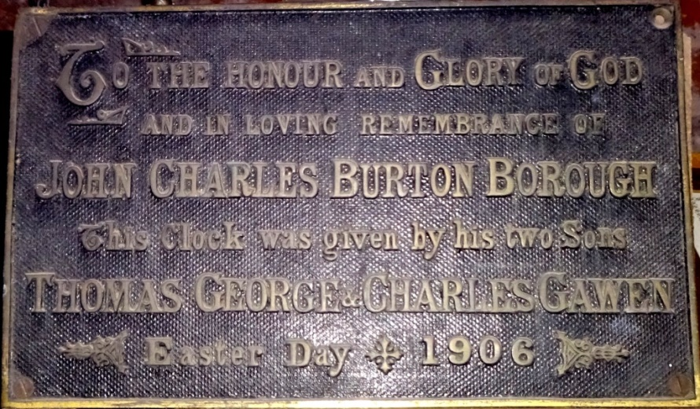

This photograph shows the brass memorial plate; recording the donors of this timepiece.

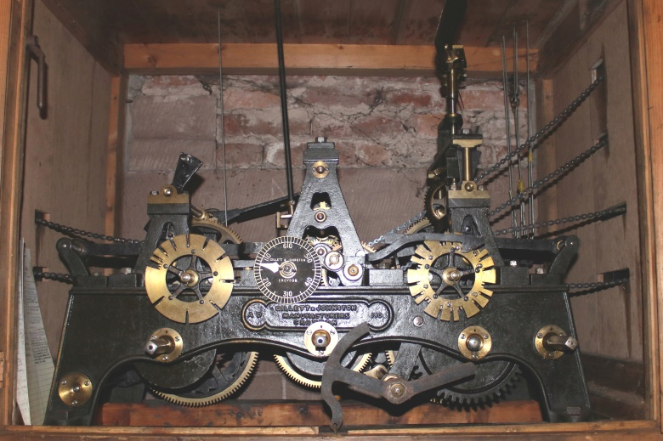

This photograph shows the clock mechanism, housed within the cabinet. The chains are attached to a series of ropes, weights and pulleys; the next photo shows the relationship of these.

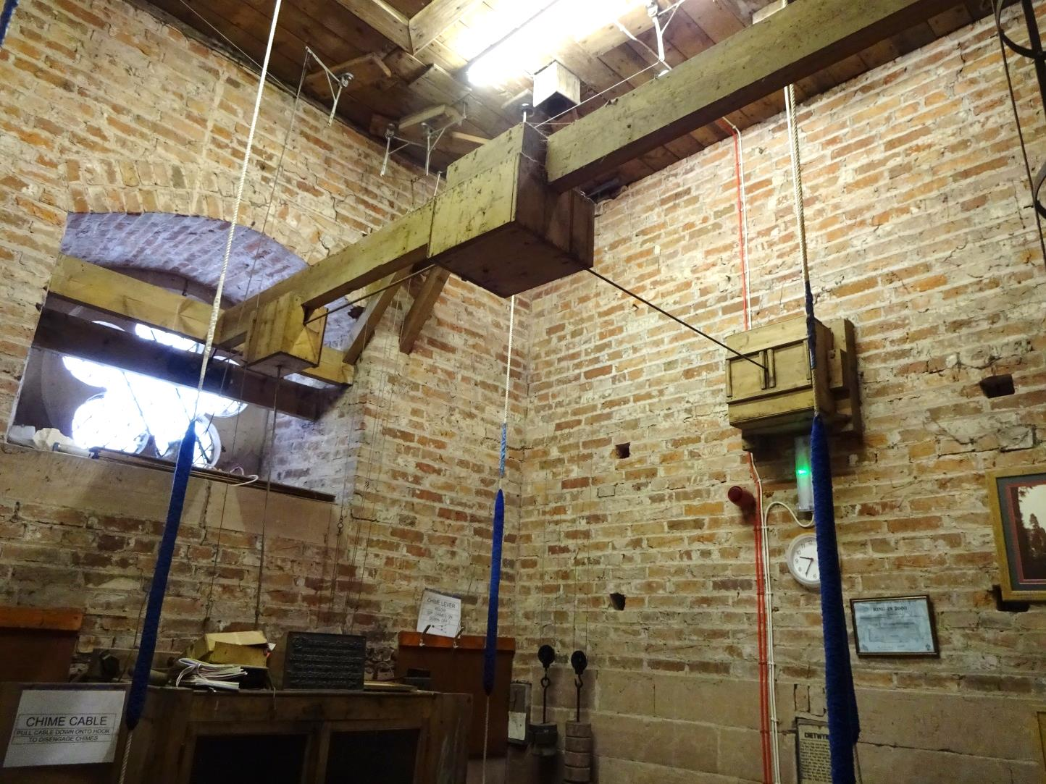

This photograph shows the inside of the bell ringing chamber; the pulleys, weights, shafts and gears that turn the hands on the clock faces can be seen. The cinquefoil window is hidden when viewed externally, by the translucent north clock face: the shaft that turns the hands passes through the window glass. The east face is behind the wall with the green light.

The brass memorial plate with inscription is sited on top of the clock mechanism cabinet.

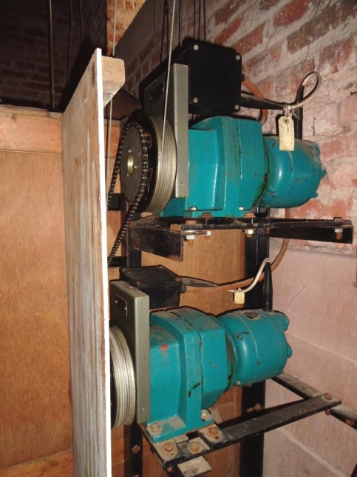The clock mechanism originally had to be wound manually, twice a week; in 1976 it was upgraded with electric motors.  This photograph shows the twin motors on the eastern side of the cabinet; there is a single motor on the western side.

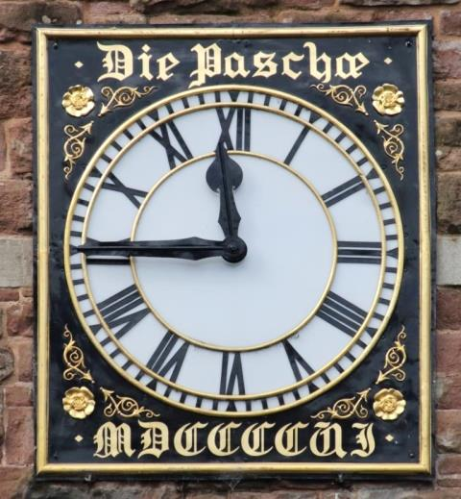

Both the north and east clock faces bear the same Latin script: ‘Die Paschae MDCCCCVI’ (Easter Day 1906): this photograph, taken in March 2023, shows the eastern clock face.