**SUNDAY 17th August 2025**



**Loving God and Loving our Neighbour**

**Sunday 17th August TRINITY 9**

**11am Watton** Contemporary Service Contact Sharon 07931 325288

**11am Aston** Holy Communion

**11.15am Waterford** Morning Prayer

**11.15am Stapleford** Prayer and Praise

**LOOKING AHEAD**

**Sunday 24th August Trinity 10**

**9.30am Watton** Prayer and Praise

**11am Watto**n No service

**11.15am Bramfield** Prayer and Praise

**11.15am Stapleford** Prayer and Praise

**Sunday 31st  August Trinity 11 Benefice service.**

**11.15am Staple**ford Benefice Holy Communion service.

No service at Aston, Bramfield, Waterford or Watton.

**You are welcome to attend ANY church**

**MIDWEEK**

**Fortnightly MONDAY 2pm ASTON Bible Study Fellowship** 3 Long Ridge Aston with tea and biscuit. All are welcome. **Next meeting Monday 1st September**  Contact Pauline at [pauline.manley1966@gmail.com](mailto:pauline.manley1966@gmail.com)

**St Andrew’s Bramfield** **Wednesday's 10am** **Morning Prayer** - short said service followed by coffee and chat 11am. All are welcome. We are not meeting during August. **Next Morning Prayer service Wednesday 10th September.**

**NIGHT PRAYER Alternate WEDNESDAYS at 7.30pm on ZOOM. Next meeting Wednesday 20th August** on ZOOM. Contact Tim Alexander for link [tim_alexander3@hotmail.com](mailto:tim_alexander3@hotmail.com)

**Wednesday 20th August** 2.30pm Stapleford village afternoon te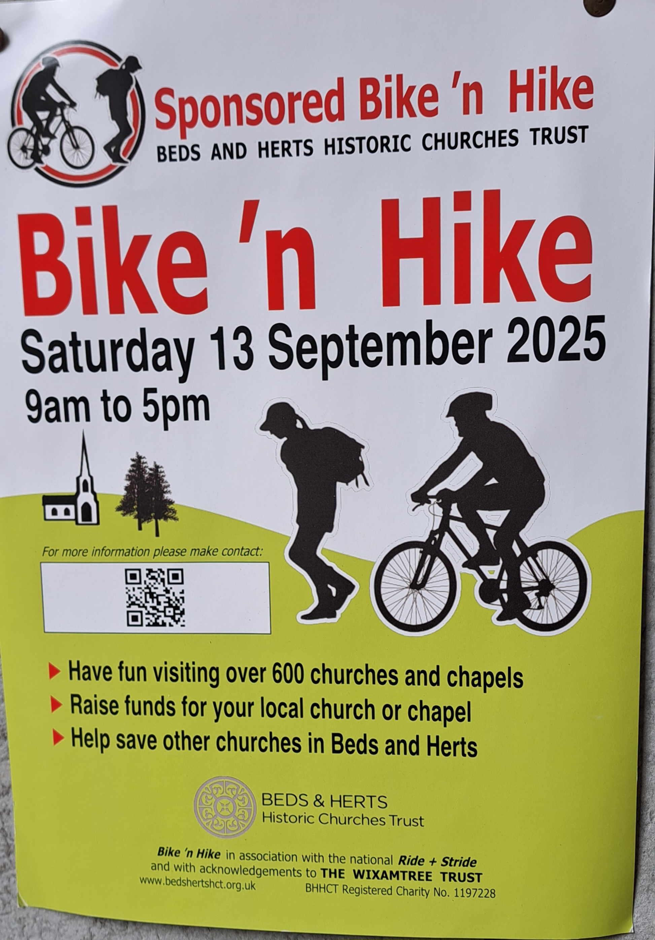a in church. All welcome.

**Saturday 13th September** Beds and Herts Historic Churches Trust Sponsored Bike ‘n Hike 9am to 5pm. [Make it lucky 13 this year - Beds & Herts Historic Churches Trust](https://bedshertshct.org.uk/bike-n-hike/)

**Sunday 14th September** Waterford Village Fete. Keep the date free.

**Last Sunday there was a Classic car show on Centre field in Aston.** Thank you to everyone who displayed a car and supplied refreshments. We would like to thank all who contributed and made delicious cakes and biscuits and to everyone who came and supported the event.

**Collect Prayer for the ninth Sunday after Trinity**

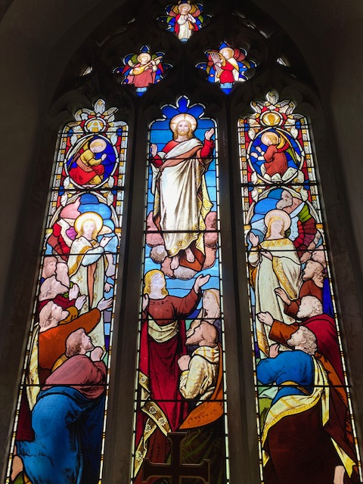

Almighty God, who sent your Holy Spirit to be the life and light of your Church: open our hearts to the riches of your grace, that we may bring forth the fruit of the Spirit in love and joy and peace; through Jesus Christ your Son our Lord, who is alive and reigns with you, in the unity of the Holy Spirit, one God, now and for ever. Amen

(The east window in St Andrew’s Church, Bramfield behind the altar shows Jesus lifted up to heaven, the end of his earthly life, his return to God’s right hand on high)

**PRAY for PEACE in ISRAEL and GAZA, UKRAINE and all areas of conflict**

Lord God, though peace seems humanly impossible,

we continue to pray for an end to violence and bloodshed.

We pray your comfort for the fearful and broken – hearted.

Change the hearts of those set on revenge and destruction.

Give wisdom to world leaders as they respond to aggression.

Bless all who work for understanding, reconciliation and justice which alone bring lasting peace. Amen.

‘God give us peace that lasts, not through the fear of might, but through the force of love, and love of life and right’. Amen

**Ascension Day to Pentecost worldwide** **9 days of prayer for** **‘Thy Kingdom Come’ hymn (**tune ‘Abide with me’) ….

*We seek your kingdom throughout every sphere*

*We long for heaven’s demonstration here*

*Jesus your light shine bright for all to see*

***Transform, revive, and heal society****.*

*Before all things, in him were all things made*

*Inspiring culture, media, and trade*

*May all our work serve your economy*

***Transform, revive, and heal society.***

*Peace, truth, and justice reigning everywhere*

*With us be present in our public square*

*Fill all who lead with your integrity*

***Transform, revive, and heal society.***

*Forgive us Lord, when we have not engaged*

*Failing to scribe your heart on history’s page*

*Make us again what we were made to be*

***Transform, revive, and heal society***

*Faithful to govern ever may we be*

*Selfless in service, loving constantly*

*In everything may your authority*

***Transform, revive, and heal society.***

(NOEL ROBINSON, ANDY FLANNAGAN, & GRAHAM HUNTER)

If you are struggling in the heat, please take care and ensure you drink enough water to remain hydrated. A hat would keep some of the heat off if you are walking to church.

We believe that responding to the climate crisis is an essential part of our responsibility to safeguard God's creation and achieve a just world. Climate change hits hardest the poorest countries and poorest people of the world. Meantime, the widespread destruction of the natural world is a crisis for creation.

Our Environment Programme exists to enable the whole Church to address this — in faith, practice and mission. This includes tackling our own carbon emissions (aiming for Net Zero Carbon by 2030) and our wider work. More information can be found using the following weblink: [http://www.churchofengland.org/about/church-england-environment-programme#na](http://www.churchofengland.org/about/church-england-environment-programme" \l "na)

Energy Hub Funded by UK Government: Find out how to:

1. Save energy

2. Save money. Reduce energy bills

3. Reduce carbon. Improve energy footprint

4.Increase comfort

For useful resources and guidance on where to get started visit: [linktr.ee/energy_hub](http://linktr.ee/energy_hub)



<https://app.ecochurch.org/user/21703/summary>

Reduce single plastic use.

It’s likely that every toothbrush you have ever used, in your whole life, still exists, in a landfill somewhere. There are now biodegradable bamboo ones and biodegradable dental floss too. Why not try them.

In these dry summer months don't forget to leave some water out for wildlife. A shallow dish of fresh water is good for birds, hedgehogs and many insects, keeping them hydrated and cool.  If you have the space, a bigger long term project might be to create a pond in your garden.

**CARING for our CHURCHYARDS**

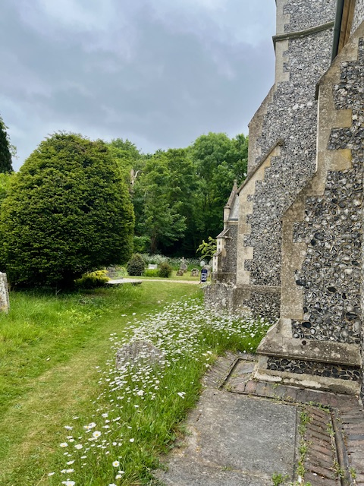**TUESDAYS Waterford** Working Parties – Contact Churchwarden Malcolm Wandrag to offer help [**m.t.wandrag@gmail.com**](mailto:m.t.wandrag@gmail.com)

To help in **Stapleford or Watton or Bramfield please** contact the Churchwardens.**ASTON church** open Sundays 12.00-16.00 and Wednesdays 10.00 -17.00 Church and churchyard working parties first Tuesday of month 10am to 12 noon. Contact Churchwarden Sara [**wardenstmarys@gmail.com**](mailto:wardenstmarys@gmail.com)

**All our churchyards are cared for by volunteers.**

**Donations and offers of help are welcomed.**

**To include a loved one in the Book of Remembrance contact the churchwardens**

**Prayer for Growth for Aston, Bramfield, Stapleford, Waterford and Watton at Stone**

Jesus teaches us to pray for our churches to grow. Jesus says: *‘Ask the Lord of the harvest, therefore, to send out workers into his harvest field’* (Matthew 9:38). In ways we don’t understand, God uses all our prayers.

**Heavenly Father, you call us to sow seeds of** **faith in our communities. We ask you to fill us with your Holy Spirit that our lives may show the joy and new life we have in you. Guide our speaking and actions that others may be drawn to know your love. Lord Jesus, bless our churches that we may grow in numbers, love and service. We ask this in your name. Amen.**

We pray for others to know God’s love.

Tie 5 knots in a piece of string - let each knot represent a friend or family member. Keep the string in your pocket and, as you feel the string, pray for those people to know God’s love. Set an alert on your phone to remind you to pray for those 5 people every day.

**A prayer for those who seek to know God.**

**Lord Jesus, when your followers walked the Emmaus road wondering what was true and what was not, you came alongside them and revealed yourself in Scripture and in broken bread. Come alongside those we know and love who may wonder or seek at this time. Especially we pray for.... Reveal yourself in your love and make us ready to walk alongside them too, until they see your face and know your presence. Amen.**

**Heavenly father we pray for guidance for our Beane valley benefice churches during the vacancy. Amen.**

**InTouch Age UK Hertfordshire**

offer confidential, non-judgemental emotional and practical support on bereavement, physical & mental health issues, cancer, end of life, a partner with dementia or any other problem. Call **01992 634964/630623** or email  [intouch@ageukherts.org.uk](mailto:intouch@ageukherts.org.uk) Web page  [Age UK Hertfordshire | Our Services](https://www.ageuk.org.uk/hertfordshire/our-services/)

**Bereavement Support** **You can access online help** at  [griefshare.org](http://griefshare.org/)

[thebereavementjourney.org](https://www.thebereavementjourney.org/) [cruse.org.uk](http://cruse.org.uk/)  [teardropgrief.co.uk](http://teardropgrief.co.uk/)  [ataloss.org](http://ataloss.org/)

|  |
| --- |
|  |



’s



afternoon

Tea

rty

at 64 Rivershill

Sunday 24th July 2.00-5.oopm



Bring & Buy <> Raffle <> Jams



**Proceeds to Both**

**TAKE AWAY AVAILABLE**