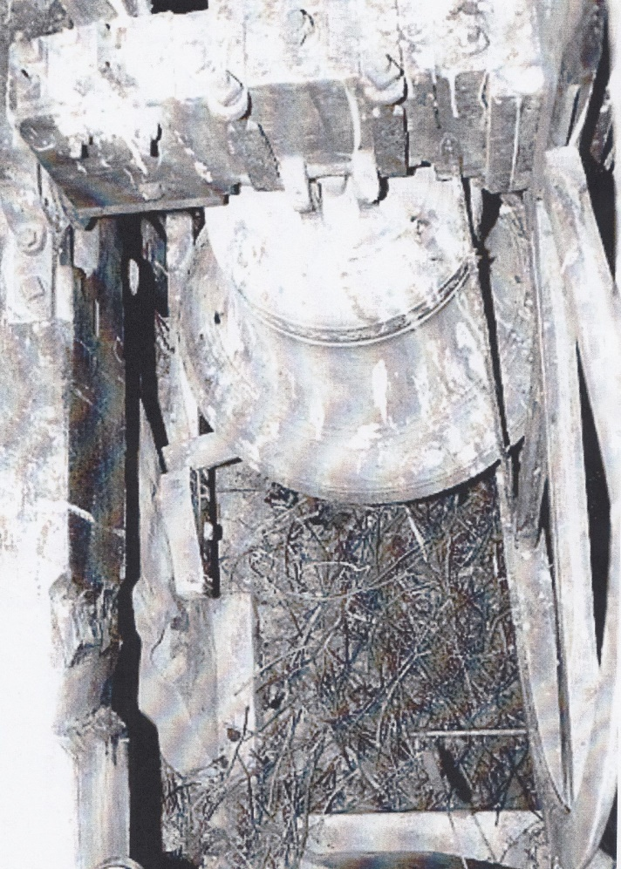The photograph left shows the remains of jackdaw nests that surrounded the bells; the entire chamber was littered with this debris.

A working party of bell ringers was set up, to clear the rubbish and restore the bells. Amongst the lunatics who volunteered to undertake this were Barry Lewis (Chetwynd tower captain), John Stokes, Edric Broom (Edgmond tower captain) and Andy Parkes (also behind the lens).

Many rubbish bags were filled with the twigs used for the nests along with mortal remains of some deceased birds; not a pleasant task. These were lowered to the ground on ropes; being passed through the west window after the louvres had been removed. The bell wheels and clappers were dismantled and similarly transferred to the bottom of the tower, where other members of the party awaited to receive them.

The photographs below show John Stokes and Barry Lewis (tower captain) undertaking some of these tasks.

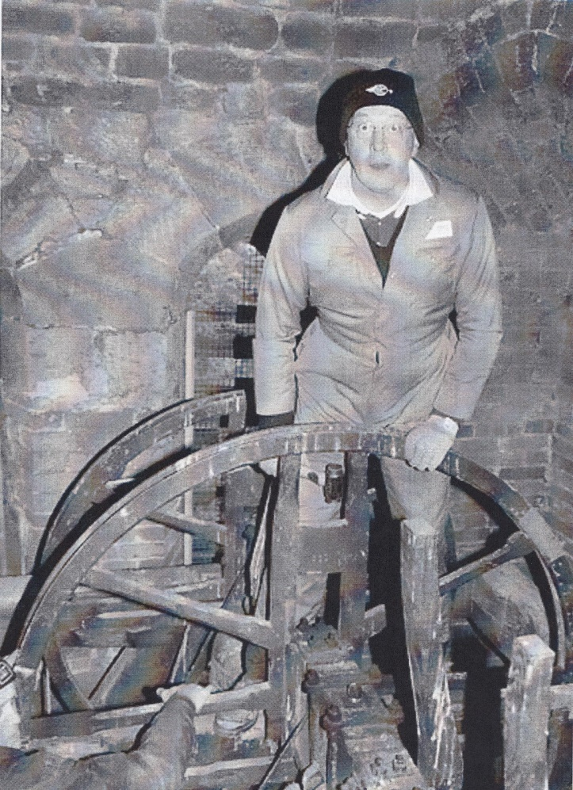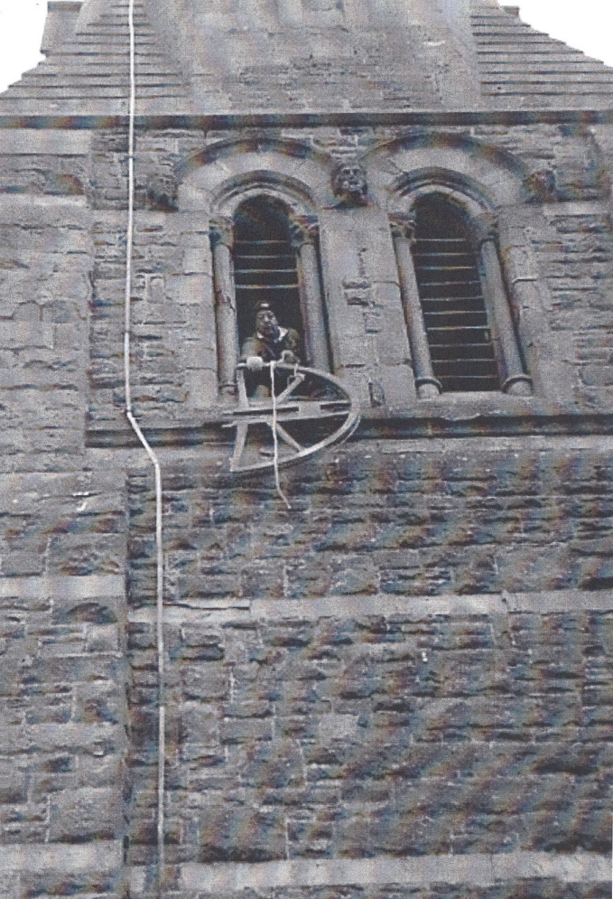

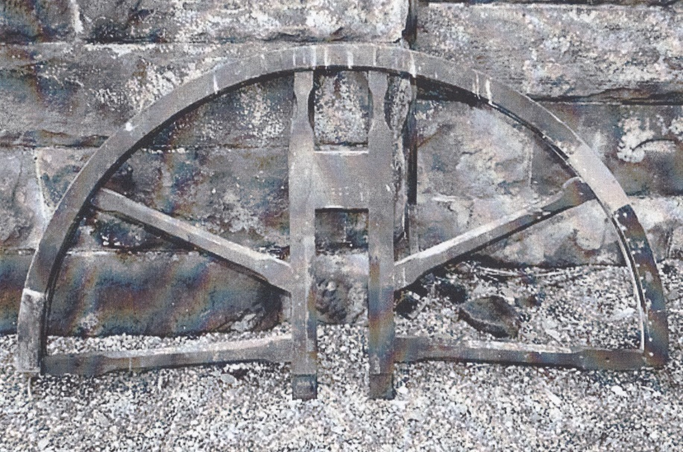The image left show a part of the bell wheel that was lowered (to the base of the tower).

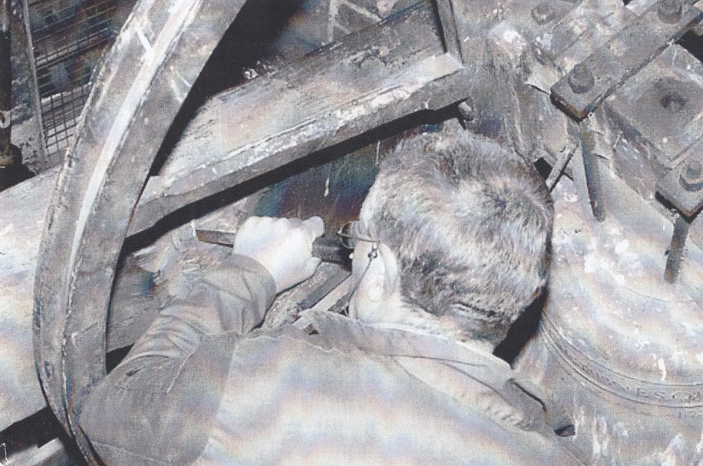This image shows Edric adjusting the frame to ensure that the bell did not catch on it.

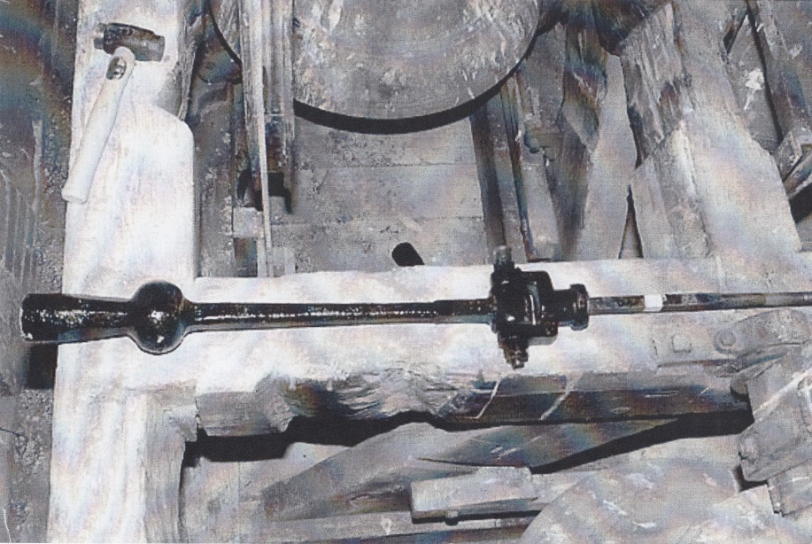This image shows the refurbished clapper about to be reinstated into the bell.

Note how clean everything now is: compare this to the first photograph.