**The following Photographs were taken (and annotated) by Smith of Derby; during the 2014 clock face restoration:**

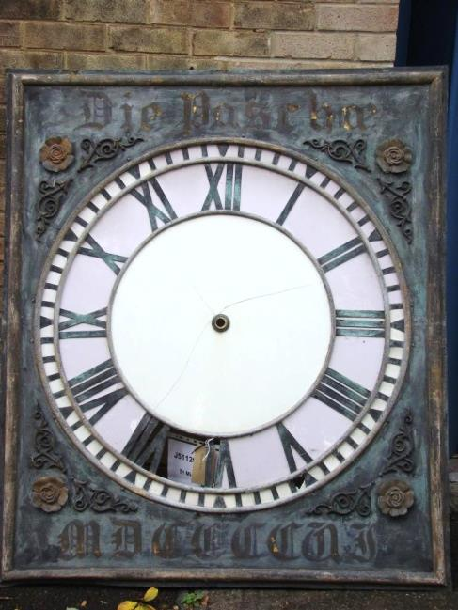

Dial as received, before restoration

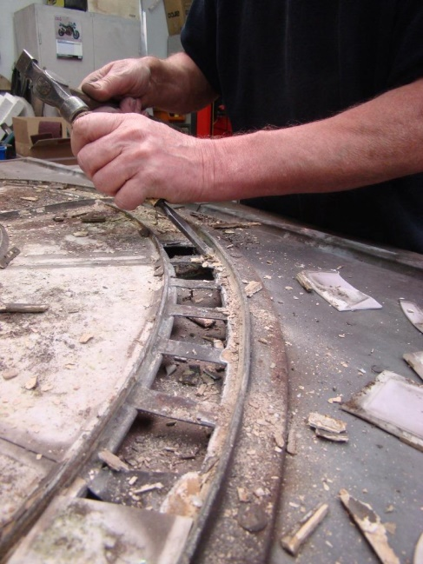

Removing the old glazing

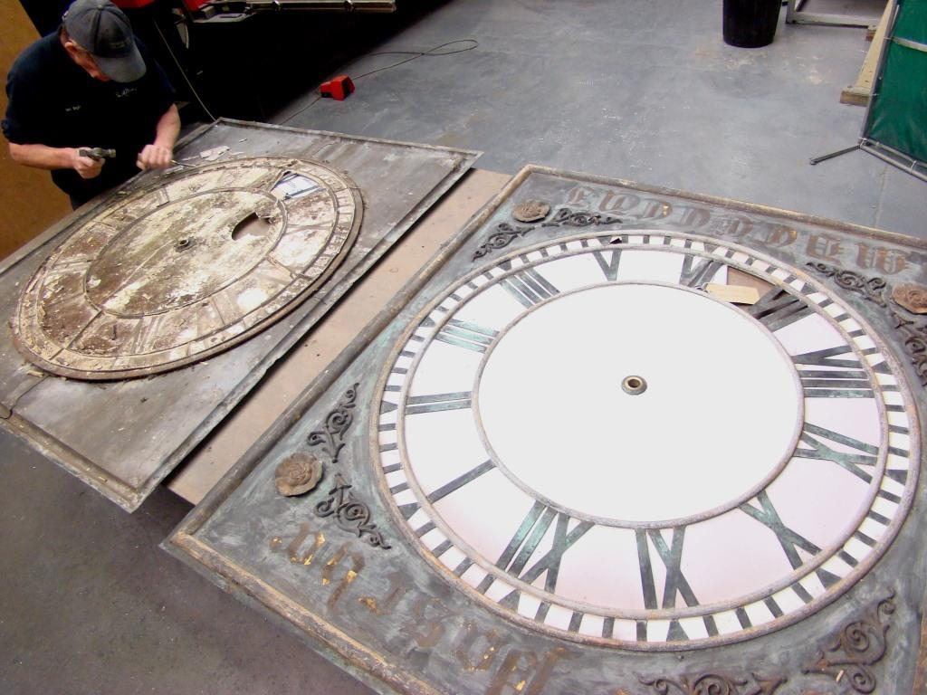

Removing the old glazing

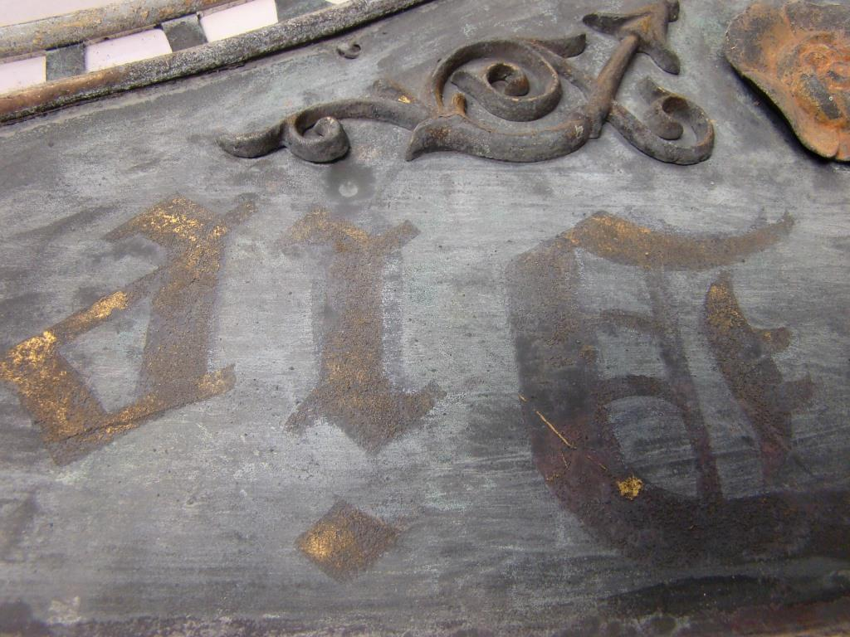

Close up of the inscription before restoration

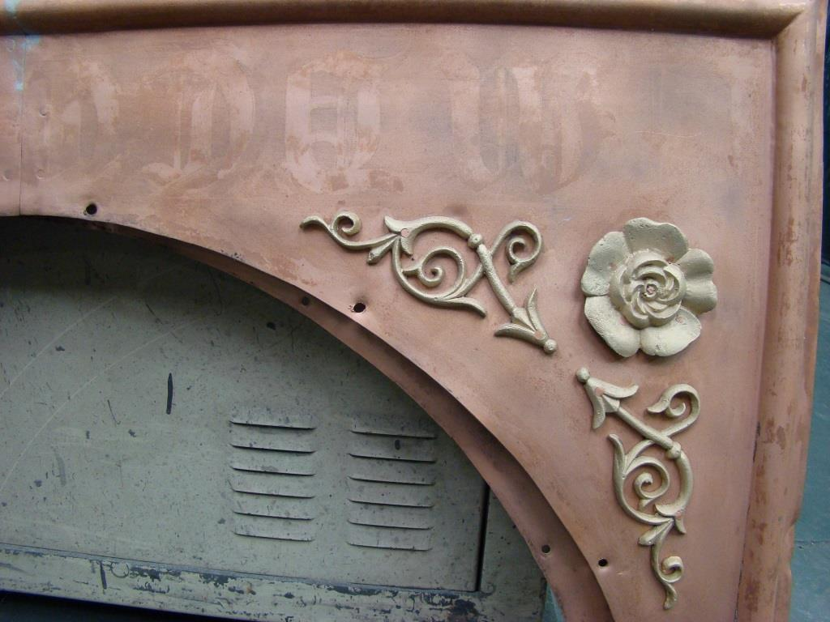

Repaired fabricated copper dials prior to repainting

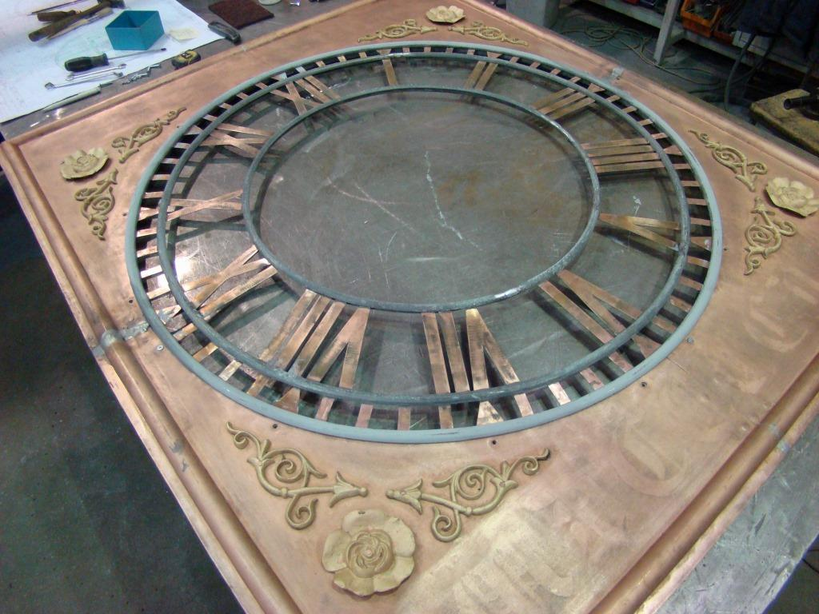

Repaired fabricated copper dials prior to repainting

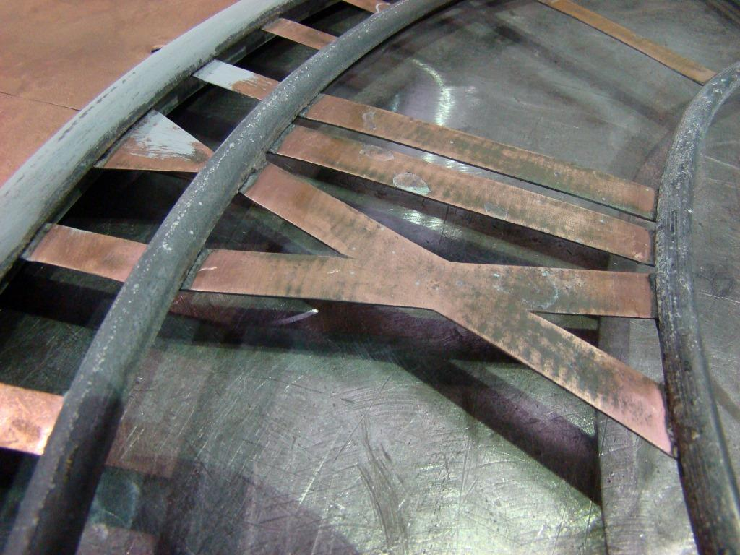

Repaired fabricated copper dials prior to repainting

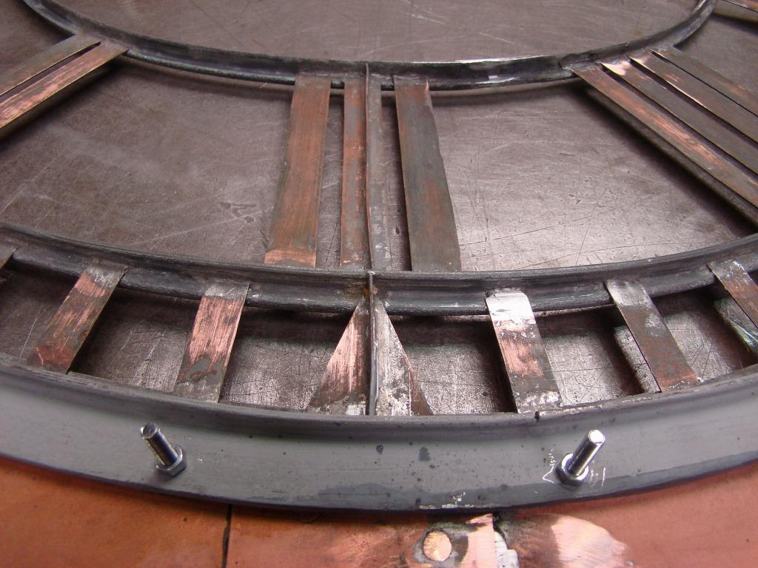

Repaired fabricated copper dials prior to repainting

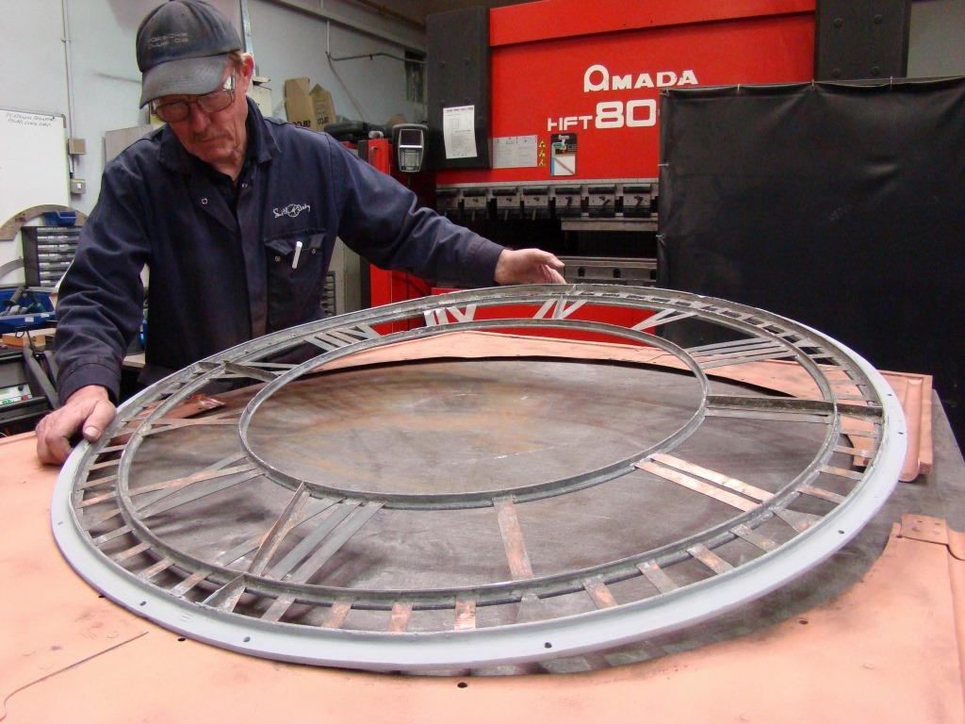

Repaired fabricated copper dials prior to repainting

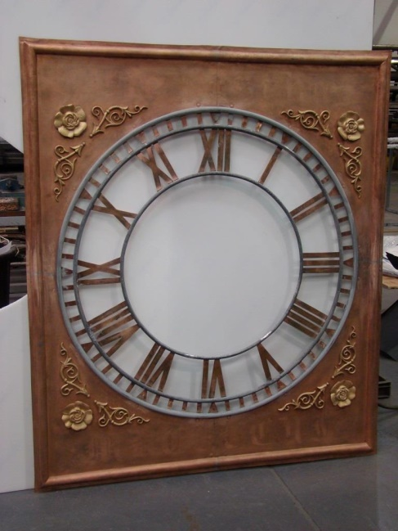

Repaired fabricated copper dials prior to repainting

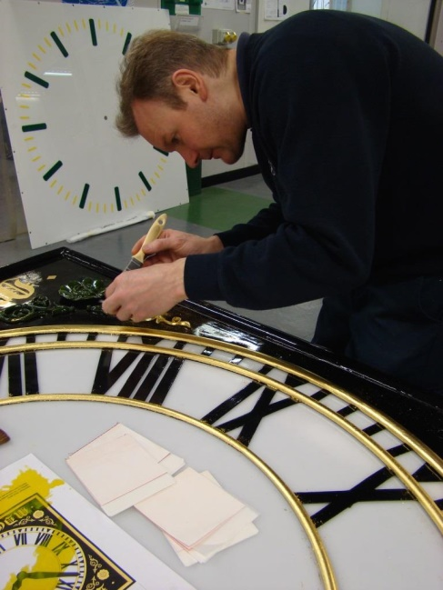

Gilding the painted dials

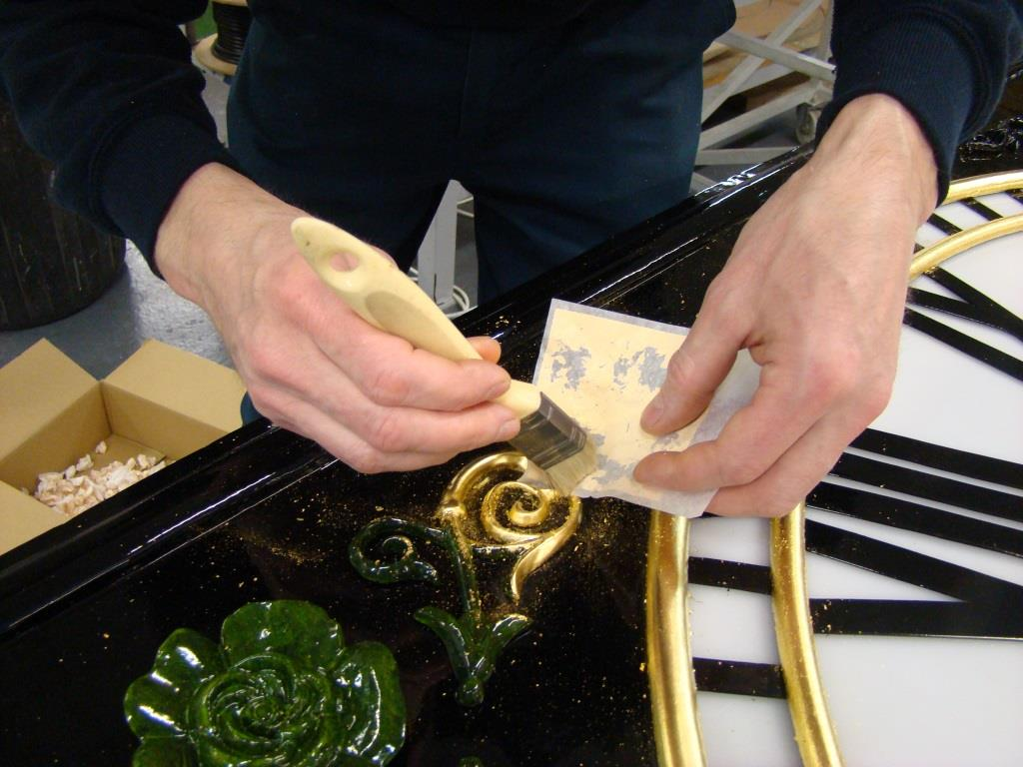

Gilding the painted dials

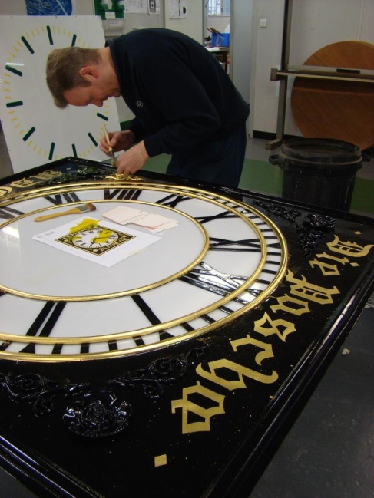

Gilding the painted dials

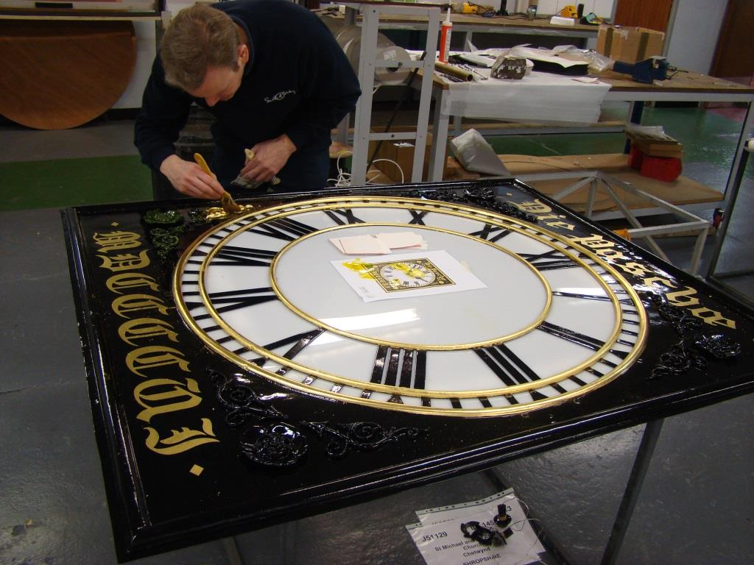

Gilding the painted dials

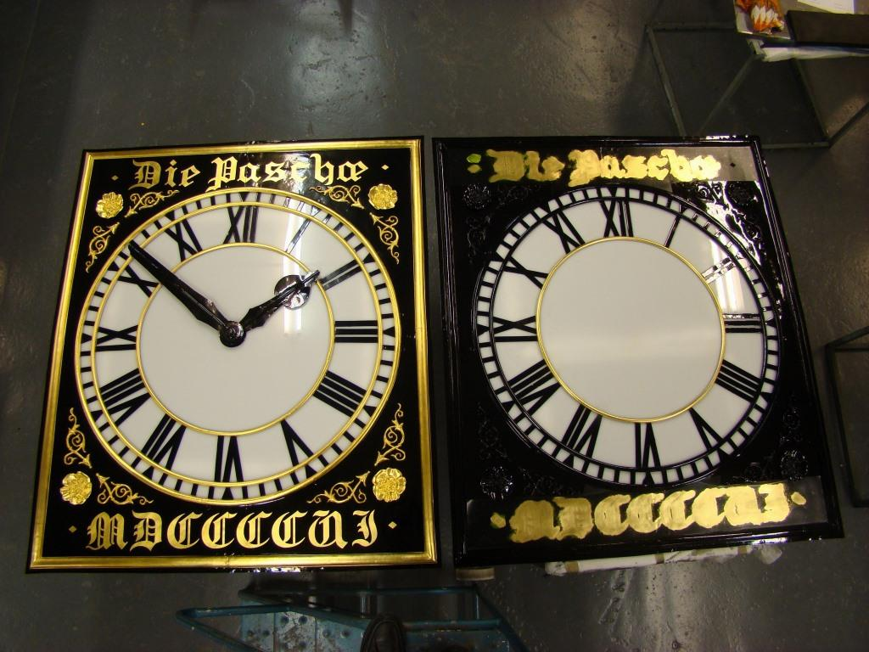

Finished gilded dial and part finished gilding

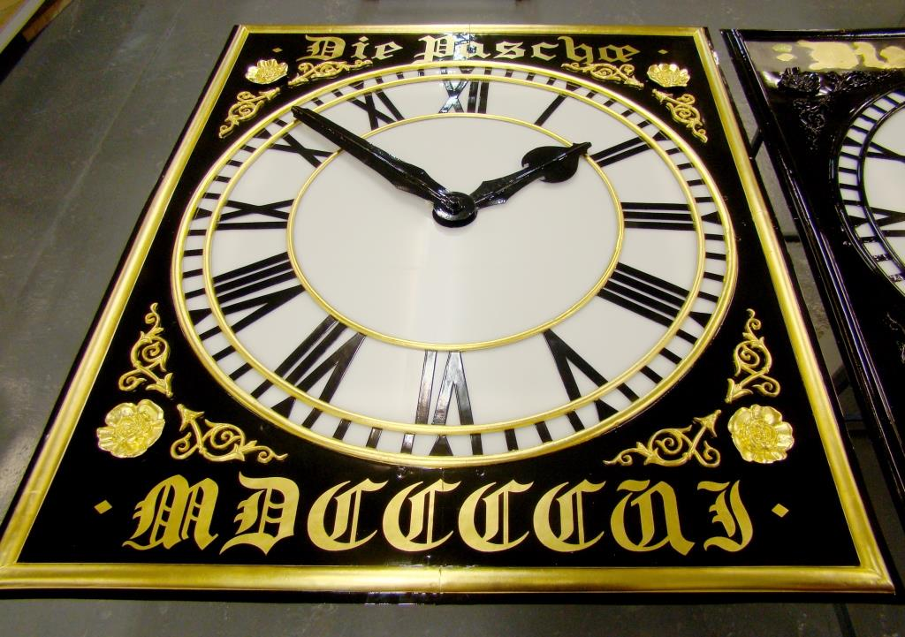

Finished gilded dial

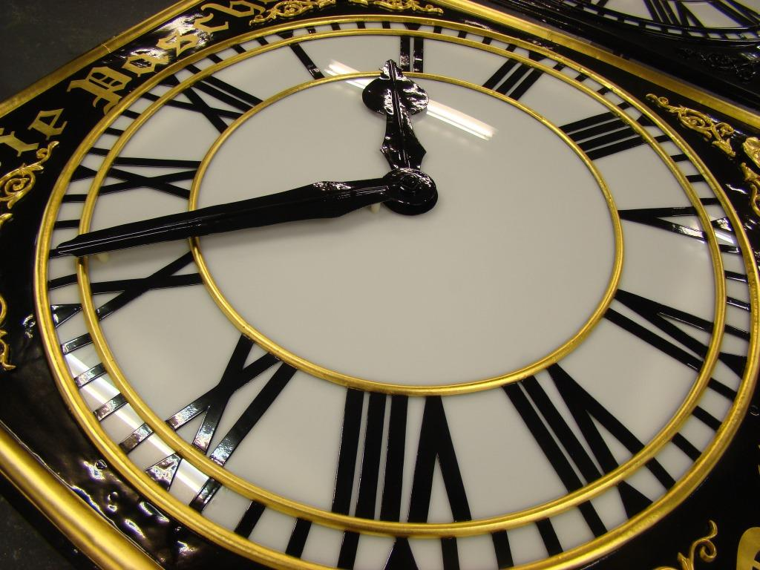

Finished gilded dial

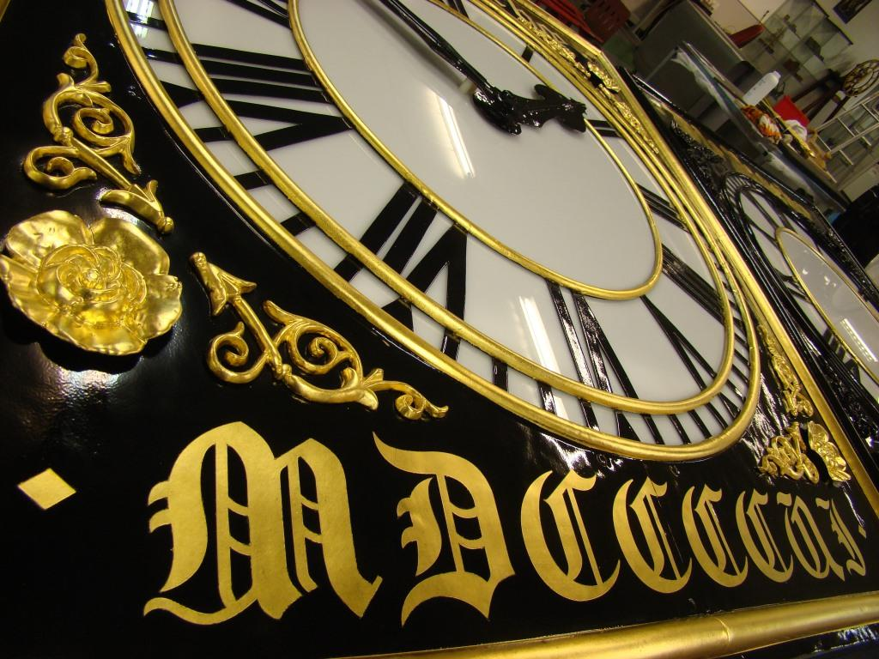

Finished gilded dial

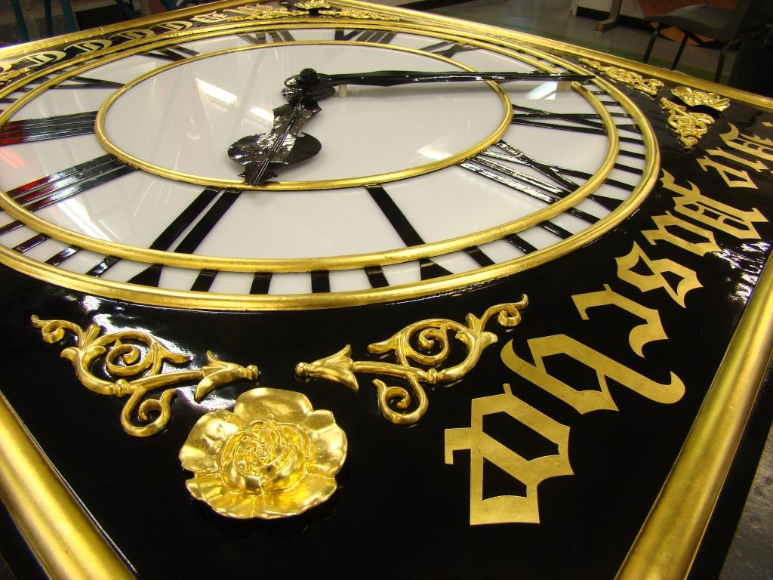

Finished gilded dial

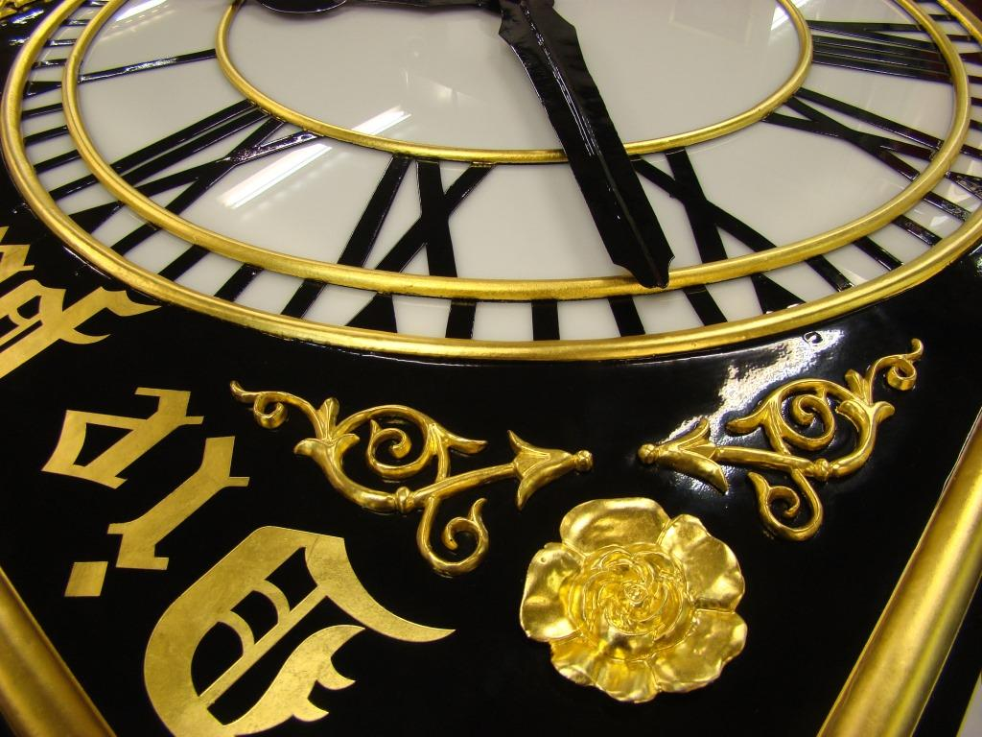

Finished gilded dial

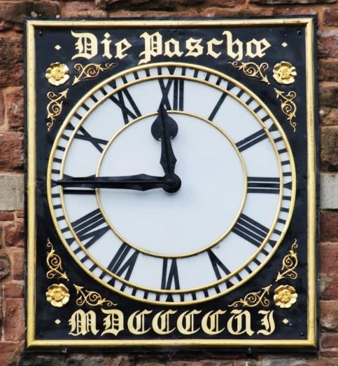

The finished article, back on the east side of the tower