PROCESSIONAL HYMN 558
Praise and Thanksgiving, Father we Offer



OPENING RESPONSES
In the name of the Father
and of the Son
and of the Holy Spirit.
Amen.

God in Christ has revealed his glory.
Come let us worship.

From the rising of the sun to its setting
the Lord’s name is greatly to be praised.

Give him praise, you servants of the Lord.
O praise the name of the Lord!

WELCOME

Prayer of preparation
Almighty God,
to whom all hearts are open, all desires known, and from whom no secrets are hidden: cleanse the thoughts of our hearts by the inspiration of your Holy Spirit, that we may perfectly love you, and worthily magnify your holy name; through Christ our Lord. Amen.

Confession
The gospel calls us to turn away from sin
and be faithful to Christ. As we offer ourselves to him in penitence and faith,
we renew our confidence and trust in his mercy.

Christ came in humility to share our lives:
forgive our pride.
Lord, have mercy.
Lord, have mercy.

Christ came with good news for all people:
forgive our silence.
Christ, have mercy.
Christ, have mercy.
Christ came in love to a world of suffering:
forgive our self-centredness.
Lord, have mercy.
Lord, have mercy.

ABSOLUTION
May God who loved the world so much
that he sent his Son to be our Saviour
forgive us our sins and make us holy to serve him in the world, through Jesus Christ our Lord. Amen.

GLORIA (stand)
Glory to God in the highest
and peace to his people on earth.
Lord God, heavenly King, almighty God and Father, we worship you, we give you thanks, we praise you for your glory.

Lord Jesus Christ, only Son of the Father, Lord God, Lamb of God, you take away the sin of the world: have mercy on us; you are seated at the right hand of the Father: receive our prayer.

For you alone are the Holy One, you alone are the Lord, you alone are the Most High, Jesus Christ, with the Holy Spirit, in the glory of God the Father.
Amen.

COLLECT
Creator God, you made us all in your image: may we discern you in all that we see, and serve you in all that we do;
through Jesus Christ our Lord. Amen.

READING: Proverbs 25:6-7
A reading from the book of Proverbs.
Do not put yourself forward in the king’s presence or stand in the place of the great; for it is better to be told, ‘Come up here’, than to be put lower in the presence of a noble.

This is the word of the Lord.
Thanks be to God.
PSALM: 112

1 O praise the Lord. Blessèd is the man who | fears the | Lord:
and greatly de|lights in | his com|mandments.
2 His children shall be | mighty · in the | land:
a race of upright | men who | will be | blessed.
3 Riches and plenty shall be | in his | house:
and his | righteous·ness | stands for | ever.
4 Light arises in darkness | for the|upright:
gracious and merciful | is the | righteous | man.
5 It goes with the man who acts | generously · and | lends:
who | guides · his af|fairs with | justice.
6 Surely he shall | never · be | moved:
the righteous shall be held in | ever|lasting · re|membrance.
7 He will not | fear bad | tidings:
his heart is steadfast | trusting | in the | Lord.
8 His heart is confident and | will not|fear:
he will see the | downfall | of his | enemies.
9 He gives | freely · to the | poor:
his righteousness stands for ever
his | head is · up|lifted · in | glory.
10 The wicked man shall see it | and be | angry:
he shall gnash his teeth and consume away and the | hope · of the | wicked · shall | fail.

READING: Hebrews 13.1–8, 15–16
A reading from the letter to the Hebrews.
Let mutual love continue. Do not neglect to show hospitality to strangers, for by doing that some have entertained angels without knowing it. Remember those who are in prison, as though you were in prison with them; those who are being tortured, as though you yourselves were being tortured. Let marriage be held in honour by all, and let the marriage bed be kept undefiled; for God will judge fornicators and adulterers. Keep your lives free from the love of money, and be content with what you have; for he has said, ‘I will never leave you or forsake you.’ So we can say with confidence, ‘The Lord is my helper; I will not be afraid. What can anyone do to me?’ Remember your leaders, those who spoke the word of God to you; consider the outcome of their way of life, and imitate their faith. Jesus Christ is the same yesterday and today and for ever.

Through him, then, let us continually offer a sacrifice of praise to God, that is, the fruit of lips that confess his name. Do not neglect to do good and to share what you have, for such sacrifices are pleasing to God.

This is the word of the Lord.
Thanks be to God.

HYMN 186
For the Healing of the Nations

GOSPEL READING: Luke 14:1,7-14
Alleluia, alleluia, alleluia, alleluia.
Alleluia, alleluia, alleluia, alleluia.

We do not live by bread alone,
but by every word that comes from the mouth of God.

Alleluia, alleluia, alleluia, alleluia.
Alleluia, alleluia, alleluia, alleluia.

Hear the Gospel of our Lord Jesus Christ according to Luke.
Glory to you, O Lord.

On one occasion when Jesus was going to the house of a leader of the Pharisees to eat a meal on the sabbath, they were watching him closely. When he noticed how the guests chose the places of honour, he told them a parable. ‘When you are invited by someone to a wedding banquet, do not sit down at the place of honour, in case someone more distinguished than you has been invited by your host; and the host who invited both of you may come and say to you, “Give this person your place,” and then in disgrace you would start to take the lowest place. But when you are invited, go and sit down at the lowest place, so that when your host comes, he may say to you, “Friend, move up higher”; then you will be honoured in the presence of all who sit at the table with you. For all who exalt themselves will be humbled, and those who humble themselves will be exalted.’ He said also to the one who had invited him, ‘When you give a luncheon or a dinner, do not invite your friends or your brothers or your relatives or rich neighbours, in case they may invite you in return, and you would be repaid. But when you give a banquet, invite the poor, the crippled, the lame, and the blind. And you will be blessed, because they cannot repay you, for you will be repaid at the resurrection of the righteous.’

This is the Gospel of the Lord.
Praise to you, O Christ.

SERMON

CREED
We believe in one God, the Father,
the Almighty, maker of heaven and earth, of all that is, seen and unseen.

We believe in one Lord, Jesus Christ, the only Son of God, eternally begotten of the Father, God from God, Light from Light, true God from true God, begotten, not made, of one Being with the Father; through him all things were made.
For us and for our salvation he came down from heaven, was incarnate from the Holy Spirit and the Virgin Mary and was made man. For our sake he was crucified under Pontius Pilate; he suffered death and was buried. On the third day he rose again in accordance with the Scriptures; he ascended into heaven and is seated at the right hand of the Father. He will come again in glory to judge the living and the dead, and his kingdom will have no end.

We believe in the Holy Spirit, the Lord, the giver of life, who proceeds from the Father and the Son, who with the Father and the Son is worshipped and glorified, who has spoken through the prophets.

We believe in one holy catholic and apostolic Church. We acknowledge one baptism for the forgiveness of sins. We look for the resurrection of the dead, and the life of the world to come.
Amen.

INTERCESSIONS
Lord, in your mercy,
hear our prayer.

Merciful Father,
accept these prayers for the sake of your Son, our Saviour, Jesus Christ. Amen.

PEACE
Jesus said: ‘Love one another. As I have loved you, so you are to love one another.’
The peace of the Lord be always with you.
and also with you.

OFFERTORY HYMN
All the room was hushed and still
And when the bowl was filled
He stooped to wash their feet
And when it was complete, he said

"This is what I'm asking you to do
This is why I'm kneeling here beside you
This is what I want my church to be
This is what I want the world to see
Who it is you follow"
Love each other, one another
Love each other
in the way that I have loved you
Walk together and whatever comes
Love each other
in the way that I have loved you

Let the room be hushed and still
Let us go to where he kneels
And join him as he serves
And learn his ways of love, he said

Chorus

PREPARATION OF THE TABLE
Blessed are you, Lord God of all creation:
through your goodness we have this bread to set before you, which earth has
given and human hands have made.
It will become for us the bread of life.
Blessed be God for ever.

Blessed are you, Lord God of all creation:
through your goodness we have this wine to set before you, fruit of the vine and work of human hands.
It will become for us the cup of salvation.
Blessed be God for ever.

OFFERTORY PRAYER
Yours, Lord, is the greatness, the power, the glory, the splendour, and the majesty;
for everything in heaven and on earth
is yours.
All things come from you,
and of your own do we give you.

EUCHARISTIC PRAYER F
The Lord is here.
His Spirit is with us.

Lift up your hearts.
We lift them to the Lord.

Let us give thanks to the Lord our God.
It is right to give thanks and praise.

You are worthy of our thanks and praise,
Lord God of truth, for by the breath of your mouth you have spoken your word,
and all things have come into being.

You fashioned us in your image and placed us in the garden of your delight.
Though we chose the path of rebellion you would not abandon your own. Again and again you drew us into your covenant of grace. You gave your people the law and taught us by your prophets to look for your reign of justice, mercy and peace.

As we watch for the signs of your kingdom on earth, we echo the song of the angels in heaven, evermore praising you and saying:

SANCTUS (sung)
Holy, holy, holy Lord,
God of power and might,
heaven and earth are full of your glory. Hosanna in the highest.

Blessed is he who comes in the name of the Lord. Hosanna in the highest.

Lord God, you are the most holy one,
enthroned in splendour and light, yet in the coming of your Son Jesus Christ you reveal the power of your love made perfect in our human weakness.

Embracing our humanity, Jesus showed us the way of salvation; loving us to the end, he gave himself to death for us; dying for his own, he set us free from the bonds of sin, that we might rise and reign with him in glory.

On the night he gave up himself for us all
he took bread and gave you thanks; he broke it and gave it to his disciples, saying:
Take, eat; this is my body which is given for you; do this in remembrance of me.

In the same way, after supper he took the cup and gave you thanks; he gave it to them, saying:
Drink this, all of you; this is my blood of the new covenant which is shed for you and for many for the forgiveness of sins.
Do this, as often as you drink it, in remembrance of me.

Therefore we proclaim the death that he suffered on the cross, we celebrate his resurrection, his bursting from the tomb,
we rejoice that he reigns at your right hand on high and we long for his coming in glory.

As we recall the one, perfect sacrifice of our redemption, Father, by your Holy Spirit let these gifts of your creation be to us the body and blood of our Lord Jesus Christ; form us into the likeness of Christ and make us a perfect offering in your sight.

Look with favour on your people and in your mercy hear the cry of our hearts. Bless the earth, heal the sick, let the oppressed go free and fill your Church with power from on high.

Gather your people from the ends of the earth to feast with St Stephen and all your saints at the table in your kingdom, where the new creation is brought to perfection in Jesus Christ our Lord; by whom, and with whom, and in whom, in the unity of the Holy Spirit, all honour and glory be yours, almighty Father, for ever and ever. Amen.

THE LORD’S PRAYER (sung)
As our Saviour taught us, so we pray;
Our Father in heaven,
hallowed be your name,
your kingdom come,
your will be done,
on earth as in heaven.
Give us today our daily bread.
Forgive us our sins
as we forgive those who sin against us. Lead us not into temptation
but deliver us from evil.
For the kingdom, the power,
and the glory are yours
now and for ever.
Amen.

THE BREAKING OF THE BREAD
We break this bread to share in the body of Christ.
Though we are many, we are one body,
because we all share in one bread.

AGNUS DEI (sung)
Lamb of God,
you take away the sin of the world,
have mercy on us.

Lamb of God,
you take away the sin of the world,
have mercy on us.

Lamb of God,
you take away the sin of the world,
grant us peace.

GIVING OF COMMUNION
Jesus is the Lamb of God who takes away the sin of the world. Blessed are those who are called to his supper.
Lord, I am not worthy to receive you, but only say the word, and I shall be healed.

HYMNS DURING COMMUNION
143 Dearest Jesu, We Are Here
448 Meekness and Majesty
81 Bread is Blessed and Broken

PRAYERS AFTER COMMUNION
God of all mercy,
in this eucharist you have set aside our sins and given us your healing: grant that we who are made whole in Christ may bring that healing to this broken world, in the name of Jesus Christ our Lord.
Amen.

Almighty God,
we thank you for feeding us with the body and blood of your Son Jesus Christ.
Through him we offer you our souls and bodies to be a living sacrifice.
Send us out in the power of your Spirit
to live and work to your praise and glory.
Amen.

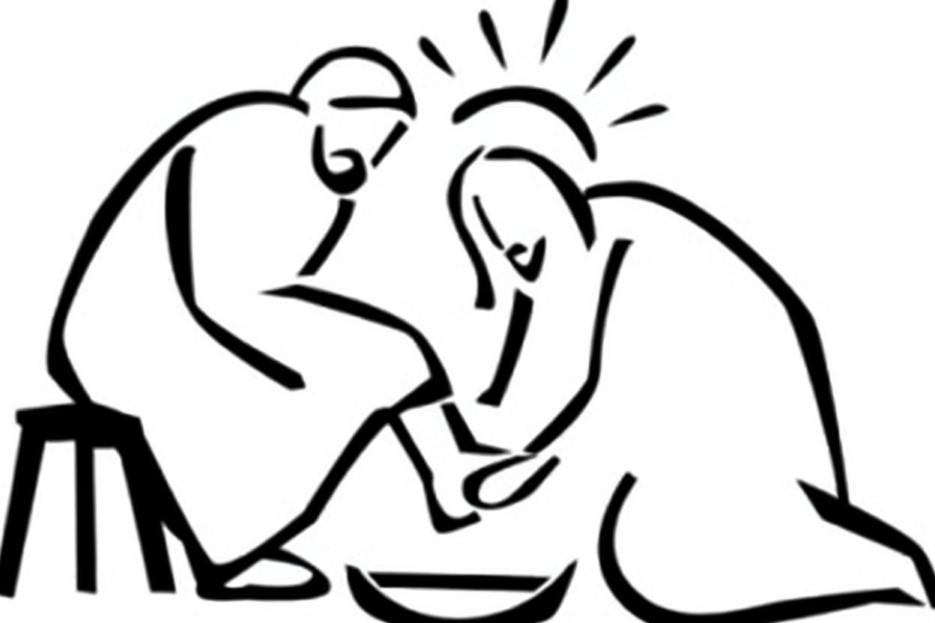

NOTICES

HYMN 19
All My Hope on God is Founded

CONCLUDING PRAYER & BLESSING
Lord Jesus Christ,
you humbled yourself in taking the form of a servant, and washed your disciples feet: give us the courage to follow your example and to proclaim you as Lord and King, to the glory of God the Father. Amen.

Go forth into the world in peace;
be of good courage;
hold fast that which is good;
render to no one evil for evil;
strengthen the fainthearted; support the weak; help the afflicted; honour everyone; love and serve the Lord,

and the blessing of God Almighty, the Father, the Son and the Holy Spirit be among you and remain with you always. Amen.

DISMISSAL
Go in peace to love and serve the Lord.
In the name of Christ. Amen.

