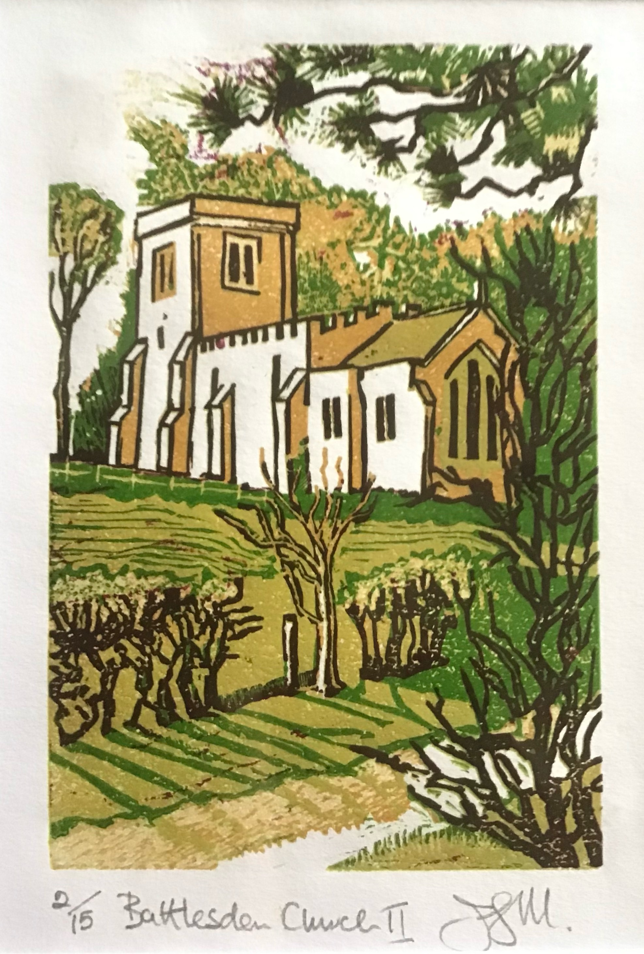
Battlesden and Potsgrove

A little history and background of two ‘Lost Villages’ of Bedfordshire.

Battlesden House

Situated only two miles from Potsgrove, the village of Battlesden was once the seat of one of the most spectacular buildings in Bedfordshire, Battlesden House. The original building, a manor house, was built in Elizabethan times and was said to have one of the finest dining rooms in England.

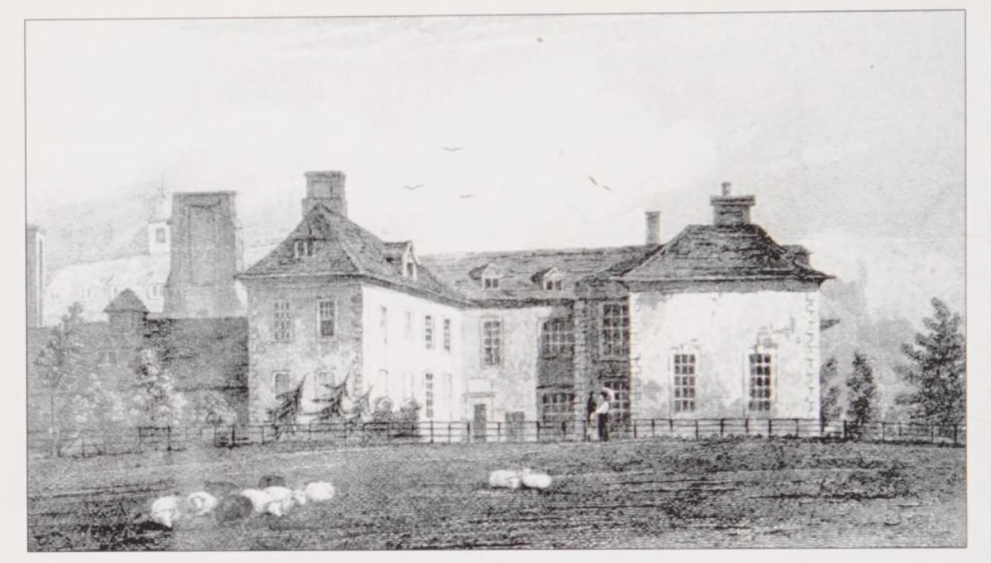

In 1706 Battlesden House was purchased by Allen Bathurst, member of Parliament for Cirencester and a highly active member of the Tory administration,

In 1711 the Princess Anne appointed him as her treasurer and on 1st January 1712 Bathurst was raised to the peerage by Queen Anne as Baron Bathurst of Battlesden, serving in the House of Lords until his death in 1775.

In 1775 the Page-Turner family bought the house and added an extra wing. When Sir Gregory Osborne Page-Turner moved to Battlesden he was not the best owner - he neglected the property and the church and was incarcerated for a while in the debtors prison at the Kings Bench in 1823, and certified insane in 1825. The property deteriorated rapidly and was demolished. He died in 1858 and buried in Battlesden Church - his memorial is the stained glass window above the altar, which was installed by his daughter.

In 1864 a much grander Battlesden House was commissioned by Sir Edward Page-Turner and designed in the style of a French Chateau. There were 40 rooms including a huge ballroom and cost £40,000 to erect. The grounds and lake were laid out by Sir Joseph Paxton, a local man from Milton Bryan who went on to build the Crystal Palace.
However, when it was completed Sir Edward didn’t like the property and leased it to David Bromilow, a wealthy Coal mine owner who resided there until he gave up the lease in 1885.

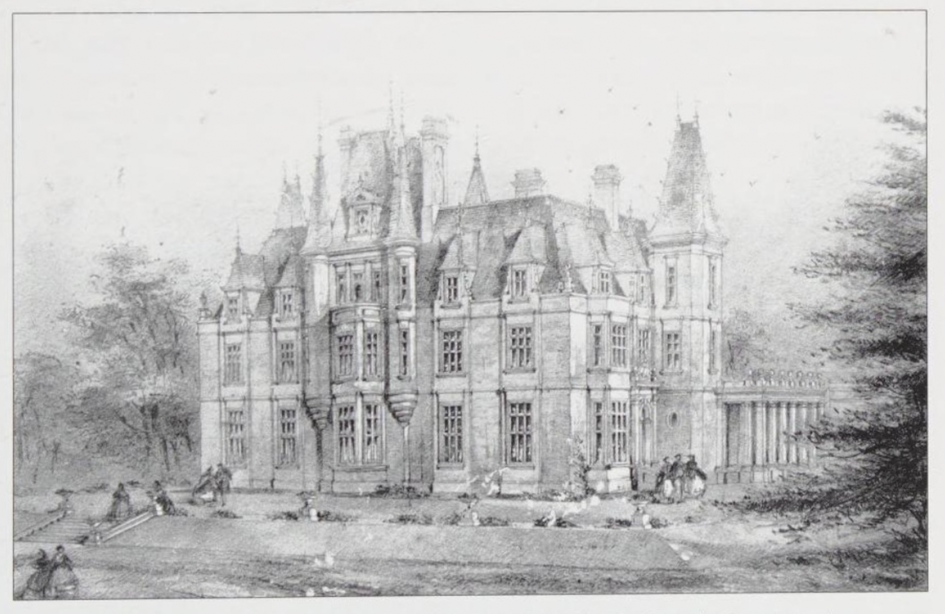

Potsgrove Manor

Potsgrove is first mentioned in the Domesday Book of 1086 as "Potesgraue", later as "Pottesgrove," and its origins can be dated back to the Manor of Potsgrove and the seven and a half hide holding of Jocelyn le Breton, where 12 men were recorded as living there - three villagers, six smallholders and three slaves, with perhaps an overall population of around 50 souls. The property later became the home to The Lucy’s in the 15th Century, The Corbet’s until the late 16th Century and then the Dunscome’s took over the land and merged the property with Blankfront Manor.

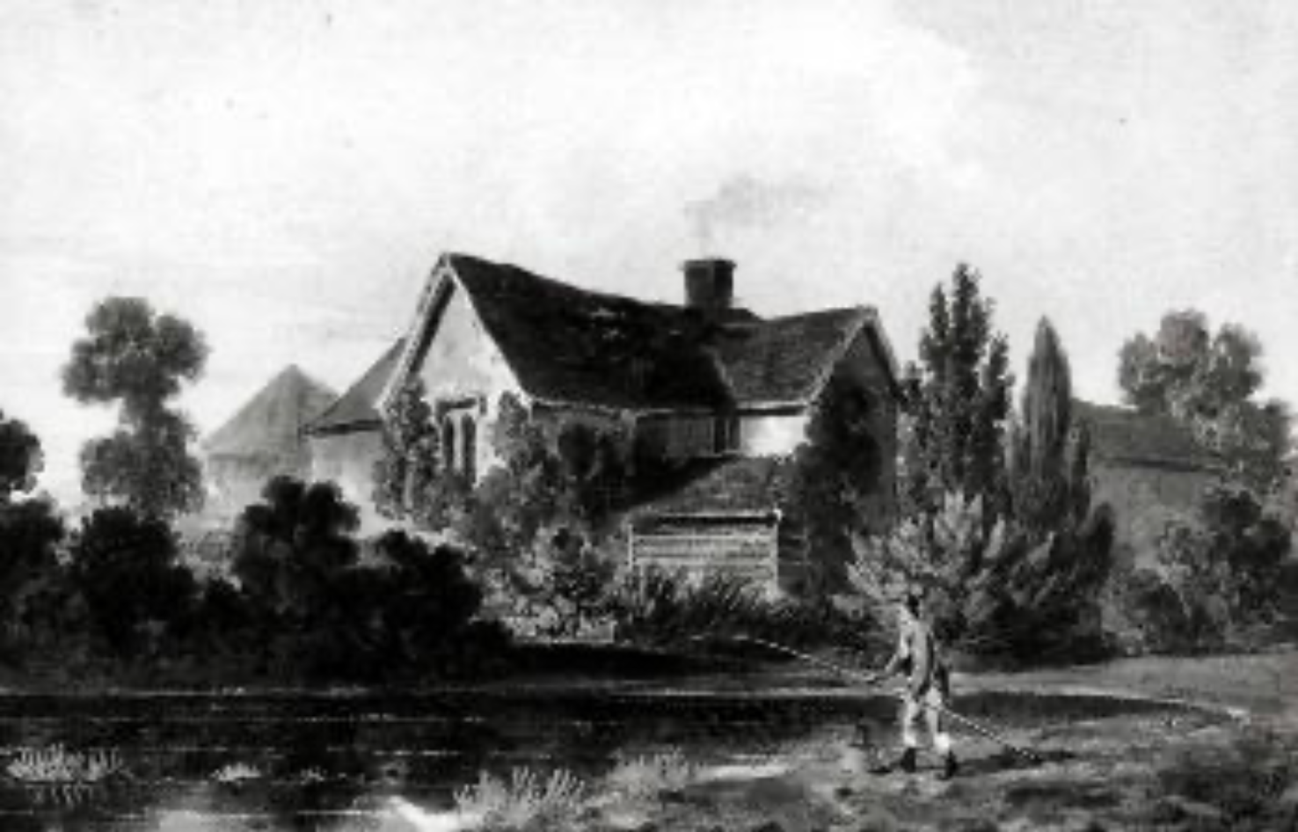

Potsgrove was a small farming community with little to remark upon, except for the presence off sheep Lane of two cock yards, the scene of heavy betting in the 17th century.

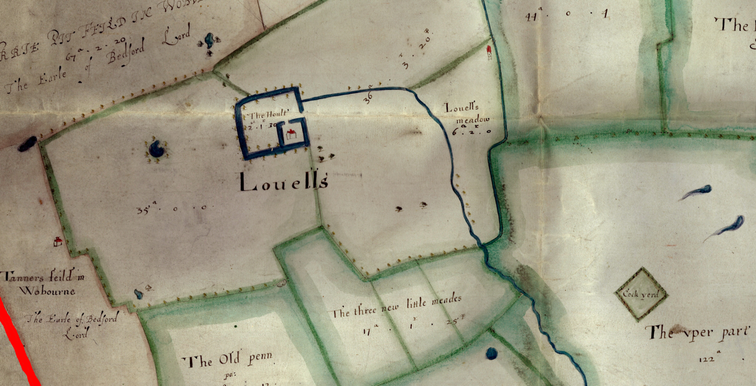

The small community around St Mary’s benefitted from a school, which in 1833 reported “One Daily and Sunday School, in which 6 boys and 6 girls attend daily, and 8 boys and 7 girls on Sundays; chiefly supported by the Rector, who pays £10 to the master and mistress”. The settlement also had a pub, known as the Sow and Pigs.

While Potsgrove has never been a large parish, the development of a settlement of workers in Sheep Lane in the mid 19th century led to a population in excess of 300. 400 yards from the Fox and Hounds on the corner of Watling Street (now the Flying Fox) the settlement also had a beerhouse in the nineteenth century, known as the Red Cow, where records give evidence of disorder, theft and a terrifying fracas which led to three local residents being sent down to the Leviathan prison hulk in Portsmouth before being transported to Tasmania for 7 years.

There was also a strong base of non-conformists in Sheep Lane which met in the Potsgrove Union Chapel, built in 1838 with seating for 110 worshippers. This was in addition to a Wesleyen Methodist chapel that had also been founded to the rear of the Fox and hounds in 1822 and a primitive Methodist chapel which was active in 1855. The presence of such worshippers must have been seen as a challenge to the vicar of St Mary’s.

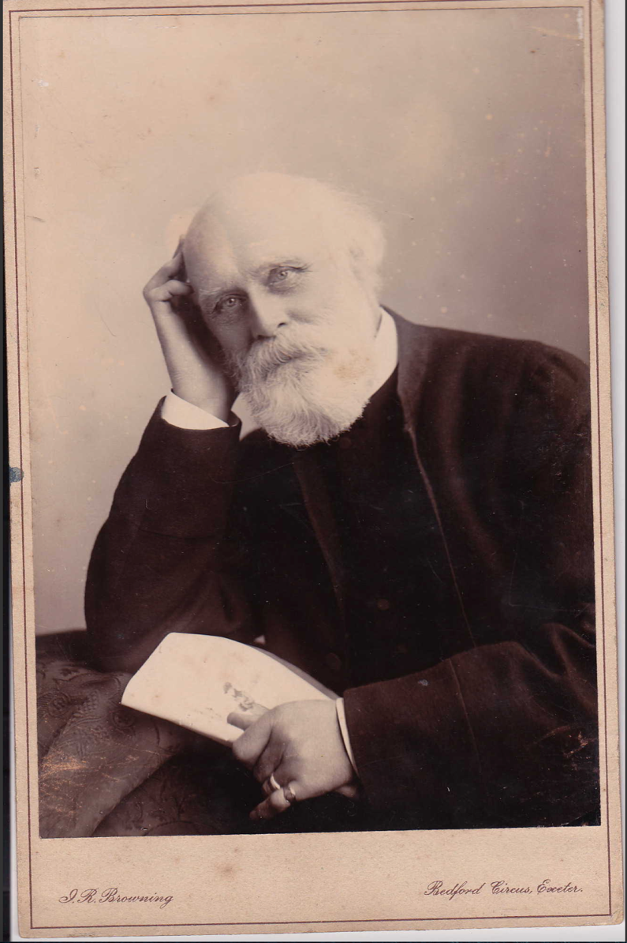
In 1862 the then Rector of St Mary’s, E. Norman Coles, built a fourth chapel almost opposite Potsgrove turn on Sheep Lane.

This chapel was dedicated to Saint John and also served as the parish’s school. The founding documents of the Revd Coles describe the population of Sheep Lane as being in desperate need of spiritual support “seeing the sunken condition and spiritual destitution of the inhabitants, he determined on opening a sanctuary for the celebration of divine worship.” Archived records show the school was providing education to the children of the agricultural workers who lived in Sheep Lane, and that it was difficult to keep going – teachers were not encouraged by undisciplined and truanting children. I

n 1895 the new teacher complained in the log book: “I find the children very talkative and noisy: and the First and Second Standard children are backward in their work, particularly in spelling”.

The Great Agricultural Depression of 1873-1896 caused the population of the parish to fall dramatically and by 1898, with the building of a new school building in Potsgrove, the chapel became a Sunday school and meeting room, finally being demolished in 1970. Today there are just a few scattered homes and The Flying Fox public house remaining on Sheep Lane.

The Parish Today

Although Battlesden with Potsgrove is part of the Woburn Group of Parishes they feel different, covering the largest plot of land and have the smallest population, currently two small communities totalling approximately 60 people living in a few farms, farm cottages and established individual homes.

The parish of Battlesden is about 3.5 miles from Woburn, while a couple of miles across the rolling fields is the hamlet of Potsgrove with its own 14th Century church of St Mary the Virgin.

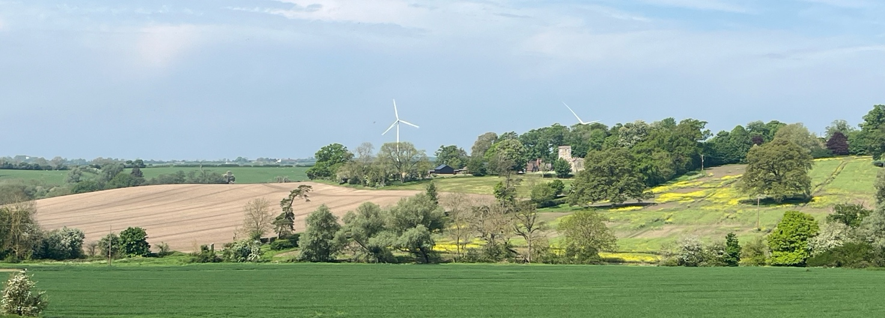

St Peter & All Saints Church, Battlesden occupies a very scenic position on a small ridge.

The Parish of Battlesden was joined in 1732 to the neighbouring Parish of Pottesgrave (Potsgrove). Both share one incumbent (Priest) and a combined vestry team and today have a United Parochial Church Council and Church Wardens.

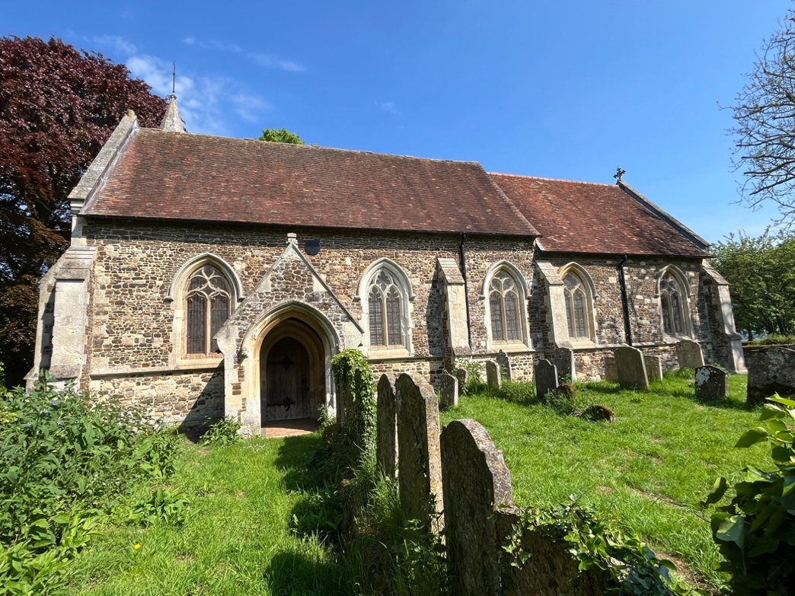
St Marys, Potsgrove dates chiefly from the early 14th Century although it was largely renewed in the 19th century.

In 1961 Battlesden with Potsgrove was joined with Woburn parish sharing the same Priest. Milton Bryan and Eversholt parishes were added to the benefice in 1979, so the Rector of Battlesden is now also Vicar of Woburn, Rector of Eversholt and Rector of Milton Bryan, although each parish retains its own parochial church council, churchwardens and services.

Since 1972 the church of Saint Peter & All Saints, Battlesden has been the parish church for the United Parish.

Battlesden Church is listed on the English Heritage ‘At Risk’ register - and costs £8,000 a year to maintain. We are extremely grateful for the generosity of the many visitors we receive here and whose donations contribute to the upkeep of the building.

Potesgrove Church is no longer open to worship. It was vested in the Redundant Churches Fund in 1972 for preservation in the interest of the nation and the Church of England and can be visited by appointment.

Architecture of All Saints, Battlesden

The present building was built in about 1280, with the Tower being added in the 15th Century, much patched and buttressed - If you look carefully, you will see the remains of sundials carved into the soft stone of the south facing buttresses. In the days before clocks, sundials were important aides to fix the times for services.

As you approach the church up the grass track, you will enter through the North Door, also known as the Batchelor’s Door because men and boys used to sit on the north side of the aisle, separated from the womenfolk who used to enter through the South Door and sit on the south side. The South Door was blocked off some 150 years ago and its remains can be seen from the outside of the church.

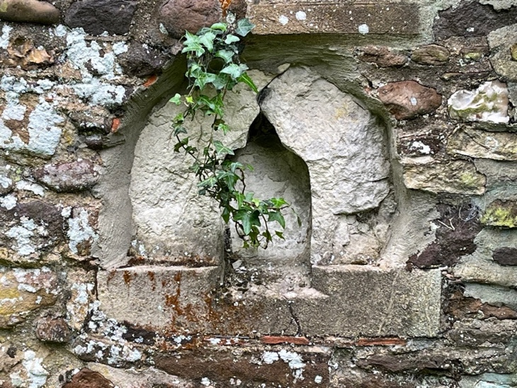
There are also the remains of a Squint Window to the Chancel in the north jamb. A squint was made in an external wall so that lepers could take part in the church services – from this position they could see the elevation of the Host at Mass and the service itself without coming into contact with the rest of the congregation.

The squint on the wall outside was open to the air and is currently blocked by a piece of stone and there is no trace in the current internal wall. However, you can still see today the window cut into the buttress into the nave that allowed a leper to see the host being elevated at the altar from their kneeling position outside. Squint Windows are also known as leper windows or lychnoscopes.

So why did the church provide this facility? In early Medieval England leprosy was a frightening, incurable disease and lepers were not allowed to pass through towns and villages. It is believed that lepers used to live in an encampment by the lake near the church, no doubt provided by the Lord of the Manor, as it was expected of the gentry to provide leper accommodation on the boundaries of their estates.

Also, on the South side, notice the small doorway near the East end - the Priests Door - and what was this for? Was it to maintain the mysteries of his profession, or perhaps so he could escape quickly at the end of the service?
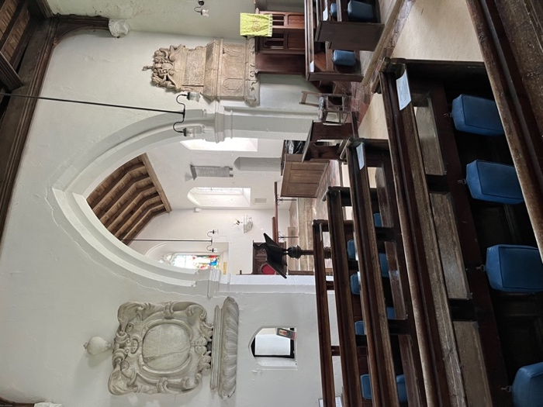
Inside, the Chancel has the original 14th Century Chancel Arch, but the East Window is a later edition, often referred to as ‘Modern’.

The Nave has a Rood Stair at the corner where the Pulpit now stands - a stair leading to the gallery or loft of a rood screen. The rood was a large crucifixion, usually carved and painted, generally with flanking figures of the Virgin Mary and St Peter. It stood on a loft, or gallery above a screen across the chancel arch. The unevennessof the Nave floor could be due to the old custom of burying the dead inside the church.

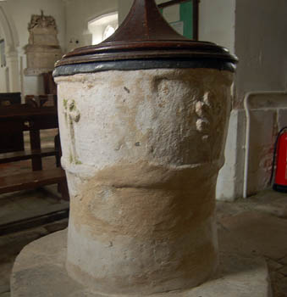
The Font, which used to stand near the pillar next to the organ (which was on the North side of the Chancel) is very old, dating from about 1180. It is decorated with carvings of leaves. Around the walls are a number of monuments, many of which are difficult to read or date.

In the small ‘Vestry’ under the Tower you will see a large beamed ladder to the Bell Chamber which houses three bells dated 1813.

The bells are set in a pre-reformation bell-frame - Oh, and don’t try and climb the ladder - the trap door is locked!

The current layout of pews in the Victorian style is a relatively recent addition – they replaced the more traditional pew stalls that were painted by George Shepherd in 1817

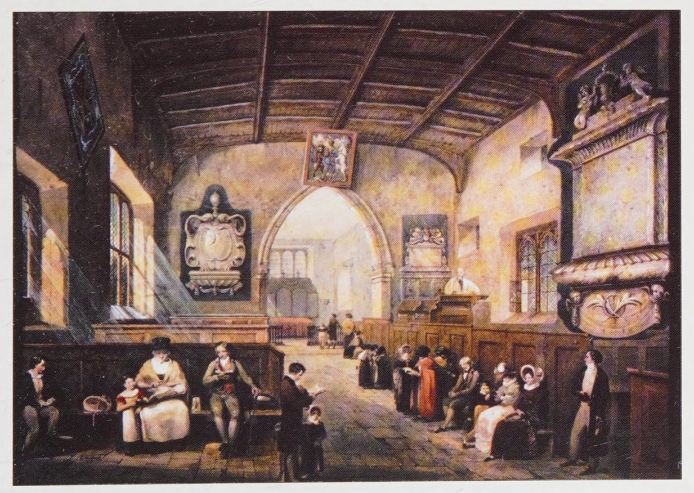

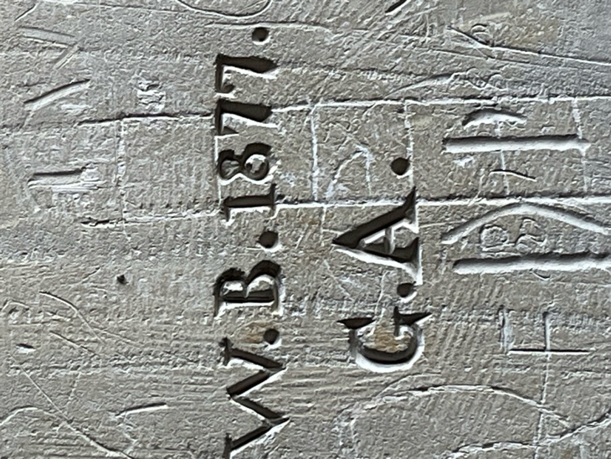
The soft stone of some of the walls has attracted a fair amount of graffiti - now known as ‘medieval graffiti’, although there are examples that date to the nineteenth century - Please don’t add any more, but do look carefully and see if you can spot the Giants, Gravestones and Windmills.

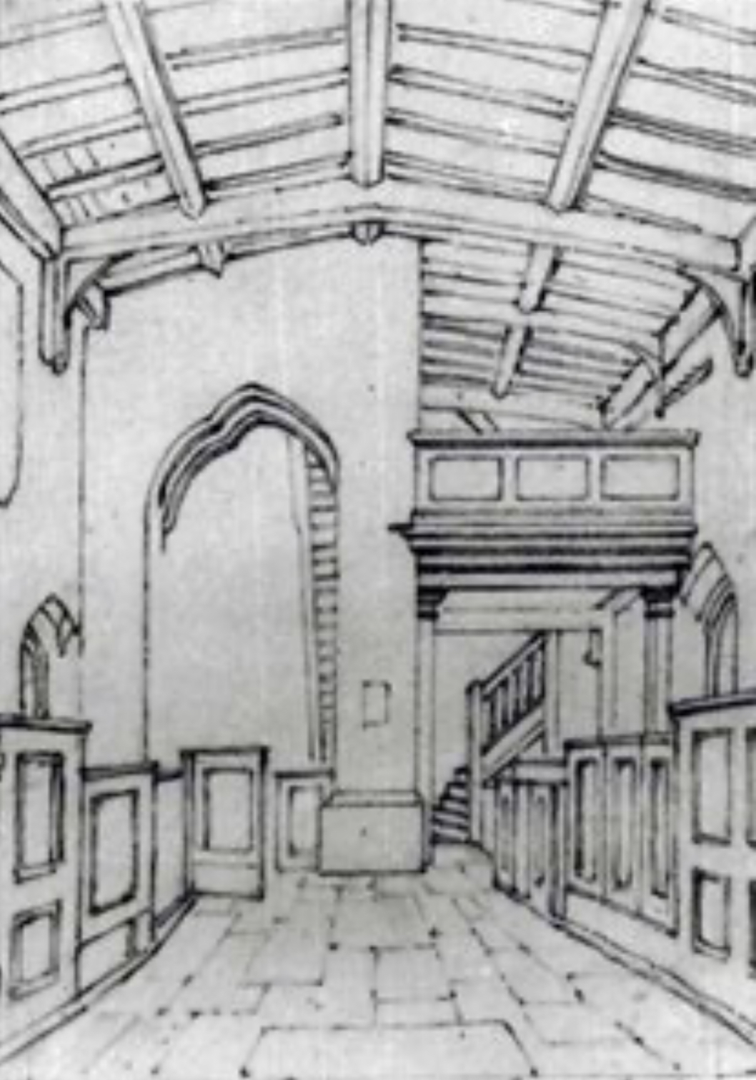
There is evidence from drawings of 1820 that there was a staircase and gallery at the west end of the church. This would have provided a vantage point for the gentry, a space for the choir or for musicians to accompany the congregation in the hymns.

In the3 picture you can also see the ladder that remains to this day.

The church still has its original silver Chalices and Paten from the reign of Charles ll, which survived the ravages of the New Model Army and are kept securely, only coming out for special services.

The Church Register shows attendances at services and special occasions such as weddings, baptisms and funerals. Our earliest register book still in the possession of the church contains entries dated 1694. Attending church by that date was no longer compulsory. From 1559 to 1650 you could be fined 12 pence (or three day’s wages) for not attending church at least once a week. Nevertheless, numbers were likely to be greater than our congregation today of 15-20 regular celebrants.

The church at Battlesden in 1291 was valued at £5 6s 8d, and at the Dissolution during Henry VIII’s reign at £12 9s 6d. While the church was in good condition in 1553, history tells more of its state of disrepair: an inventory of 1663 describes the “parish church of Battlesden ruinous- Charles Newport of Battlesden should repair”, and in 1775 the suggestion was made that the building at Battlesden was so ruinous it should be pulled down. It escaped this fate, but was not restored - the church was said to be in very poor repair by the middle of the 19th Century too.

The church was closed in 1928 but reopened and rehallowed for worship in 1949 following restoration work, further restoration being carried out in the 1960s and 1970s and indeed we have a continual list of works being carried out to keep it in its current healthy condition.

A building steeped in history is still an active centre for regular worship for the Parishes of Potsgrove and Battlesden, and we hold a monthly Eucharist service on the second Sunday of each month at 9am. We are always very well supported by other Parishes within the Benefice when we hold special services and when it is our turn to host a United Benefice Service.

Battlesden Church is the only community building in the Parish and almost all social functions held in the community tend to be church related events. These are held in the Church or hosted by neighbours, or in the case of our Harvest Supper - a very popular and traditional event - which takes place in the neighbouring village hall at Milton Bryan.
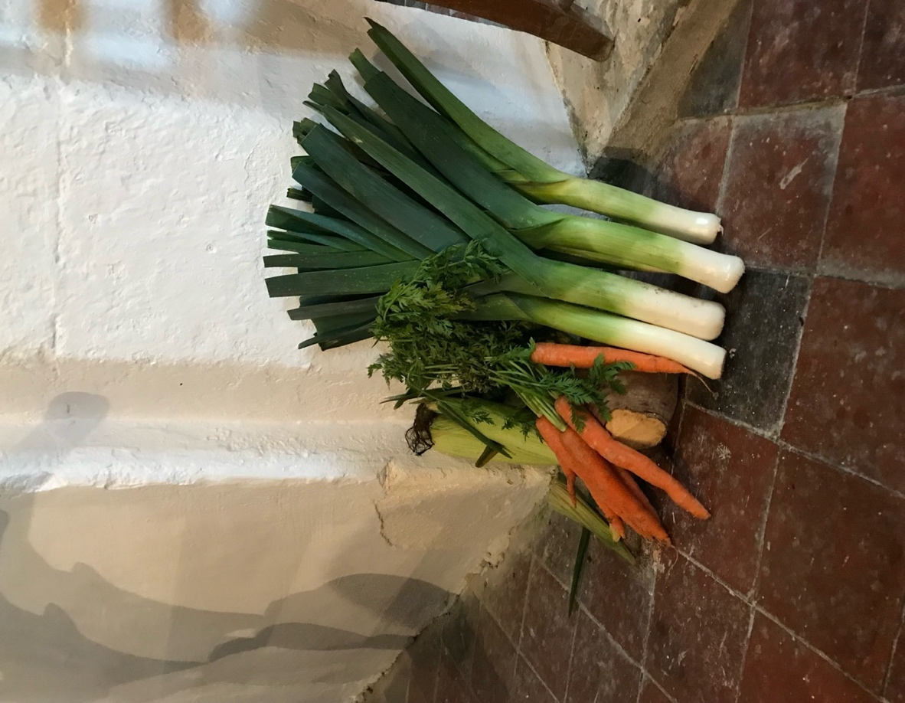

This event grows from strength to strength and we now expect to feed around 70 people, filling the village hall almost to capacity. A great time is had by all, allowing our wider community to come together at a traditional time of celebration when the harvest was gathered in and the farm workers were treated by the farmers to a feast. Today the Harvest Supper is a successful fundraiser, where we always split the proceeds between the church and a local charity.

In recent years we received a generous legacy with specific instructions that this be spent on restoration and preservation. With this generous legacy we have been able to repair windows, repaint and lime wash the walls, repair gates and replace fencing, clean out the Tower, replace downpipes and we are working on replacing the Louvre wooden slats in the tower to make it bird proof.

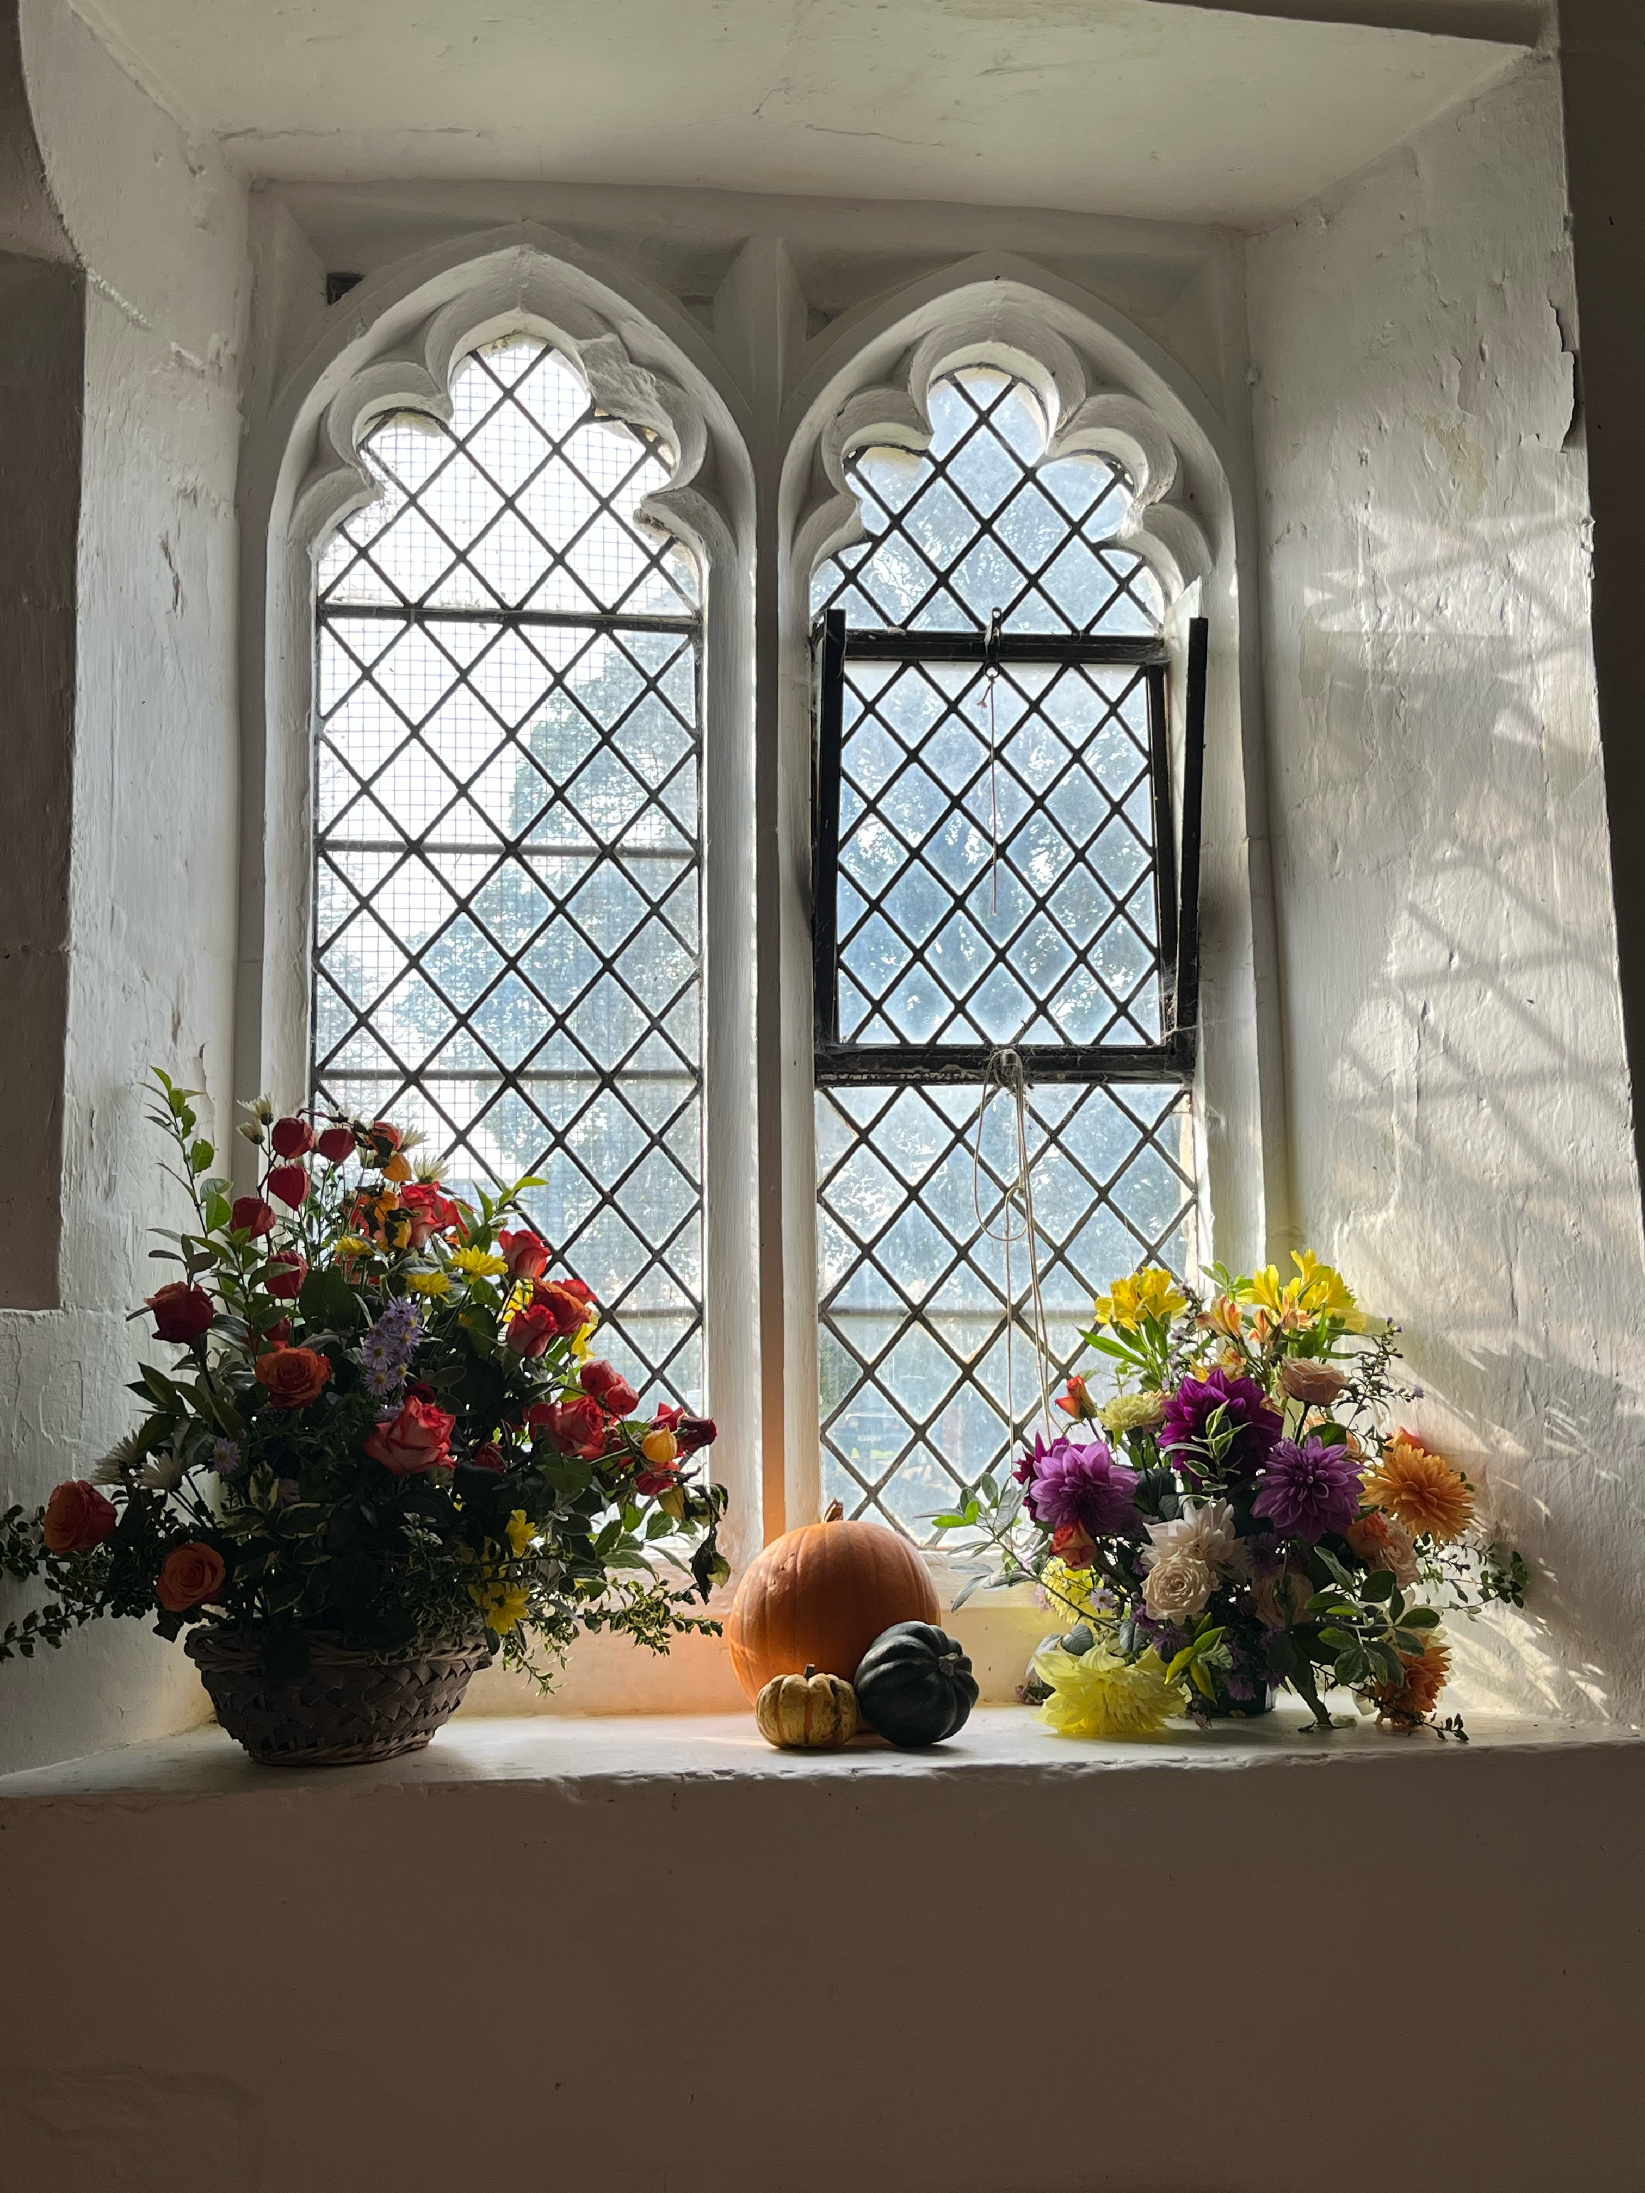
We hope you will find your visit interesting. For example, you could have a look in the book on the lectern – “Saints and Pilgrims in the Diocese of St. Albans” which was donated to the church by Bishop Alan Smith. The book contains a short chapter for each day of the year, recounting the story of some of the men and women who have shaped the Diocese of St Albans and examples of their works. Please turn the pages to today’s date. Before you go, do pause for a moment and drink in the peace and quiet of Battlesden.

Remember this ancient church has been a place where countless men and women down through the centuries have come to worship and have discovered here the love and living presence of God. Pray then for yourself and for the people who in this our generation care for this place and worship here month by month.

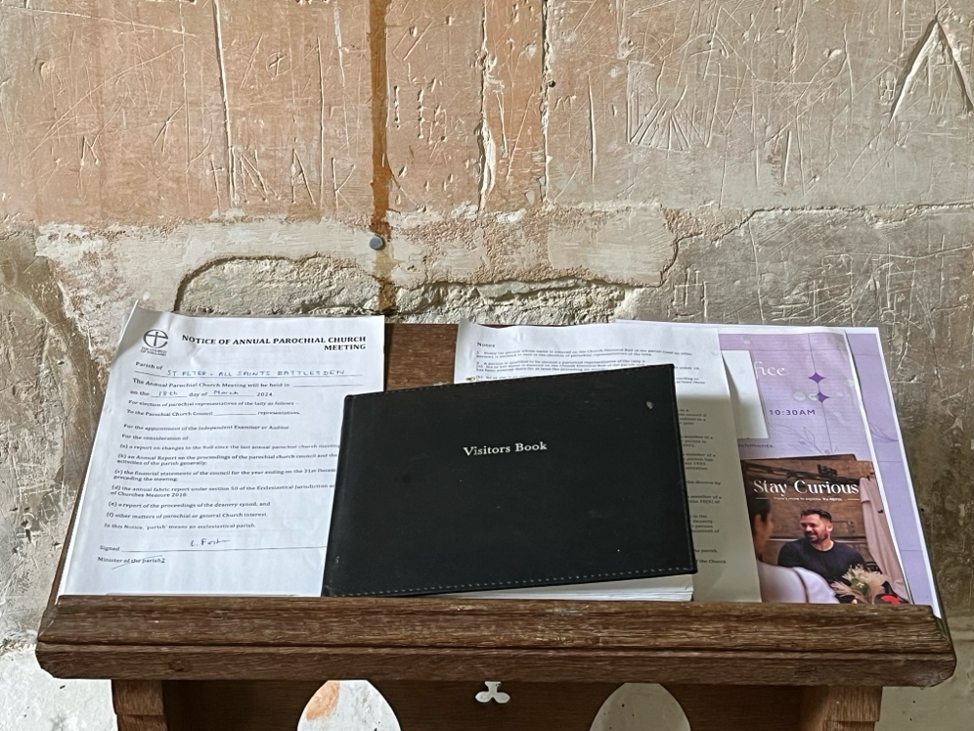
Our church door is always open and you can see from our visitors’ book by the organ that here has been a special place for so many people over the years, whether it be a quiet interlude in a busy day, a place to sit and rest inside or to enjoy the sunshine in the churchyard and visit the snowdrops & primroses or see the sheep grazing in the wilder area.

We are a small group of dedicated people who wish to keep the unique survivor that is Battlesden Church alive. Once visited we know you will feel the special peace that surrounds this exceptional place.

Ruth Barton
Church warden 1983-2024

