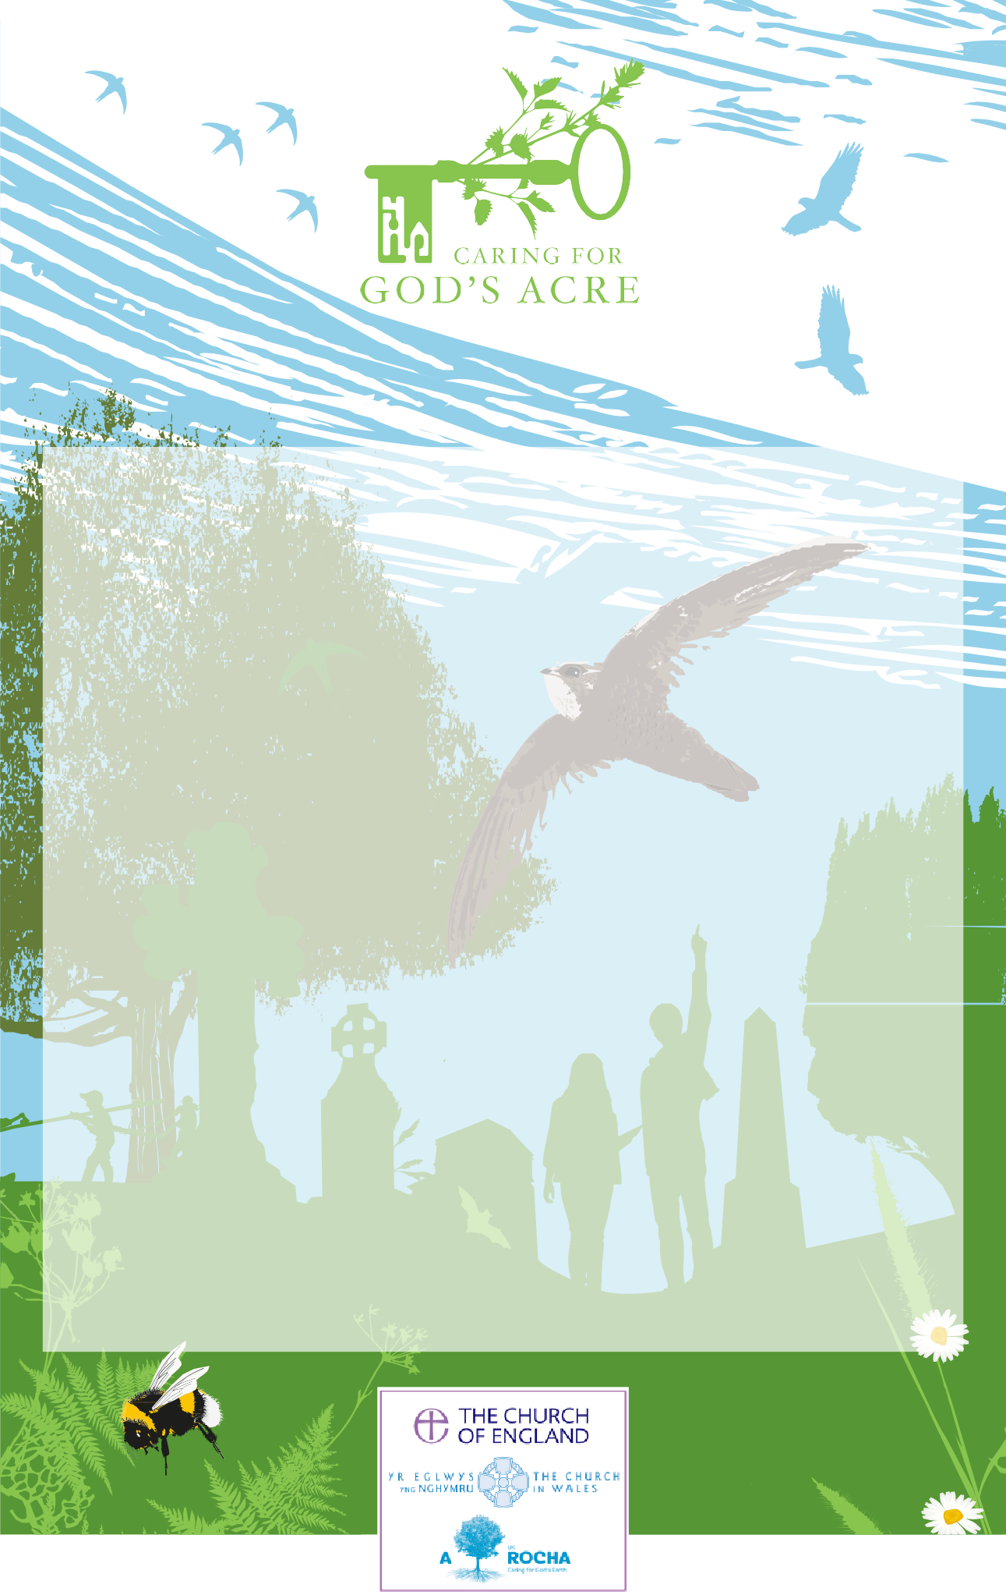

This certificate is awarded to:

St Mary’s Church

Walsham-le-Willows

for participating in

Love Your Burial Ground Week and Churches Count on Nature 2025 and recording the wildlife of

Thank you for recording and sharing your findings. This helps us discover the diverse wildlife in these special spaces and is a crucial step towards protecting and preserving it!