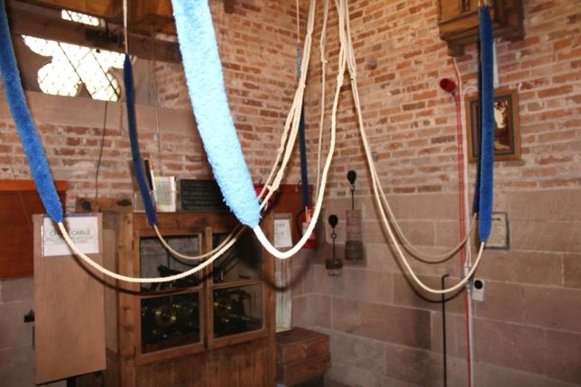The following photographs show the interior of the ringing chamber at our church.

The wooden boxes at the top of this image have rods passing through them that rotate the dials on the north and east clock faces.

The metal hand rail that can be seen close to the orange wiring is directly above the trap door (and iron ladder that leads to it).

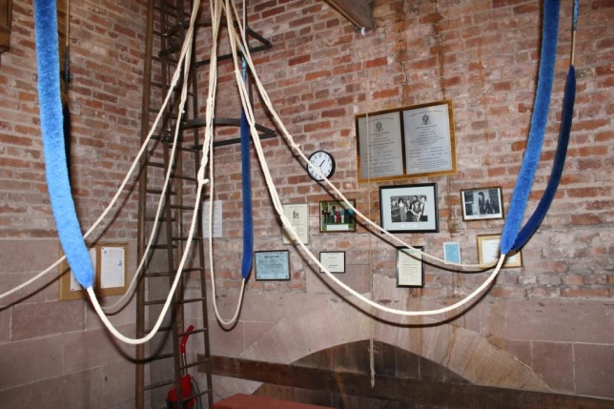This image shows a number of framed photographs, certificates and plaques relating to past ringers and the peels that have been rung.

The bricks lining this part of the tower are Georgian and were reused as the Pigott church was demolished. The demarcation line between brick and stone shows the level of a previous floor.

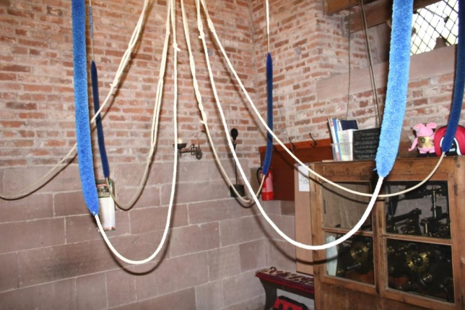In this image can be seen a wooden cabinet holding the clock mechanism: this has a brass plate surmounting it, with a dedication to JCB Borough.

The window that can be seen in this (and the first) image is behind the translucent north clock face. Careful inspection of the external masonry gives a clue to location of the hidden window.

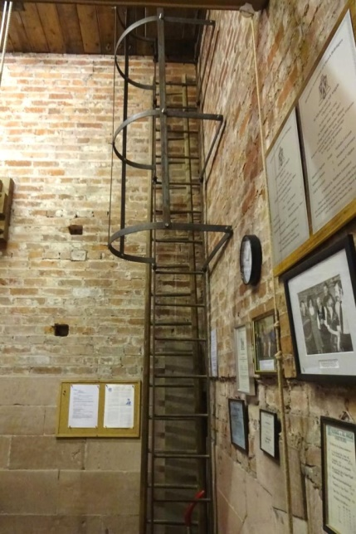This image shows the tall iron ladder and cage that leads from the ringing chamber to the bells. The sliding trap door at the top is very narrow and access to the bells involves climbing through a gap at the edge of the bell frame.

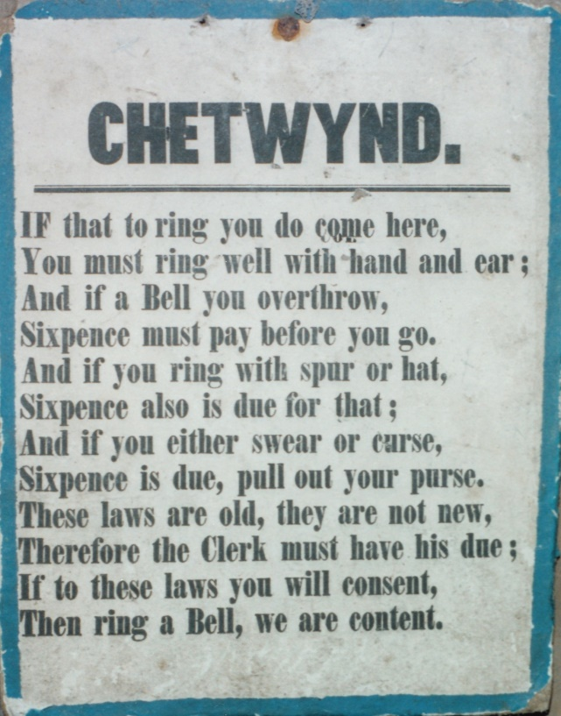

This sign is mounted on the east wall in the ringing chamber.