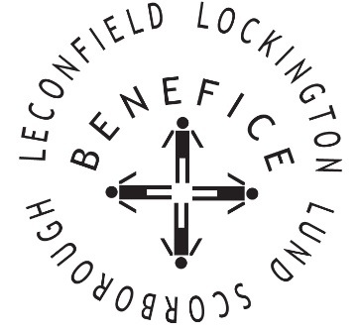

**Church Services for**

**September 2025**

Wherever you are from, you are welcome to join us for any of these services

Wednesday 3rd 9.30am Mid Week Service

With healing prayers St Mary’s Lockington

Sunday 7th 9:30am Holy Communion St Leonard’s Scorborough

11:00am Morning Worship St Mary’s Lockington

Sunday 14tth **9:30am Holy Communion St Leonard’s Scorborough**

11:00am Morning Worship All Saint’s Lund

Wednesday 17th 9:30am Mid Week Service

With healing prayers St Catherine’s Leconfield

Sunday 21st 9:30am Holy Communion St Mary’s Lockington

**Thursday 25th 7:00pm Celtic Evening Prayers St Catherine’s Leconfield**

Sunday 25th **9:30am Harvest Holy Communion All Saints Lund**

11:00am Contemporary Worship St Mary’s Lockington

**11:00am Harvest Festival St Catherine’s Leconfield**

For more information see the benefice newsletter *‘*Messenger’pasted-image.tiff

Service times, events and *Messenger* can also be found at:

<http://www.achurchnearyou.com> for the four churches