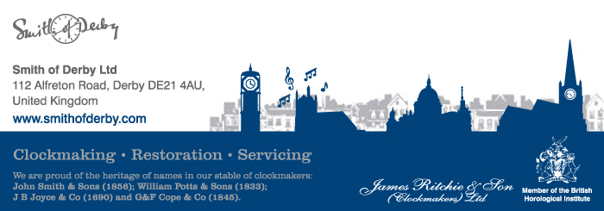

**Remit:**

To attend on site, approach the dials using scaffold, remove the North dial take details for new stainless steel fixings & replacing the broken section between 6 & 7. Take details for a new centre section on the East dial. Return to site refit North dial & fit 2 new sections.

**Background information:**Clock fitted to tower of church in 1906. Dial made of copper sheet fabricated to form the skeleton for glazing and backlighting, with rectangular surround, beaten-out half-round frame and cast spandrel decorations, painted, gilded details and inscribed. The Roman numerals read 1906, the date of the clock, condition of the dial when received in our works (2014) suggested that there had been little restoration or repainting since they were first made. The last recorded work undertaken by the company was in 1970.

**Regarding the work carried out:**

* Both dials were in a poor condition, i.e. the cast iron dial framework and parts of the glazing and we removed both dials back to our Works for a full restoration.
* Additional repair work was required as a supporting ring at the rear was corroded causing the copper dial to twist. This is possibly one of the reasons that several sections of glazing had cracked.
* The ring on the rear of the dials was removed and then all bead-blasted to remove the rust or verdigris on the copper dials.
* The dials then were suitably straightened and repaired, the steel ring treated with zinga primer and all undercoated and finished in a durable black gloss.
* The three rings of the dial, the outer rib, decorative corner features and inscription were re-gilded using 23½ carat double thickness gold leaf all as original.
* We dismantled and cleaned the dial motion works paying particular attention to the outer ends where they protrude through the dial thus becoming exposed to all weather elements.
* Returned to site and refitted the dials using stainless steel fixings.
* Refitted the dial motion works.
* Resynchronised the hands to the dials and clock movement.
* Set up and left all in good order.

Hope this is helpful.

Hilary Hallam-Gray

Territory Co-ordinator

T:  +44 (0) 1332 345569 Ext 205

F:  +44 (0) 1332 290642

M: +44 (0) 7791 022360

[**www.smithofderby.com**](http://www.smithofderby.com)