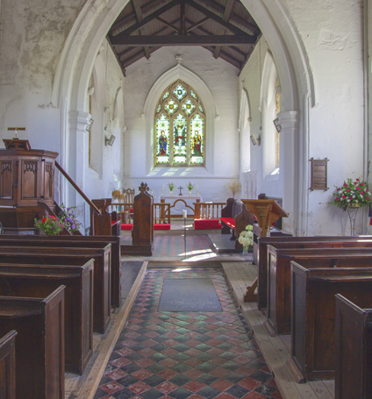**Gift Aid Declaration**

**All Saints Ratcliffe Culey**



If you are a UK taxpayer and eligible to Gift Aid your donation, please complete the declaration below. This will increase your gift by 25p for every £1 given (at current rate), at no extra cost to you or us.

Thank you.

Please treat as Gift Aid donations all qualifying gifts of money made from the date of this declaration and in the past four years. I am a UK taxpayer and understand that if I pay less Income Tax and/or Capital Gains Tax than the amount of Gift Aid claimed on all my donations in that tax year it is my responsibility to pay any difference.

Full Name: __________________________________________________________________________

Full Address: __________________________________________________________________________

_______________________________________________________________________________________

Post Code: ________ _________

Signature: __________________________________________________ Date: ___________________

NOTES

1. Please notify the Treasurer if you:

a. Want to cancel this declaration

b. Change your name or home address

c. No longer pay sufficient tax on your income and/or capital gains. Gift Aid is linked to basic

rate tax. Basic rate tax is currently 20%, which currently allows charities to reclaim 25 pence

on the pound.

2. Higher rate taxpayers can claim back the difference between basic rate and higher rate or

additional rate tax. If you pay Income Tax at the higher or additional rate and want to receive the

additional tax relief due to you, you must include all your Gift Aid donations on your Self-Assessment

tax return or ask HM Revenue and Customs to adjust your tax code.

**Please return this form to our Treasurer:**

**Mrs Helen Anderton 11 Ormes Lane, Ratcliffe Culey CV9 3PB**