**The Rector's Ramblings**

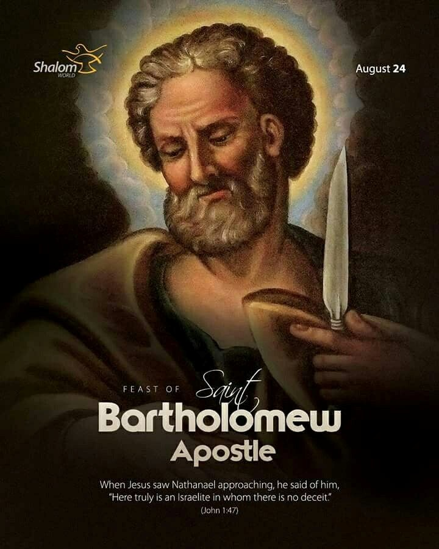

This Sunday, the church celebrates the Feast of St. Bartholomew, one of the Twelve Apostles. Now you may never have heard of St Bartholomew, except in the name of a church or chapel, and to make things even more complicated, he is also known as Nathanael, the incredibly sceptical, if not a little rude, friend of Philip. I mean, how insulting can you be, when told that Jesus was from Nazareth, you reply with ‘Can anything good come out of Nazareth!’.

Because St. Bartholomew doesn’t have the fame of Peter, the passion of Paul, or the poetry of John he often gets overlooked. He’s not the one standing up in front of the crowds at Pentecost or writing letters far and wide that get read in church pretty much every Sunday. In fact, if someone handed me a Bible and asked, “So what did Bartholomew do?” I’d probably flip through the pages, scratch my head, and say, “Um… he showed up?”

And that’s pretty much it. Bartholomew is one of the apostles who is listed by name (and even then, only a couple of times) but otherwise fades into the background. No recorded sermons, no dramatic adventures, no flashy miracles. Just a name on a list of those who followed Jesus. But before we think he was a “background character” in the Twelve, just there to make up the numbers, to ensure Jesus’ inner circle reflected the Old Testament Twelve Tribes of Israel, we need to stop for a second. Isn’t that what makes him wonderful, isn’t that what makes him one of us, someone we can relate to?

After insulting Jesus, he may have thought he would get a rebuke, or an equivalent put down about his background, but no, Jesus’ response? - *“Here is truly an Israelite in whom there is no deceit.”* In other words: “This guy is genuine. What you see is what you get.”. And that is what makes Bartholomew stand out as an example to us all, not his deeds, not his speeches, not his miracles, just his heart and his faith.

And maybe that’s why the Church celebrates him, and why we should. Because let’s be honest: most of us are more like Bartholomew than Peter or Paul. We’re not out preaching to crowds of thousands, heaven forbid. We’re not writing letters, blogs, or emails, that people will be reading 2,000 years from now. Most of the time, we’re just trying to get dinner on the table, pay the bills, remember to pray, and maybe get to bed before midnight.

Our lives may never be remembered in history books, and that’s okay. St. Bartholomew shows us that holiness, faithfulness, being a good friend, a kind neighbour, isn’t about being famous, being recognised, even being rewarded, for our actions —it’s about being faithful in our hearts. Because when you think about it, the people who have most shaped your life probably aren’t world-famous either. Maybe it’s a parent or grandparent who, through what they did or what they said, taught you how to be the best you you can be. Maybe it’s a teacher who encouraged you when you were struggling with that essay, or nervous about an exam. Maybe it’s a friend who really listened when you needed it most. Their names may never be carved into monuments, but they left their mark on you.

And that’s the legacy Bartholomew left. He wasn’t a headline-grabber, but he was faithful, steady, and true. And sometimes, that’s exactly what the world, and the church, needs most.

Now Bartholomew did, in fact, travel far and wide to preach the Gospel, the Good News, and he, like most of the Apostles, died a martyr’s death, but what we know about him is less about what he did, and more about who he was, a man who followed Christ to the very end, without compromise, without deceit, without wanting, or needing, recognition or status.

And that’s what we need to learn from this “forgotten” apostle? That we don’t need to be remembered to matter. We don’t need to have our deeds written down to be a saint. We don’t even need to be in the spotlight to change lives. What matters is that Jesus sees us, knows us, and loves us. That’s enough.

So next time you feel like your life is a little too ordinary, or that your efforts go unnoticed, remember St. Bartholomew. He may not have been the star of the show, but he still did amazing things and changed lives, because he was chosen, loved, and sent by Jesus Himself, as we all are. And that’s the kind of recognition that really counts.

*Rev Sarah*

**Worship in the Valley Parish**

# 24th August

## Holy Communion 10am St Andrew's, West Dean

**Rev Sarah Manouch**

*07468 854864 priestvalleyparish@gmail.com*

*Please note that I am part-time. My principal working days are Friday and Saturday as well as Sunday. I am not available on a Thursday.*