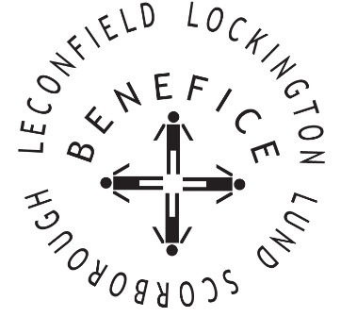

Church Services for
September 2025
Wherever you are from, you are welcome to join us for any of these services

Wednesday 3rd 9.30am Mid Week Service
With healing prayers St Mary’s Lockington

Sunday 7th 9:30am Holy Communion St Leonard’s Scorborough

11:00am Morning Worship St Mary’s Lockington

Sunday 14tth 9:30am Holy Communion St Leonard’s Scorborough

11:00am Morning Worship All Saint’s Lund

Wednesday 17th 9:30am Mid Week Service
With healing prayers St Catherine’s Leconfield

Sunday 21st 9:30am Holy Communion St Mary’s Lockington

Thursday 25th 7:00pm Celtic Evening Prayers St Catherine’s Leconfield

Sunday 25th 9:30am Harvest Holy Communion All Saints Lund

11:00am Contemporary Worship St Mary’s Lockington

11:00am Harvest Festival St Catherine’s Leconfield

For more information see the benefice newsletter ‘Messenger’
Service times, events and Messenger can also be found at:
http://www.achurchnearyou.com for the four churches

