**Our regular pattern of services All Saints, Clifton**

|  |  |  |  |
| --- | --- | --- | --- |
| **Sunday** | **11am** | **6.30pm** |  |
| 1st | Holy Communion |  |  |
| 2nd | All Age Worship |  |  |
| 3rd | Holy Communion | Evensong |  |
| 4th | Morning Prayer |  |  |
| 5th | Holy Communion – an **alternate** **joint service with Haynes or Southill** at **10.00am**. The venue will be on the web, A church near you and in the Chronicles. | | |
| **Wednesday** | **10.00am** | Holy Communion | |

Refreshments are served after the 10.00 and 10.30 services.

# **All Saints, Southill and Haynes at 9.30am**

|  |  |  |
| --- | --- | --- |
| **Sunday** | **Southill** | **Haynes** |
| 1st | Holy Communion | Praise and Thanksgiving at St Mary’s |
| 2nd | Holy Communion | Service at Southill |
| 3rd | Morning Prayer | Holy Communion (Mission Hall) |
| 4th | Messy church at Clifton | Holy Communion at St Mary’s |
| 5th | Holy Communion - this is an **alternate joint service with Haynes or Clifton** at **10.00am**. The venue will be in Outlook | |

Refreshments are served after the services.

For more details, please contact Rev Caren Topley. Tel: 07885176079

Email: rector4clifton@gmail.com

8

The Welcoming Benefice of

All Saints Clifton, St Mary’s Haynes

And

All Saints Southill

Baptism

A Guide for Parents and Godparents

**What is baptism?**

In baptism, you as parents are thanking God for his gift of life, deciding to start your child on the journey of faith, and asking for the support of the Church.

For your child, baptism marks the start of a journey of faith which involves turning away from the darkness of self-centredness, turning towards Christ, and becoming a member of the local and worldwide Christian family.

Baptism (also known as christening) is a ‘sacrament’ - a visible sign of God’s love. In baptism, we are thanking God for his gift of life, acknowledging his love and the need we all have to turn away from the darkness of evil and to make a new start with God.

**When did baptism start?**

Jesus was himself baptised in the River Jordan, which marked a turning point in his life. (You can read about the story at the beginning of Mark’s Gospel in the Bible.) He told his followers to baptise others as a sign that they had turned away from their old life, been assured of God’s forgiveness, and begun a new life as Christ’s disciples and members of His Church. Baptisms often took place in a river. New Christians were often dipped under the water and lifted up again as a sign of new birth. Some churches still follow the practice of full immersion today.

**Shouldn’t children make their own decisions?**

Some people worry that they are imposing views on their children. But from the moment they are born, parents make choices on their behalf. For example, parents don’t wait until babies are old enough to ask to be fed. In the same way, it is right to give children spiritual nourishment and teach them about God’s love from an early age. However, it is possible for people of any age to be baptised. Please feel free to discuss any issues with your priest and her team.

2

**What happens after baptism?**

Baptism marks a new start for your child as a member of the worldwide Christian community. In turn the Church welcomes you and your child and promises to help you and your child and to support you in bringing up your child in faith. Please see details of our services on the back of this leaflet or speak to the priest about other activities you can get involved in or if you have any questions yourself about the Christian faith.

**What is confirmation?**

We hope that in later years your child or godchild will want to make his or her own declaration of faith by being confirmed. This special service is conducted by the Bishop and attended by family and friends as well as members of the congregation. It is an important occasion when he or she will confirm the decisions you made on their behalf when they were young. Before the service, they will have attended a series of classes or meetings run by the church to discuss what it means to be a Christian and enable them to make their own commitment.

A Prayer for your child or godchild

Heavenly Father

Thank you for the gift of [child’s name]

And for the joy he/she brings us.

Be with him/her on his/her Christian journey So he/she may come to know our Lord Jesus Christ as Saviour and friend. Amen.

7

**Candles** Jesus is called the light of the world. A large candle may be lit and the parents may be given a lighted candle as a reminder of the light that has come into your child’s life.

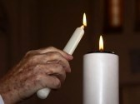

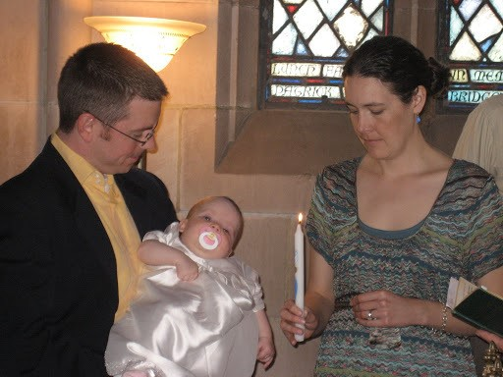

**How much will it cost to have my child baptised?**

There is no charge, but a collection is taken at the service and you are invited to make a contribution if you wish.

6

**What is the role of godparents?**

Parents may choose three or more trusted and reliable family members or friends to act as godparents. Their role is to pray for the child, speak to them about God, and encourage them in their membership of the local church and in their Christian faith. Godparents must themselves have been baptised. The Church is there to support in carrying out these important responsibilities, but if you have any concerns or questions, please feel free to discuss these with the priest and her team.

**What happens in the Baptism service?**

Baptisms can take place during a normal Sunday service or as a separate service. Either way, the priest will explain fully each step of the procedure so you will know exactly where to sit and when to sit or stand and what to do.

For the baptism itself, parents and godparents will be invited to gather around the font at the back of the church. The font is the large basin on a pedestal containing the water for baptism.

3

The priest will ask the parents and godparents to make the following declarations on behalf of the child:

Do you turn to Christ? **I turn to Christ**.

Do you repent of your sins? **I repent of my sins.**

Do you renounce evil? **I renounce evil**.

And later:

Do you believe and trust in God the Father, source of all being and life, the one for whom we exist**? I believe** **and trust in Him.**

Do you believe and trust in God the Son, who took our human nature, died for us and rose again? **I believe and trust in Him**.

Do you believe and trust in God the Holy Spirit, who gives life to the people of god and makes Christ known in the world? **I believe and trust in Him**

**Important symbols**

**The sign of the cross** The priest will make the sign of the cross on the child’s forehead. This is like an invisible badge to show that Christians are united with Christ and must not be ashamed to stand up for Him.

4

**Water** The priest will pour water on your child’s head. Water is a sign of washing and cleansing, symbolising being washed free of sin and starting a new life with God.



**Anointing** The priest will anoint the child with oil as a sign of the outpouring of God’s Holy Spirit.

**The** **welcome**  The church congregation will formally welcome the child into the Church family if the Baptism is during morning service.

We kindly request that you refrain from taking photos during the service, as it tends to distract from the meaning of the Baptism, but you are welcome to take as many as you like around the font, when the service is over.

5