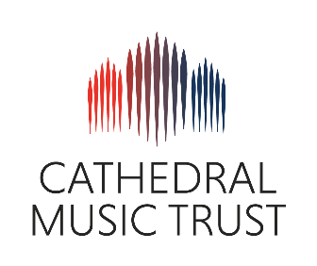THE PARISH CHURCH OF ST GABRIEL, HEATON

Newcastle upon Tyne

**Choral Scholarship Application 2025-2026**

|  |  |
| --- | --- |
| **Name:** | **Date of Birth:** |
| **Address:** | |
| **Email:** | **Telephone:** |
| **Voice Part:** | |
| Please detail your previous singing and musical experience (what choirs you’ve sung in, any experience of church music, and any relevant qualifications): | |
| **Personal Statement** Please tell us why you’re applying for this scholarship and what experience and skills you would bring to the role. What would you want to achieve by taking this scholarship? | |

**References**

**Applicants Name _____________________________________________**

* Please give the names and contact details of two referees
* All referees must be over 18 years of age and cannot be related to you by birth or marriage

**Referee 1**

|  |  |
| --- | --- |
| **Name** |  |
| **Telephone** |  |
| **Email** |  |
| **In what capacity does this person know you?** |  |
| **How long has this person known you?** |  |

**Referee 2**

|  |  |
| --- | --- |
| **Name** |  |
| **Telephone** |  |
| **Email** |  |
| **In what capacity does this person know you?** |  |
| **How long has this person known you?** |  |

**Please return this form to Tim Burke (Choir Director) by email:** [**singingstgabriel@gmail.com**](mailto:singingstgabriel@gmail.com) by Friday 22nd August 2025.

Auditions will be held in early September 2025.