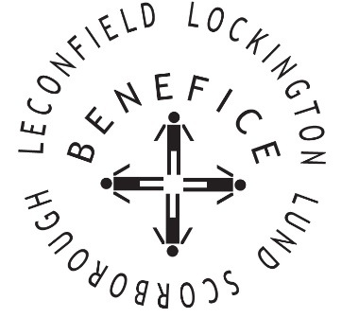

**Church Services for**

**August 2025**

Wherever you are from, you are welcome to join us for any of these services

Sunday 3rd 9:30am Holy Communion St Leonard’s Scorborough

11:00am Morning Worship St Mary’s Lockington

**Wednesday 6th 9.30am Mid Week Service**

**With healing prayers St Mary’s Lockington**

Sunday 10th **9:30am Holy Communion St Catherine’s Leconfield**

11:00am Morning Worship All Saint’s Lund

Sunday 17th 9:30am Holy Communion St Mary’s Lockington

**Wednesday 20th 9:30am Mid Week Service**

**With healing prayers St Catherine’s Leconfield**

Sunday 24th 9:30am Holy Communion All Saints Lund

11:00am Contemporary Worship St Mary’s Lockington

**Thursday 28th 7:00pm Celtic Prayers St Catherine’s Leconfield**

**Sunday 31st 10:00am Benefice Holy Communion All Saints Lund**

For more information see the benefice newsletter *‘*Messenger’pasted-image.tiff

Service times, events and *Messenger* can also be found at:

<http://www.achurchnearyou.com> for the four churches