Our regular round up of news and forthcoming events from our diocese [View this email in your browser](https://us2.campaign-archive.com/?e=%5BUNIQID%5D&u=c52dd45d5732d5bd4c5aa7748&id=1c9851f8d6)

## Summer 2025

**“Little children, let us love, not in word or speech, but in truth and action” 1 John 3 18**

You could be forgiven for thinking that our mission and ministry for the environment is an optional extra as the issues of global warming, damage to the natural world and climate injustice seem to be slipping down the world's political agenda. Or you might feel overwhelmed by the scale of the problems that face us, becoming despondent about our ability to change things.

As Christians, we are called to live out our faith, even when what we do seems difficult and unpopular. The Church of England is very clear that caring for creation is central to being a Christian in today’s world:

“Care for God’s creation is part of the Christian life. We honour the Creator when we care for creation. We show love to our neighbours when we care about the places they live,

near and far. And we work for justice when we seek to tackle climate change and halt the loss of nature.” [Environment in prayer, worship and teaching | The Church of England](https://www.churchofengland.org/about/environment-and-climate-change/environment-prayer-worship-and-teaching)

Creation care can become an integral part of the five marks of mission, enabling us to share the Christian faith within our communities and beyond. It’s hard to avoid the

negative impacts our lifestyles are having if we take seriously our commitment to respond to human need by loving service, to transform unjust structures of society, and to

safeguard the integrity of creation and sustain and renew the life of the earth. In St

Edmundsbury and Ipswich, our Environment Champions network and Eco Church support group are keen to help churches to take small but significant steps on their caring for

creation journey. We can offer simple practical ideas for worship, nature-based projects, and community engagement, as well as guiding churches through the benefits from sustainable energy.

Our “Care into Action” morning on Saturday 5 July at the Salvation Army Hall in Stowmarket is open to anyone in the diocese who is keen to get involved. Talks and

workshops will offer you the opportunity to learn more about the reasons for action and explore ways their church or organisation can get started or continue with their mission and ministry for the environment - please book [here.](https://eur02.safelinks.protection.outlook.com/?url=https%3A%2F%2Fcofesuffolk.us2.list-manage.com%2Ftrack%2Fclick%3Fu%3Dc52dd45d5732d5bd4c5aa7748%26id%3D73898652c2%26e%3De6a59b42b2&data=05%7C02%7Cleonie.ryle%40cofesuffolk.org%7C7e4f6d985c68416bfea008dda44c3e21%7C64990a9c67994442988fcb8b9e9dbb7f%7C0%7C0%7C638847369579570828%7CUnknown%7CTWFpbGZsb3d8eyJFbXB0eU1hcGkiOnRydWUsIlYiOiIwLjAuMDAwMCIsIlAiOiJXaW4zMiIsIkFOIjoiTWFpbCIsIldUIjoyfQ%3D%3D%7C0%7C%7C%7C&sdata=3Pafen9%2BYexU%2FnoMsvemBuIhg9swp5R3pVVvq4yDvhI%3D&reserved=0)

The Revd Canon Alison Alder, Diocesan Environment Officer.

[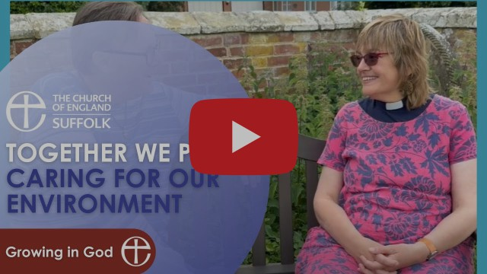](https://www.youtube.com/watch?v=z0Jeb_lyMGc)

The Revd Canon Alison Alder talks about her role as Diocesan Environment Officer and the benefits of completing the Energy Footprint Tool.

# Completing the 'Energy Footprint Tool' - 30 June deadline

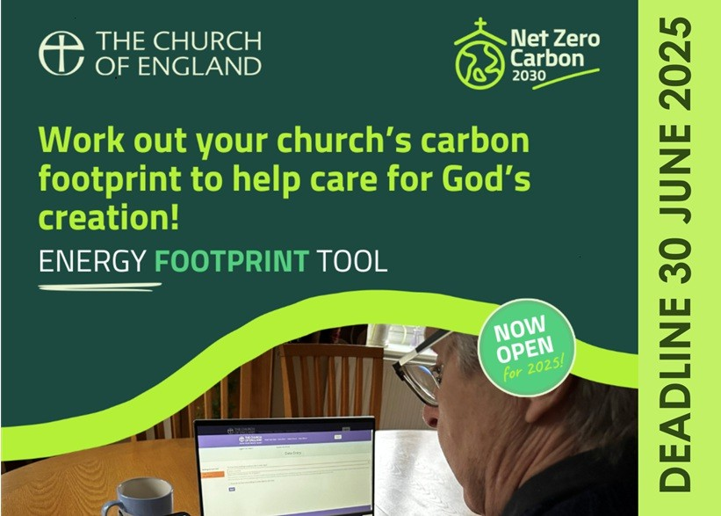Did you know that last year over £100,000 of funding was available to parishes that had completed the Energy Footprint Tool? Numerous parishes have already

benefitted from this funding to improve their heating and upgrade their lighting.

We want to say a huge thank you to everyone who has submitted the Energy Footprint Tool for their church.

This gives us an understanding of our progress towards net zero carbon and helps us to continue to care for creation. There is still time to submit your entry. You can find the Energy Footprint Tool on the [Online Parish Returns System](https://parishreturns.churchofengland.org/login).

**The deadline for entries to be included in national statistics is 30 June 2025.**

# ECO CHURCH

## All Hallows' Church, Ipswich - Our Eco Church story so far

"Last April the PCC agreed to register for the Eco-Church Bronze Award. We looked at the five different categories, ticked what we were already doing and agreed to do one or two

more things from each category – the quick fixes. Things like asking intercessors to include environmental issues in the Sunday services, changing some light bulbs to LED, changing

to Fairtrade tea and coffee for our after-service drinks were all fairly painless!

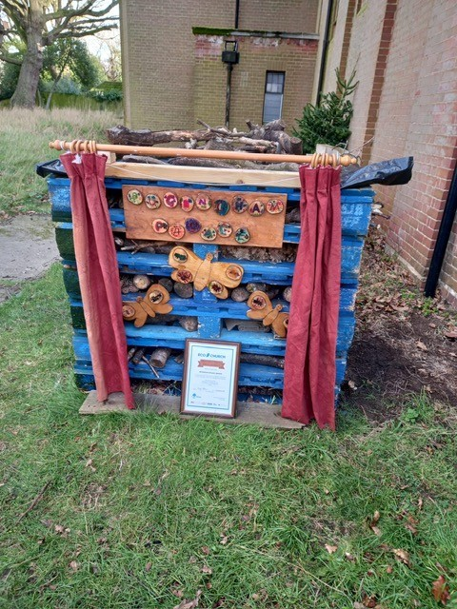How to engage the congregation and wider community was more challenging. We opted for monthly Facebook posts – including the ‘eco-tip of the month’. The biggest challenge was the churchyard - we started by digging a flower bed and planting for pollinators, and installing a new water butt. Little by little people have come along and had a go at doing different things. We’ve built a big bug hotel and a compost bin, the Brownies and Guides made nest boxes, bee and mini beast hotels and hedgehog homes, and we had a morning in the autumn planting bulbs in the grass. The crocuses looked great in March!

We found that the scheme does need someone (the Eco Church lead) to organise and

source materials and to make regular reports to the PCC - and PCC support is vital. Our

treasurer applied for a grant from the Council; Suffolk Wildlife Trust, Ipswich Wildlife Group and Save our Swifts have also helped.

It’s been one step at a time, doing what’s do-able. We achieved our Bronze Award in December and celebrated in church. It will take longer to get the Silver, but that’s OK.

What really matters is that we’re doing something to help the environment and people are ‘getting it’ and joining in as they see and hear more about it. Silver will happen – one day!" Jeanette Gosney (All Hallows' Eco Church lead)

If you are looking for help, our **Eco Church Support Group** has a wide range of experience of A Rocha’s Eco Church Award scheme and they are here to help you. The Group consists of:

Diane Ekins-Powell: [diane1961erica@gmail.com](mailto:diane1961erica@gmail.com) Jackie Orbell: [risbyecochurch@gmail.com](mailto:risbyecochurch@gmail.com)

James Rolls (Net Zero Carbon Officer): [james.rolls@cofesuffolk.org](mailto:james.rolls@cofesuffolk.org)

# EVENTS

**Churches Count on Nature - NOW ON |** Saturday 7 June to Sunday 15 June

Right now hundreds of church communities across the country are taking part in a week-long nature count to monitor and

celebrate the incredible biodiversity in churchyards. In 2024

there were 6,354 records of nature spotted that were submitted by nearly 6,000 participants. This initiative is jointly run by the conservation charities Caring for God’s Acre and A Rocha UK. We would love for your church to take part in this initiative - to register and get involved [please click here.](https://eur02.safelinks.protection.outlook.com/?url=https%3A%2F%2Fwww.caringforgodsacre.org.uk%2Fget-involved%2Fevent-register-25%2F&data=05%7C02%7Cleonie.ryle%40cofesuffolk.org%7C4b2acea748bb4421278908dd87ec08f7%7C64990a9c67994442988fcb8b9e9dbb7f%7C0%7C0%7C638816170044492383%7CUnknown%7CTWFpbGZsb3d8eyJFbXB0eU1hcGkiOnRydWUsIlYiOiIwLjAuMDAwMCIsIlAiOiJXaW4zMiIsIkFOIjoiTWFpbCIsIldUIjoyfQ%3D%3D%7C0%7C%7C%7C&sdata=vauYcCT2eHJr%2F6Jz9lEXKL4rq8eGa0j9xzyo8AOCVs4%3D&reserved=0)

## Events at Foxearth Meadows

Foxearth Meadows Nature Reserve, Sudbury CM8 3JD

* **Glory, Gifts, Glee and Gratitude Open Air Service** - 3.00pm, 22 June | Join for an open air service with speaker Dr Andrew Crowson. Refreshments included, bring along a rug for comfort.
* **Big Bug Day** - 10.30am-3.00pm, 28 June | Come along to a free family event celebrating all creatures tiny - in celebration of Insect Week. [Book here.](https://eur02.safelinks.protection.outlook.com/?url=https%3A%2F%2Fcofesuffolk.us2.list-manage.com%2Ftrack%2Fclick%3Fu%3Dc52dd45d5732d5bd4c5aa7748%26id%3Debd01a8046%26e%3De6a59b42b2&data=05%7C02%7Cleonie.ryle%40cofesuffolk.org%7C7e4f6d985c68416bfea008dda44c3e21%7C64990a9c67994442988fcb8b9e9dbb7f%7C0%7C0%7C638847369579490467%7CUnknown%7CTWFpbGZsb3d8eyJFbXB0eU1hcGkiOnRydWUsIlYiOiIwLjAuMDAwMCIsIlAiOiJXaW4zMiIsIkFOIjoiTWFpbCIsIldUIjoyfQ%3D%3D%7C0%7C%7C%7C&sdata=JfRxE1Mw5CSeHXNlJpoUPaVkOQy2ooMgYOBOduuOvzU%3D&reserved=0)
* **Dragonflies and Damselflies for Beginners -** 10.30am - 12.15pm or 1.15pm - 3.00pm, 26 July | A guided walk led by David Chandler, author of 'Dragonfly' and 'A Beginner's Guide to Dragonflies and Damselflies of Britain'. [Book here for the](https://eur02.safelinks.protection.outlook.com/?url=https%3A%2F%2Fcofesuffolk.us2.list-manage.com%2Ftrack%2Fclick%3Fu%3Dc52dd45d5732d5bd4c5aa7748%26id%3D3d3c27166f%26e%3De6a59b42b2&data=05%7C02%7Cleonie.ryle%40cofesuffolk.org%7C7e4f6d985c68416bfea008dda44c3e21%7C64990a9c67994442988fcb8b9e9dbb7f%7C0%7C0%7C638847369579507969%7CUnknown%7CTWFpbGZsb3d8eyJFbXB0eU1hcGkiOnRydWUsIlYiOiIwLjAuMDAwMCIsIlAiOiJXaW4zMiIsIkFOIjoiTWFpbCIsIldUIjoyfQ%3D%3D%7C0%7C%7C%7C&sdata=gxCZqlO8e2VX5v89qE1CQuj1%2Fiplz17F1ctSBm0HJzc%3D&reserved=0) [morning slot.](https://eur02.safelinks.protection.outlook.com/?url=https%3A%2F%2Fcofesuffolk.us2.list-manage.com%2Ftrack%2Fclick%3Fu%3Dc52dd45d5732d5bd4c5aa7748%26id%3D3d3c27166f%26e%3De6a59b42b2&data=05%7C02%7Cleonie.ryle%40cofesuffolk.org%7C7e4f6d985c68416bfea008dda44c3e21%7C64990a9c67994442988fcb8b9e9dbb7f%7C0%7C0%7C638847369579507969%7CUnknown%7CTWFpbGZsb3d8eyJFbXB0eU1hcGkiOnRydWUsIlYiOiIwLjAuMDAwMCIsIlAiOiJXaW4zMiIsIkFOIjoiTWFpbCIsIldUIjoyfQ%3D%3D%7C0%7C%7C%7C&sdata=gxCZqlO8e2VX5v89qE1CQuj1%2Fiplz17F1ctSBm0HJzc%3D&reserved=0) | [Book here for the afternoon slot.](https://eur02.safelinks.protection.outlook.com/?url=https%3A%2F%2Fcofesuffolk.us2.list-manage.com%2Ftrack%2Fclick%3Fu%3Dc52dd45d5732d5bd4c5aa7748%26id%3Dbfcdb77fa0%26e%3De6a59b42b2&data=05%7C02%7Cleonie.ryle%40cofesuffolk.org%7C7e4f6d985c68416bfea008dda44c3e21%7C64990a9c67994442988fcb8b9e9dbb7f%7C0%7C0%7C638847369579524007%7CUnknown%7CTWFpbGZsb3d8eyJFbXB0eU1hcGkiOnRydWUsIlYiOiIwLjAuMDAwMCIsIlAiOiJXaW4zMiIsIkFOIjoiTWFpbCIsIldUIjoyfQ%3D%3D%7C0%7C%7C%7C&sdata=96g2cI6RVHFriUEp7Tf0r8UlMt6LLZnHrMNBFBB89Vk%3D&reserved=0)

## The World We’re Passing On | A Service of Reflection

Wednesday 25 June, 10.30am | St Peter and St Paul's Church, Fressingfield IP21 5PE

This gathering is designed to provide a moment of peace and reflection in our busy lives in a service led by the Revd Alison Alder, Diocesan Environment Officer, focused on the 'World We're Passing On'. Join us as we come together to reflect on our thoughts and feelings in a supportive and welcoming atmosphere. The service is followed by a Ploughman’s Lunch at midday in the Sancroft Memorial Hall. To book, [please click here.](https://eur02.safelinks.protection.outlook.com/?url=https%3A%2F%2Fcofesuffolk.us2.list-manage.com%2Ftrack%2Fclick%3Fu%3Dc52dd45d5732d5bd4c5aa7748%26id%3Daae9c0b77b%26e%3De6a59b42b2&data=05%7C02%7Cleonie.ryle%40cofesuffolk.org%7C7e4f6d985c68416bfea008dda44c3e21%7C64990a9c67994442988fcb8b9e9dbb7f%7C0%7C0%7C638847369579539460%7CUnknown%7CTWFpbGZsb3d8eyJFbXB0eU1hcGkiOnRydWUsIlYiOiIwLjAuMDAwMCIsIlAiOiJXaW4zMiIsIkFOIjoiTWFpbCIsIldUIjoyfQ%3D%3D%7C0%7C%7C%7C&sdata=Hgsr50xM%2BHe7KKBIGBdtXa%2Fd9xPQIkqVWR3R3tsAuHQ%3D&reserved=0)

## Care into Action

Saturday 5 July, 9.15 - 1.00pm | Salvation Army Hall, 3 Violet Hill Road, Stowmarket IP14 1NE

A morning of talks and workshops to support our mission for the environment. Do you need help getting started with an Eco Church award? Do you want to explore how your church could move forward with its mission for the environment and climate justice? Do you need to find out how your church could benefit by addressing environment issues? Wherever you are with your mission to care for God’s creation, the “Care into Action” conference is for you. Book [here.](https://eur02.safelinks.protection.outlook.com/?url=https%3A%2F%2Fcofesuffolk.us2.list-manage.com%2Ftrack%2Fclick%3Fu%3Dc52dd45d5732d5bd4c5aa7748%26id%3D73898652c2%26e%3De6a59b42b2&data=05%7C02%7Cleonie.ryle%40cofesuffolk.org%7C7e4f6d985c68416bfea008dda44c3e21%7C64990a9c67994442988fcb8b9e9dbb7f%7C0%7C0%7C638847369579570828%7CUnknown%7CTWFpbGZsb3d8eyJFbXB0eU1hcGkiOnRydWUsIlYiOiIwLjAuMDAwMCIsIlAiOiJXaW4zMiIsIkFOIjoiTWFpbCIsIldUIjoyfQ%3D%3D%7C0%7C%7C%7C&sdata=3Pafen9%2BYexU%2FnoMsvemBuIhg9swp5R3pVVvq4yDvhI%3D&reserved=0) For more information, please contact [the Revd Canon](mailto:revalialder@gmail.com) [Alison Alder](mailto:revalialder@gmail.com), the Diocesan Environment Officer.

## Eco Day | St Mary's Church Blakenham

Saturday 30 August, 2.00pm | The Parish Room, Great Blakenham IP6 0LN

St Mary's Church, Great Blakenham has recently achieved an Eco Church Silver Award and in the wake of this, church members are organising an Eco information day to inspire others with ideas to help the environment and the planet. There will be stalls with Eco information and products. Details from [wendy atstmaryschurch@gmail.com](mailto:wendyatstmaryschurch@gmail.com). All are welcome.

**Could you help the Diocese on its Net Zero Carbon journey?**

We are looking for a lay member to join the diocesan Net Zero Carbon Steering Group, which is working to coordinate the Diocese’s ambition to achieve net zero carbon by 2030. We are looking for a passionate and dedicated person with knowledge and/or experience of carbon emissions reduction in buildings and

transport. Group meetings are one hour and take place quarterly, three of these meetings will take place online, with one meeting per year taking place at the Diocesan offices in Ipswich. If you are interested please email [James Rolls](mailto:james.rolls@cofesuffolk.org), Diocesan Net Zero Carbon Officer.

## Latest national Net Zero Carbon Impact Report

A new interactive digital report and video highlights the impact of the Church of England’s Net Zero Programme so far. [**The Net Zero Carbon Impact Repor**](https://www.churchofengland.org/sites/default/files/2025-06/impact-report-2024_landscape_final_0.pdf)**t** [(2024)features videos, easy to read graphics and case studies from around the country, all aimed at](https://www.churchofengland.org/sites/default/files/2025-06/impact-report-2024_landscape_final_0.pdf)

providing a snapshot of the work and impact of the Net Zero Carbon Programme.

The Church of England’s ambitious programme aims to equip, resource and support all parts of the Church to reduce carbon emissions from the energy used in its buildings, schools and through work-related transport by 2030. The new digital report reveals many churches across the country are saving money on their energy bills after making changes to their buildings to lower their carbon emissions.

Read the report [here](https://www.churchofengland.org/sites/default/files/2025-06/impact-report-2024_landscape_final_0.pdf), it has been designed to be easy to navigate. You can scroll using your mouse or cursor keys and you can jump to your desired section using the navigation menu at the top of each page.

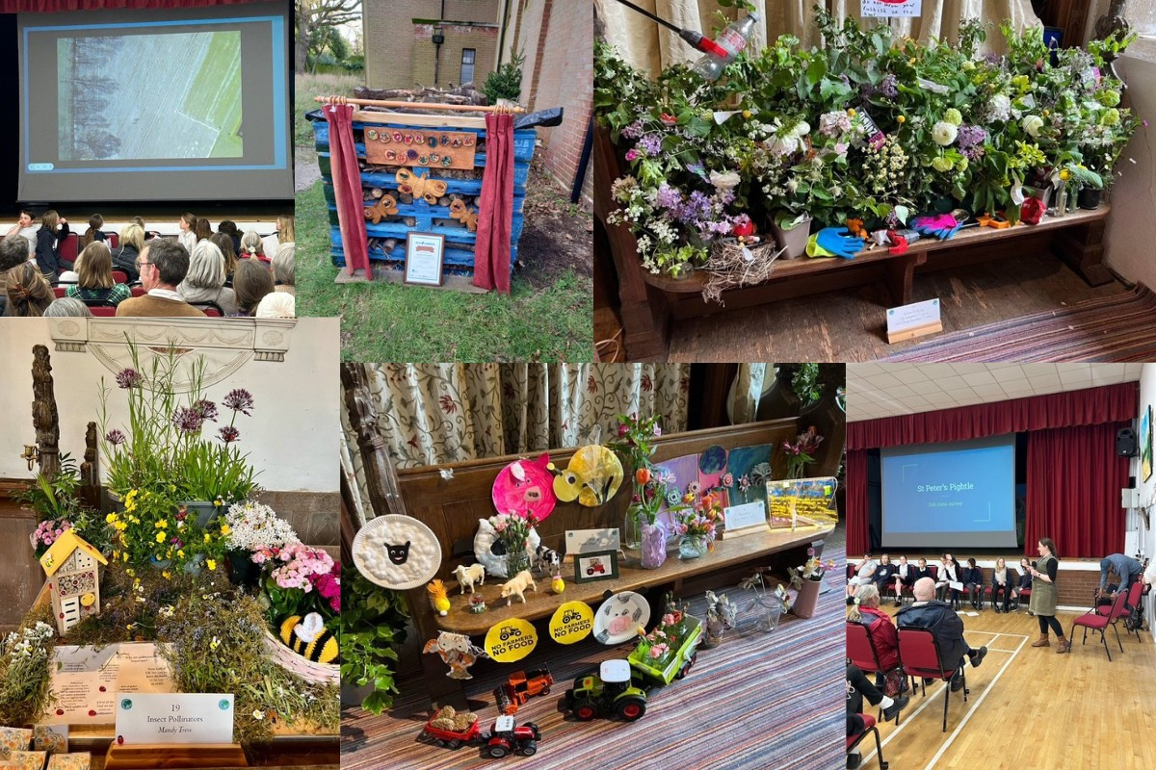

# [Click here to print a pdf copy](https://mcusercontent.com/c52dd45d5732d5bd4c5aa7748/files/41aa8b9b-3bf5-41a3-487a-eaa959c4f392/Latest_news_from_the_Diocesan_Environment_Group.01.pdf)

**[Twitter](http://www.twitter.com/)[Facebook](http://www.facebook.com/)[Website](http://mailchimp.com/)**

*Copyright © 2025 Diocese of St Edmundsbury and Ipswich, All rights reserved.*

*This email is generated from the Communications Office at the Diocese of St Edmundsbury and Ipswich.* A Company Limited by Guarantee and a Registered Charity. Registered in England and Wales Reg No. 143034.

**Our mailing address is:**

Diocese of St Edmundsbury and Ipswich St Nicholas Centre, 4 Cutler Street, Ipswich

Suffolk IP1 1UQ

[Add us to your address book](https://emea01.safelinks.protection.outlook.com/?url=http%3A%2F%2Fcofesuffolk.us2.list-manage.com%2Fvcard%3Fu%3Dc52dd45d5732d5bd4c5aa7748%26id%3Df9db65220e&data=01%7C01%7Cleonie.ryle%40cofesuffolk.org%7C644e979053b54add58bd08d4efae3d55%7C64990a9c67994442988fcb8b9e9dbb7f%7C0&sdata=%2F2Vz2hGE%2FvsiDfT8xFyWuMIbPzrbf7dZZ8mXaYUX338%3D&reserved=0)

[unsubscribe from this list](https://emea01.safelinks.protection.outlook.com/?url=http%3A%2F%2Fcofesuffolk.us2.list-manage2.com%2Funsubscribe%3Fu%3Dc52dd45d5732d5bd4c5aa7748%26id%3Df9db65220e%26e%3D%26c%3Dace862c9c2&data=01%7C01%7Cleonie.ryle%40cofesuffolk.org%7C644e979053b54add58bd08d4efae3d55%7C64990a9c67994442988fcb8b9e9dbb7f%7C0&sdata=nM9RzTZu0k6e1BZbjWFpk%2FZdgtK8oc9abkaTghskyVM%3D&reserved=0) [update subscription preferences](https://emea01.safelinks.protection.outlook.com/?url=http%3A%2F%2Fcofesuffolk.us2.list-manage.com%2Fprofile%3Fu%3Dc52dd45d5732d5bd4c5aa7748%26id%3Df9db65220e%26e%3D&data=01%7C01%7Cleonie.ryle%40cofesuffolk.org%7C644e979053b54add58bd08d4efae3d55%7C64990a9c67994442988fcb8b9e9dbb7f%7C0&sdata=9kGVlQxG2U3nyqxzh6EXJ6W%2BAC8dKndd7QUqxygcnsA%3D&reserved=0)